Nitrates Action Programme - Ireland

Derogation Report 2019

Report for 2019 for the purposes of Articles 7 and 9

of the Commission Decision of 27/02/2014 granting

a derogation requested by Ireland, pursuant to

Council Directive 91/676/EEC.

CONTENTS

Introduction

Operation of the Derogation in 2019

Applications

Description of Maps

Controls

5.1 Administrative Checks

5.2 Results of Administrative Checks

5.3 Administrative Penalties

5.4 Field Inspections

Overview of Methodologies, Monitoring and Results of the impact of the derogation granted in this Decision on water quality, as referred to in Article 8(2) and the Agricultural Catchments Programme.

Conclusion

Appendices

1. Derogation holdings shown as a percentage of whole country

2. Nitrates Derogations 2019: Applications by County

3. List of documentation relating to Nitrates Derogation in 2019

(provided as separate documents)

4. Maps (provided as separate documents)

Map 1: Percentage of holdings with grazing livestock encompassed by Derogation in 2019 at county level

Map 2: Percentage of grazing livestock units encompassed by Derogation in 2019 at county level

Map 3: Percentage of net area encompassed by derogation in 2019 at county level

5. Report on Nitrogen and Phosphorus in Irish Waters (2019) (provided as separate document)

1. Introduction
Regulations giving statutory effect to certain elements of Ireland’s first Action Programme under the Nitrates Directive were enacted in 2005 i.e. the European Communities (Good Agricultural Practice for Protection of Waters) Regulations 2005 (S.I. No. 788 of 2005). These Regulations were subsequently replaced by S.I. No. 378 of 2006. The European Communities (Good Agricultural Practice for Protection of Waters) Regulations 2009 (S.I. No. 101 of 2009) revised and replaced amending legislation made in 2006 and 2007. The 2009 Regulations provided for strengthened enforcement provisions and for better farmyard management. They also provided the legal basis for the operation of derogation under the Nitrates Directive (91/676/EEC), which was granted to Ireland by the European Commission on 22nd October 2007 (2007/697/EC), and subsequently amended on 24th February 2011 (2011/127/EU). The 2009 Regulations were replaced on 20th December 2010 by the European Communities (Good Agricultural Practice for Protection of Waters) Regulations 2010 (S.I. No. 610 of 2010). These Regulations were subsequently replaced by the European Communities (Good Agricultural Practice for Protection of Waters) Regulations 2014 (S.1. No.31 of 2014). The most recent legislation following the NAP Review in 2017 is the European Communities (Good Agricultural Practice for Protection of Waters) Regulations 2017 (S.I. 605 of 2017) which came in to force on 1st January 2018.
The Commission Decision of 8th February 2018 permits the land application of up to 250 kilograms of nitrogen per hectare per year from livestock manure under certain conditions. Article 7 of the Commission Decision requires that maps showing information concerning approved derogations on a county basis be submitted annually to the Commission. Article 8 sets out the reporting requirements for the purposes of the Commission Decision. This report is submitted to address the requirements of Articles 8 and 10 and relates to operation of the derogation in Ireland during 2019.

2. Operation of the Derogation in 2019
The documentation associated with the administration of the Nitrates Derogation in Ireland in 2019 is shown in Appendix 3.

3. Applications

Summary of derogation applications 2007-2019
Year | 2007 | 2008 | 2009 | 2010 | 2011 | 2012
Applications received | 4,889 | 6,357 | 5,247 | 4,291 | 4,685 | 5,273
Applications approved | 4,133 | 3,855 | 4,908 | 4,100 | 4,471 | 5,093

Year | 2013 | 2014 | 2015 | 2016 | 2017 | 2018 | 2019
Applications received | 5,408 | 5,793 | 6,330 | 6,804 | 6,995 | 6,897 | 6,786
Applications approved | 4,943 | 5,273 | 5,997 | 6,533 | 6,557 | 6,554 | 6,410

The 2019 application process resulted in applications from a total of 6,786 herdowners; 131 were rejected and 245 were withdrawn, leaving 6,410 applications approved for derogation (a breakdown by county is given at Appendix 2).

4. Description of Maps
Three maps have been prepared for the purpose of Article 8 of the Commission Decision (Appendix 4 and attached as separate documents); the maps are based on the numbers of approved applications in 2019.

Map 1: Percentage of holdings with grazing livestock encompassed by derogation in 2019 at county level.
Map 1 categorises the number of derogation holdings as a percentage of the total number of holdings in the country with cattle and or sheep, on a county basis. Counties are categorised into one of four categories (less than 3%, between 3% and 5%, between 5% and 10% and greater than 10%).

Map 2: Percentage of grazing livestock units encompassed by derogation in 2019 at county level.
Map 2 categorises the number of grazing livestock units (one grazing livestock unit = 85kgs N from cattle or sheep manure) on approved derogation holdings as a percentage of the total grazing livestock units in the country, on a county basis. Counties are categorised into one of four categories (less than 3%, between 3% and 5%, between 5% and 10% and greater than 10%).

Map 3: Percentage of net area encompassed by derogation in 2019 at county level.
Map 3 categorises the total net area on approved derogation holdings as a percentage of the total net area in the country, on a county basis.
Derogation holdings accounted for 4.9% of the total number of holdings with cattle and or sheep in the country in 2019. 15.9% of the total number of grazing livestock units were on derogation holdings. Derogation holdings accounted for 9.6% of the total net area of the country in 2019. Table at Appendix 1 refers.

5. Controls
Farmers were obliged to submit a 2019 online Derogation application by 31st March 2019.

Farmers who availed of the derogation facility in 2018 were required to submit fertiliser accounts by 31st March 2019. All of these accounts were subject to administrative checks.

5.1 Administrative checks
Administrative checks on applications/fertiliser accounts
A database of all derogation applications received was generated. The following administrative checks were undertaken:

- Derogation applicants’ particulars were checked against the Department’s Corporate Customer System (CCS) by means of the herd number supplied.
- Type of livestock on holding – checked that farmer had grazing livestock (consulted other Department databases).
- Declared area of holding checked re 80% grassland requirement.
- Compliance with the maximum limit of 250kg/N/ha/annum from grazing livestock manure;
- Quantities of livestock manure exported to other holdings (if applicable).
- Check if herd restricted.
- Deadline for receipt of completed Record of movement of organic fertiliser (Record 3) forms if applicable was 31st December 2019.
- Deadline for receipt of Short-Term Rental Grazing Agreement (Record 5) if applicable was 31st December 2019.

5.2 Results of administrative checks
The following is a breakdown of the numbers of derogation applicants and the results of administrative checks for 2019.

Numbers of derogation applicants and the results of administrative checks 2019
Number of applications | 6,786
Number withdrawn | 245
Number rejected | 131
Number approved | 6,410

5.3 Administrative Penalties (for breaches of Nitrates Regulations)
As part of our controls under the Nitrates Regulations, DAFM carries out a 100% check on all herdowners with livestock on an annual basis. This check requires compilation of the total kgs of Nitrogen (N) for every herd from the Animal Identification and Movement System (AIM), divided by the declared area under the Basic Payment System, to arrive at a kg/N per hectare figure for each herd. Herdowners in breach of the 170/250 kg per hectare limit incur penalties. The penalty levels for breaching the application limits of 170/250 kg of Nitrogen from livestock manure per hectare per annum on holdings are as follows:

Non-Derogation cases |  | Derogation cases
Band | % Penalty | Band | % Penalty
>170 <=180 | 1% | <=300 | 5
>180 <=210 | 3% | >300 | 20
>210 <=250 | 5%
>250 | 20%

These percentage penalties are applied on EU funded direct payments schemes and Rural Development Programme measures, i.e. including Basic Payment Scheme, ANC and GLAS where applicable. This sanction is provided for in EU Regulations 1306/2013, 640/2014 and 809/2014 and is applied under the Terms and Conditions of the Direct Payment Schemes and Rural Development Programme measures.

In 2019, the number of farmers penalised for exceeding the Nitrogen limits in 2018 was 1,884. Of that 90 exceeded the 250 kg limit. To date, 1,376 farmers are identified as having exceeded the Nitrates limits in 2019 and have received notification of the resulting penalties. These letters will continue to issue in tranches to year end as further cases are identified. Each farmer is entitled to appeal any sanction imposed to the Agricultural Appeals Office.

The details of final decision penalty letters that issued for the period 2007-2019 to date are outlined in the table below.

Year | 2007 | 2008 | 2009 | 2010 | 2011 | 2012
No. of penalties issued | 1,263 | 903 | 1,423 | 1,334 | 1,320 | 1,653

Year | 2013 | 2014 | 2015 | 2016 | 2017 | 2018 | 2019
No. of penalties issued | 2,252 | 1,583 | 1,834 | 1,888 | 1,658 | 1,884 | 1,376*

* As at 22/10/20e, Work in progress

5.4 2019 Field inspections
A total of 341 inspections were carried out which complies with the 5% inspection requirement in 2019. A total of 23 herd owners will incur penalties as a result of these inspections, which will result in a deduction from their Basic Payment Scheme, Greening, YFS, Protein Aid, ANC, REPS, AEOS, GLAS, Organics and BDGP payments, where applicable.

Of these 4 herdowners received a 3% penalty, 6 herdowners received a 5% penalty and 13 herdowners received a 20% penalty.

Of these, 1 herdowner received a 1% penalty on their payment, 2 herdowners received a 3% penalty, 4 herdowners received a 5% penalty.

6. Overview of Methodologies, Monitoring and Results of the impact of the derogation granted in this Decision on water quality, as referred to in Article 8(2)
Monitoring Programme
EU Member States are required to monitor the effectiveness of their Nitrates Regulations, under Article 5 (6) of the EU Nitrates Directive. Ireland monitor the implementation of the Nitrates Regulations in part through the Agricultural Catchments Programme (ACP) and have been monitoring the effectiveness of Ireland’s measures since 2008 through its significant funding of the Teagasc delivered Agricultural Catchments Programme (ACP). The fourth cycle of the ACP was approved in November 2019 for a further four-year period to 2023 a cost of €2.5m.

The Agricultural Catchments Programme
The Irish Agricultural Catchments Programme (ACP) was established in 2008 to:
- monitor the effectiveness of the Good Agricultural Practice measures, initially for compliance with the Nitrates Directive (ND) and since 2014 with the Water Framework Directives (WFD),
- provide a scientific basis for policy review
- monitor derogation in Ireland.

The programme is a collaboration with over 300 farmers in six small river catchments in Ireland. The ACP is funded by the Department of Agriculture Food and the Marine (DAFM) and is currently in its fourth 4-year cycle of funding. The programme has taken a whole catchment approach. By using the “nutrient transfer continuum” (Haygarth et al., 2005) as a conceptual frame work an extensive monitoring programme of nutrient sources and hydro-chemo-metrics have been designed similarly across all six catchments (Table 1) to understand how nutrients are lost from agricultural sources, how they can be mobilised and transferred via different hydrological pathways, how they are delivered to water and where there may be a negative impact on water quality and aquatic ecology. The whole catchment approach was agreed upon during the first phase of the programme by the ACP Expert Steering Group composed of internationally leading scientists and national policy makers.

Table 1. Bio-physical data collected within each of the six catchments monitored within the Agricultural Catchments Programme since 2009.
 | Location | Parameters | Frequency | Number of sites per catchment
Weather | Catchment centre low-land | Rain, T_{air}, T_{soil} , RelHum, SolRrad, WindSpeed, WindDir | 10-minutes | 1  (2 in one catchment)
 | Highland | Rain | 10-minutes | 1
Groundwater | Focused study sites | Water level  Chemistry: nutrients, metals, DO, Rh, EC, Temp, pH | 30-minutes  Month | 18 piezometers (two catchments),  10 piezometers (one catchment)  6 piezometers (one catchment)
Surface water | Outlet | River flow, T_{water}, Water Chemistry: TP, TRP, TON, TOC, Turb, EC | 10 minutes | 1
 | River network | Chemistry: nutrients, metals, DO, Rh, EC, Temp, pH | Monthly | 10
 | River network | Aquatic ecology: macro invertebrates, diatomes | 6 months | 8
Soil | Whole catchment | Soil sampling: N and P | 4 year | Each field
Soil/bedrock | Focused study sites | Geophysical survey: EM, 2-D res, seismic refraction | once | 2 hillslopes
Topography | Whole catchment | LiDAR survey 0.5m | once

Methodologies reflecting Irish Conditions

Ireland given our unique typology and geographical circumstances and primarily grass based system of production have implemented a “Whole Catchment Approach” to water monitoring as regards nitrate concentrations, including information on water trends, both under derogation and non-derogation conditions as well as the impact of the derogation granted in this decision on water quality, as referred to in Article 8(2). While Article 8 (2) specifies the requirement to report the results of ground and surface water monitoring, this approach given Irelands multi facet soil type does not reflect the homogenous nature of soil type of other EU member states and Ireland consider from a scientific perspective the approach adopted at a Catchment level reflects the true scientific reporting on water quality.

The approach adopted “Whole catchments approach”
The ACP has six catchments ranging in size from 4 – 30 km². These have been continually monitored since 2008 and were selected by a multi-criteria analysis (Fealy et al., 2010) to represent intensively managed agricultural land on different physical settings and dominating land use, therefor different type of riskiness for N and P loss in terms of vertical drainage or lateral runoff risk (Figure 1, Table 2). Since both surface and groundwater bodies are deemed to be at risk for N and P transfers in Ireland, the catchment scale was chosen to include monitoring of surface and groundwater. Catchments allow monitoring of hydrologically isolated source areas which is suitable since the WFD operates on the scale of catchments and a catchment evaluation was also directed for Ireland by EU legislation (OJEC, 2007). The catchment size was further chosen to be large enough to encompass the range of hydrological conditions from headwaters to main river channel, allowing for normal N and P transformation and mobilisation processes to occur, and also to integrate the impacts of a realistic range of farm practices within a typical farming system (Wall et al., 2011). Importantly the size was also chosen to be small enough to engage with all farmers in each catchment. Knowledge exchange occurs frequently via the specialised farm advisors either one-to-one or in discussion groups. There are also public events and farm walks arranged, and research dissemination events are held annually.

Figure 1. The six catchments monitored within the Agricultural Catchments Programme.
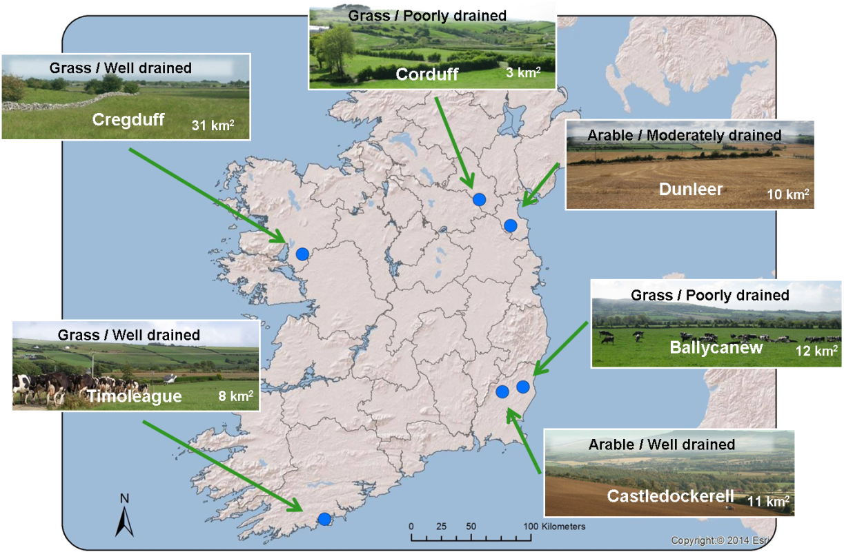

Table 2. Dominating catchments characteristics, annual average organic N loading (2010-2018), organic P loading (2008-2014) and annual average hydrochemistry (2010-2018).
Catchments |  |  |  | Input per annum |  |  | Output per annum
Name | Land use | Soil drainage | Size | Rain  fall | Org P | Org N | River flow | TRP | TP | NO₃-N
 |  |  | [km²] | [mm] | [kg ha⁻¹] | [kg ha⁻¹] | [mm] | [mg ^{l-1}] | [mg l⁻¹] | [mg l⁻¹]
Corduff | Grass | Poor | 3 | 855 | 12 | 87 | 550 | 0.031 | 0.055 | 1.39
Dunleer | Arable | Moderate | 10 | 850 | 9 | 67 | 405 | 0.118 | 0.164 | 5.01
Ballycanew | Grass | Poor | 12 | 1040 | 11 | 101 | 500 | 0.077 | 0.115 | 2.61
Castle  dockerell | Arable | Well | 11 | 1000 | 4 | 41 | 520 | 0.028 | 0.046 | 7.04
Timoleague | Grass | Well | 8 | 1105 | 23 | 166 | 680 | 0.066 | 0.101 | 5.97
Cregduff | Grass | Well | 31 | 1150 | 10 | 90 | - | 0.017 | 0.023 | 1.32

Comparing the Catchment Scale Approach
The annual total organic N loading has increased in the Timoleague catchment, which had the highest loading throughout the period (Figure 2a). On average, Timoleague had 54% of the land in derogation (2010-2018) and 66% in 2018. There has also been an increase in total annual organic N loading in Ballycanew with an average of 22% of the land in derogation and 30% in 2018. The lowest organic N loading was found in the Castledockerell catchment where none of the land was in derogation during the period.
Ten-years of high frequency monitoring of N and P concentration in the catchments outlets showed that not only the magnitudes of concentrations but also the dynamics varied across the catchments. The link between the percentage of land in derogation and the stream water concentration of NO₃-N was not clear, reflecting differences in soil type, land-use and meteorological factors which were evident at the catchment scale of the ACP (Figure 2b).
For example, Castledockerell catchment with the highest NO₃-N concentration in the stream water was the catchment with only 5% of the land in derogation. The physical setting overrides the source pressure (Jordan et al., 2012; Mellander et al., 2012a; Shore et al., 2016). Despite catchments having similar organic N and P loading the water quality, in terms of N and P concentration, was very different in the catchment outlets (Table 2). There was a large difference in loss of nutrients to water due to soil drainage (Jordan et al., 2012). Despite similar source loading Ballycanew catchment with poorly drained soils and a “flashy hydrology” had three times higher total P loss than the well-drained and mostly groundwater driven Castledockerell catchment (Figure 3) (Mellander et al., 2015). However, also catchments with similar soil drainage can differ in nutrient loss due to processes associated to the soil chemistry as a controlling factor for P solubility. In Timoleague catchment with iron rich soils there was more P loss to the stream via leaching to shallow groundwater (Mellander et al., 2016; Dupas et al., 2017). Iron rich soils have also been found to increase the loss of medium sized colloidal P (Fresne et al., 2020). In another free draining catchment with calcium rich soils P was instead largely retained (Mellander et al., 2012b; Mellander et al., 2013). The research so far has highlighted the overriding importance of soil type, subsoil geology and groundwater hydrochemistry in controlling N and P loss to water.

Figure 2 Ten years of a) annual total organic N loading in the whole catchments (2008-2018), and b) monthly average (antecedent moving average) nitrate-N concentration in the catchments river outlets monitored within ACP (2010-2019). The Water Framework Directive nitrate-N threshold concentration is 11·3 mg/l marked as dashed line.
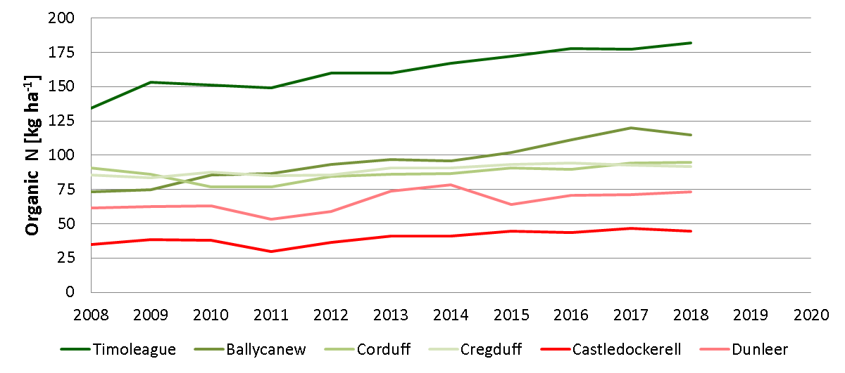
a)
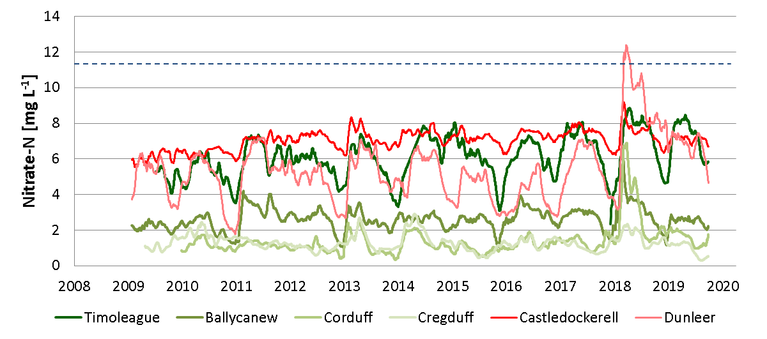
b)

Figure 3. Monthly Total P mass load as a function of river flow in two catchments with contrasting soil drainage and hydrology but with similar P loading (from Mellander et al., 2015)
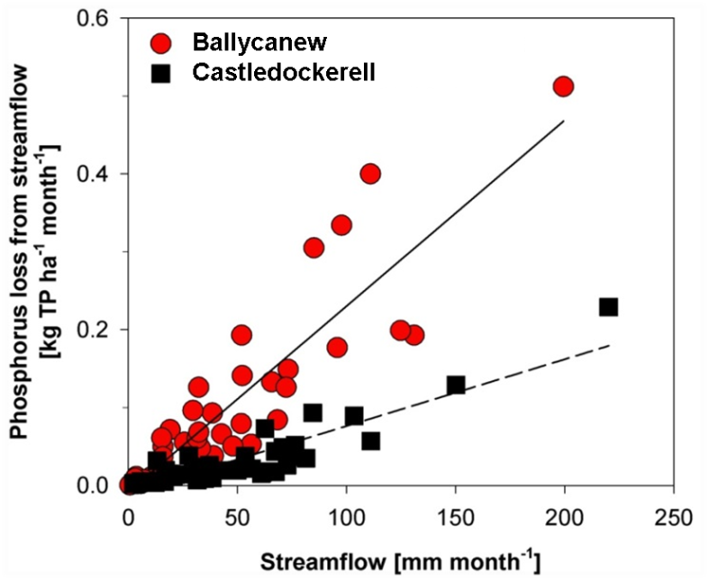

The controls of nutrient loss
The Irish agricultural landscape is heterogeneous in terms of its physical setting and even within smaller meso-scale catchments, such as those monitored within the ACP, there can be a large variability in soil types and the factors controlling both N and P transfer pathways and the transformation processes (such as topography, soil and bedrock properties – mainly permeability).
Leaching of N is not a steady state process and there are many factors controlling NO₃-transport and transformation in the unsaturated zone (Fenton et al., 2011; Jahangir et al., 2012). Such factors include both static (e.g. soil and bedrock type, thickness and permeability) and dynamic factors (e.g. climate, soil moisture deficit, depth to water table) which are spatially and temporally variable across any farming landscape (Huebsch et al., 2015; Mellander et al., 2018; Fenton et al., 2017). The N removal capacity varied highly between and within two of the catchments monitored within ACP (McAleer et al., 2017). At the catchment scale there was a poor link with the surplus NO₃-N leached to the groundwater and the concentrations of NO₃-N monitored in the catchment river outlet.
For example, in one of the catchment monitoring sites the NO₃-N concentration in the shallow groundwater locally reached highly elevated levels of 23.9 mg/L as the result of a ploughing and pasture reseeding event. This was however not detected in the river due to the locally high N removal capacity and likely also due to mixing of deeper groundwater with lower NO₃-N concentrations (Mellander et al., 2014). That catchment further had significantly lower NO₃-N concentrations than an intensively managed Arable catchment on similar physical setting in Brittany (Dupas et al., 2017). Amplified cycles of weather can largely influence N loss to water and the influence is different within the agricultural landscape due to the physical and chemical settings (Mellander et al., 2018). Therefore, a reduction in N surplus can enable N load transfer to groundwater to decrease over time leading to improvements in water quality in some areas after hydrologic and biogeochemical time lags (including immobilisation, attenuation capacity) are considered (e.g. NO₃⁻ improvements in free draining soils and ammonium (NH₄⁺) improvements in poorly drained soils). In heavier textured soils emissions along other pathways (e.g. gaseous emissions) must also be considered and conversion of NO₃⁻ to NH₄⁺ which can be lost to surface water along intercepting artificial drainage systems.
Expected water quality improvement as the results of mitigation measures may be delayed for groundwater due to variable drainage amounts and delayed responses of NO₃⁻ in deep aquifers (Fenton et al., 2011). In meso-scale catchments a positive response occurred from 1 to 10 years after decreased N surpluses were achieved, with the response time broadly increasing with catchment size (Melland et al. 2018). However, it took from 4 to 20 years to confidently detect the effects in water body monitoring systems. Such time lag may be a useful indicator to reveal the hydrogeological links between the agricultural pressure and water quality state, which is fundamental for a successful implementation of any water protection plans (Kim et al., 2020).

Sub-catchments approach
Due to the apparent influence of the complexity of many soil types, as well as a range of agronomic intensities existing even within meso-scale catchment, the ACP has taken on a sub-catchment approach. The two hydrologically contrasting catchments with a high percentage of land in derogation (Timoleague and Ballycanew) were divided into 8 sub-catchments (ca. 1 km²) corresponding to the water quality monitoring sites along the river network. Sub-catchments dominated by land in derogation and with minimum amount of land in derogation were selected for comparison of nutrient concentrations in the stream water.
In Ballycanew, the catchment with mostly poorly drained soils, the percentage of land in derogation was not reflected in the NO₃-N or in the Total Reactive Phosphorus (TRP) concentrations monitored in the stream water of the sub-catchments, despite a large difference in the percentage of land in derogation (Figure 4, Table 3). Two sub-catchments (T2 and M1) substantially increased in the percentage of land in derogation in 2014 (from 0 to 46% and 11 to 57% respectively). That sharp increase was not detected in the stream water of those sub-catchments.
However, in Timoleague catchment, with mostly freely drained soils, the sub-catchment with higher percentage of land in derogation had higher concentrations of NO₃-N and TRP in the stream water (Figure 5, Table 4).

Table 3. Proportion of land in derogation in the Ballycanew catchment, average Nitrate-N concentration and average total Reactive Phosphorus (TRP) for the period 2010-2018.
 | Out | M5 | M6 | M1 | T2
Derogation [%] | 34 | 3 | 0 | 39 | 27
Nitrate-N [mg l⁻¹] | 2.60 | 3.40 | 3.04 | 2.36 | 3.23
TRP [mg l⁻¹] | 0.077 | 0.041 | 0.042 | 0.047 | 0.020

Table 4 Proportion of land in derogation in the Timoleague catchment, average Nitrate-N concentration and average total Reactive Phosphorus (TRP) for the period 2010-2018.
 | Out | M5 | T1A
Derogation [%] | 80 | 12 | 80
Nitrate-N [mg l⁻¹] | 5.97 | 4.24 | 5.73
TRP [mg l⁻¹] | 0.066 | 0.025 | 0.078

Figure 4. a) The Ballycanew catchment with sub-catchments. Land under derogation in 2018 is coloured red b) monthly average nitrate-N concentration (antecedent moving average) in the catchments stream outlet (black line) and in the stream by the sub-catchments with low proportion of land in derogation (green symbols) and high proportion of land in derogation (red symbols) based on monthly grab samples.

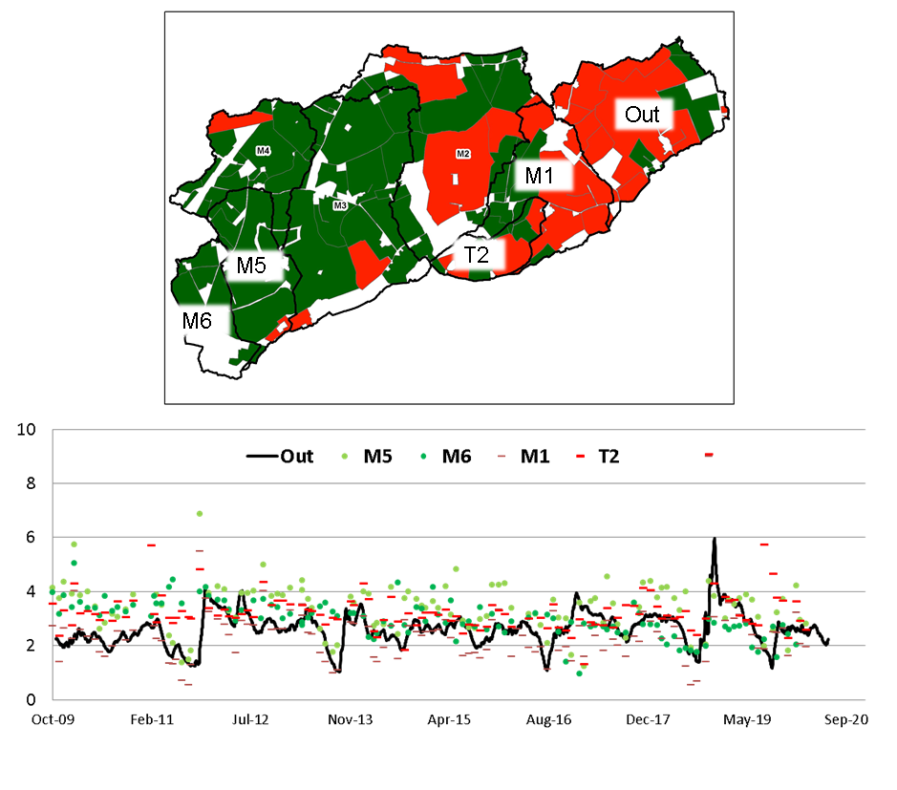
b)
NO₃-N [mg l⁻¹]
a)

Figure 5. a) The Timoleague catchment with sub-catchments. Land under derogation in 2018 is coloured red b) monthly average nitrate-N concentration (antecedent moving average) in the catchments stream outlet (black line) and in the stream by the sub-catchments with low proportion of land in derogation (green symbol) and high proportion of land in derogation (red symbol) based on monthly grab samples.

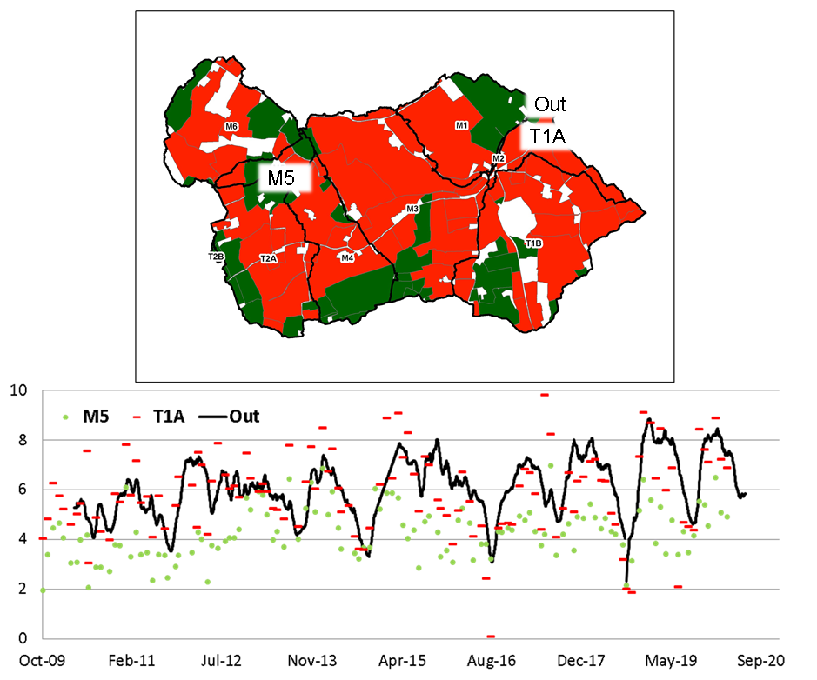
b)
NO₃-N [mg l⁻¹]
a)

Water quality trends
In the Timoelague catchment there was a high annual organic N loading with an increase from 134 to 182 kg ha⁻¹ in 2008-2018 (Figure 2a) but there was no statistically significant temporal trend found in the groundwater NO₃-N concentration during 2010-2017 (McAleer et al., in prep). In the Castledockerell catchment, which is dominated by spring barley, there was a low annual organic N loading with a minor increase from 35 to 45 kg ha⁻¹ from 2008-2018, and there was a higher groundwater NO₃-N concentration with a positive trend during 2010-2017 (McAleer et al., in prep). It was found that factors such as N application, soil moisture deficit and soil/bedrock permeability explained 60-80% (P<0.0001) of the nitrate occurrence in the groundwater suggesting that it was not possible to separate agronomic factors from meteorological ones. Despite having lower sources the Castledockerell catchment had high NO₃-N concentrations in both groundwater and surface water due to a combination of free draining soils, lower drainage and tillage management practices (McAleer et al., in prep).

Meteorological impacts on water quality
In 2018 a nation-wide drought caused a build-up of a large soil N pool due to poor grass growth and enhanced soil N mineralisation. That pool of N was flushed out and transferred to the stream in the large rain events in November causing elevated NO₃-N concentrations. The influence of this weather extreme was clearly seen in the ACP catchments where the monthly average NO₃-N concentrations increased in all catchments and in Dunleer catchment exceeded the WFD threshold concentration of 11.3 mg l⁻¹ (Figure 2B). The daily average NO₃-N concentration also exceeded the WFD threshold in the Ballycanew catchment which in other times has a relatively low NO₃-N concentration. The long-term shifts in weather patterns and more occurring weather extremes, as expressed by the North Atlantic Oscillation index, was found to influence both N and P concentration in the ACP catchments and in similar sized (ca. 10 km²) agricultural catchments in Norway and Brittany (Mellander et al., 2018). The response was different for catchments with different physical and chemical settings. There can also be an increased sensitivity of small rivers in summer drought caused by a lack of dilution of a small point-source which may significantly elevate P concentrations during an ecological sensitive period (Shore et al., 2017).

Sediment Impact
Excessive sediment can significantly impact the condition of freshwater habitats, resulting in a deterioration of water quality. Sediment can have a greater impact on freshwater insects (key indicators of water quality) than both N and P concentrations.
Meso-sale atchments with low permeability exported larger suspended sediment yields than those with high permeability. Where arable land occurred on low permeability soils, the highest sediment export was recorded. High inter-annual variability resulted from rainfall fluctuations. The results indicate that catchment soil erosion risk can be classified according to soil drainage characteristics and land use type (Sherriff et al., 2019). Suspended sediment export from five of the six ACP catchments was low compared to values for the UK and mainland Europe. This was attributed to greater density of landscape features such as hedgerows and drainage ditches which reduced field sizes, and act as natural mitigation measures (Sherriff et al., 2015). Assessment of the provenance of suspended sediments highlighted that field topsoils, channel banks/sub-surface soils and roads were the dominant contributors to suspended sediments in the ACP catchments and contrasted between catchments e.g. grassland catchments dominated by low permeability soils with extensive sub-surface and surface drainage primarily exported sediment originating from channel banks due to delivery of high velocity flows from up-catchment drained hillslopes (Sherriff et al., 2018).
Both soil drainage type and season have a significant influence in structuring macroinvertebrate communities. Poorly-drained catchments were most impacted, with communities dominated by pollution-tolerant taxa (O hUallachain, 2019). Sediment was found to be a more pervasive stressor on freshwater ecosystems than N or P, with high sediment cover levels having the greatest negative impact on macroinvertebrate communities (Davis et al. 2018, 2019)

ACP Phase 4 (2020 – 2024)
The current fourth phase of the ACP has received an increased budget of 65%. This will facilitate the recruitment of new researchers, technicians and technologists to conduct new experiments and support the on-going and extended data collection and research. This phase of the programme will include new farm-scale experiments and monitoring of N and P concentrations in soil solutions and groundwater on derogation and non-derogation farms on similar physical setting. These farms will be selected based on the derogation history and current derogation situation as well as on the soil type and location in the landscape. A catchment modeller will further test scenarios of intensification of farming and weather. Above baseline mitigation measures will be tested and evaluated. These temporal data-rich meso-scale catchments (ca. 10 km²) can be used to scale-up to regional and national scale using the spatially rich national data set provided by the EPA. An important part of the fourth phase of the programme is the inclusion of monitoring and research on greenhouse gas (GHG) emission and carbon sequestration. This will give a comprehensive insight to intensified agriculture on both water quality and GHG emission in representative areas of Ireland.

Summary
The influence of derogation in Ireland has been assessed at a small catchment scale by detailed water quality monitoring of surface and groundwater bodies in intensively managed and agricultural catchments with different physical setting. Ireland has a large variety of soil types and geology. The heterogeneous physical settings largely influence the nutrient transfer pathways and the associate transformation process along the pathways.
At the scale of the ACP catchments these settings can override the source pressure causing a poor link between nutrients leaving the root zone and nutrients monitored in the stream water. The percentage of land in derogation within a catchment was not reflected in the water quality in the streams.
In the catchment with most land in derogation and with a gradual increase in annual organic N loading there was no increase in NO₃-N concentration in groundwater. In the catchment with no derogation and only minor increase in organic N loading there was an increase in the NO₃-N concentration in groundwater. A clear weather signal in both N and P concentration has been found in streams in the Irish ACP catchments and in other catchments in NW Europe.
At the sub-catchment scale (ca. 1 km²), of a freely drained catchment, there was a higher NO₃-N and TRP concentrations in the sub-catchment with a higher proportion of land in derogation. In a catchment with poorly drained soils the percentage of land in derogation in sub-catchments was not reflected in the stream water. Sediment can have a greater impact on key indicators of water quality than N and P concentrations. The heterogeneous physical settings and land use also largely influence the suspended sediment transfer. The fourth phase of the ACP includes detailed farm-scale experiments and monitoring of N and P concentrations in soil solutions and groundwater on derogation and non-derogation farms.

Key messages
- Ireland’s landscape is heterogeneous in terms of factors controlling N and P transfer pathways, transformation processes and timing of delivery
- The influence of soil type, subsoil and geology on nutrient loss to water can override source pressures. At the meso-scale catchment (ca. 10 km²) the link between nutrients source pressures and nutrients monitored in the stream water was not clear
- Weather changes can override temporal trends of agronomic pressures
- The influences of weather shifts were different for different physical settings. Both long-term weather shifts and short-term offsets need consideration
- Sediment can have a greater impact on key indicators of water quality than N and P
- Site specific information is required to implement appropriate measures
- ACP will monitor N and P concentrations in soil solutions and groundwater on derogation and non-derogation farms
- ACP will use high temporal resolution water quality data from meso-scale catchments together with spatially high resolution data from the national data to scale-up to regional and national scale.
7. Conclusion
In 2019 the Department of Agriculture, Food and the Marine received a total of 6,786 derogation applications before the closing date; of these, 131 were rejected; 245 were withdrawn giving a total of 6410 that were approved for derogation.
Derogation holdings accounted for 4.85% of the total number of holdings with cattle and or sheep in the country in 2018. 16.93% of the total number of grazing livestock units were on dderogation holdings. Derogation holdings accounted for 9.86% of the total net area of the country in 2018.
Administrative checks are conducted and monitored on an on-going basis on all applications for derogation. A total of 370 inspections were carried out which exceeds the 5% inspection requirement in 2018. To date a total of 14 herd owners incurred penalties as a result of these inspections, which resulted in a deduction from their Basic Payment Scheme, Greening, YFS, Protein Aid, ANC, REPS, AEOS, GLAS, Organics and BDGP payments, where applicable. Of these, 1 herdowner received a 1% penalty on their payment, 2 herdowners received a 3% penalty, 4 herdowners received a 5% penalty. Additional field inspections were also carried out on derogation farms as part of normal cross compliance inspections.

Irelands proactive policy approach to further reducing the impact of agriculture on the environment

2019
Ireland work collaboratively across both Government Departments and their agencies to collectively protect water quality in Ireland. The Department of Housing, Planning and Local Government (DHPLG) is the lead authority for the Nitrates regulations (SI 605 2017) and the Department of Agriculture, Food and the Marine implements and operates the Nitrates Derogation (SI 65 2018). Teagasc both a research and advisory level is actively researching and promoting mitigation measures for farmers and the Environmental Protection Agency (EPA) is responsible for monitoring and reporting environmental indicators.
A review of Ireland’s nitrates derogation was undertaken in 2019 conducted to examine further opportunities for derogation farmers to improve efficiencies and continue to reduce their environmental footprint with regard to water, climate and air quality. It was conducted against the background of derogation farms being a very significant intensive cohort and the increasing area being farmed under the derogation. Furthermore, recent EPA reports have highlighted deterioration in water quality and increasing greenhouse gas and ammonia emissions.
Following this review, recommendations in relation to how derogation farmers can improve their nutrient use efficiency and environmental footprint were presented. These recommendations were translated into environmental measures through the enactment of new legislation through Statutory Instrument 40 2020. The new measures are aimed at further strengthening the protection of water and attaining optimum soil fertility that is consistent with both efficient agricultural production and effective water quality protection.
The evidence in this report highlights that at the national scale, nitrogen concentrations are relatively low in comparison to other member states. However, there are places where the concentrations are too high, and the trends are increasing, particularly in the south and south east of the country which is where most of the intensive farming takes place. The EPA national datasets highlight that there is a good relationship between farming intensity and nitrate concentrations in waters, but that there is water quality variability within and between sub-catchments. Detailed research work in the Agricultural Catchments Programme has highlighted that soils, weather and farming practices have a significant influence on nitrate concentrations at the local scale. This has important implications for selecting the right measures. Ireland’s heterogeneous landscape means that measures need to be targeted to achieve the best environmental outcomes. Ireland is adopting a collaborative approach to identifying these measures, and will seek to implement them using a range of policy instruments including the Nitrates regulations, the national river basin management plan and Climate action policy.

Appendix 1

Ireland: Nitrates Derogation 2019

Derogation as percentage of whole country

2019 | % of whole country
Number of holdings with grazing livestock | 4.98%
Number of grazing livestock units | 15.90%
Total net area | 9.61%

Appendix 2

Ireland: Nitrates Derogation, 2019

Nitrates Derogations 2019: Applications by County

County | Number of holdings who applied for derogation
Carlow | 96
Cavan | 108
Clare | 56
Cork | 2,149
Donegal | 104
Dublin | 2
Galway | 147
Kerry | 395
Kildare | 67
Kilkenny | 517
Laois | 242
Leitrim | 1
Limerick | 359
Longford | 19
Louth | 82
Mayo | 44
Meath | 166
Monaghan | 276
Offaly | 128
Roscommon | 17
Sligo | 20
Tipperary | 866
Waterford | 399
Westmeath | 61
Wexford | 384
Wicklow | 81
Total | 6,786

Appendix 3 – Provided as separate documents

Documentation relating to Nitrates Derogation in 2019

Terms and Conditions 2019

Fertiliser Accounts 2018

Note 1 – farmers were obliged to make on-line applications in 2019

Note 2 - 2018 Nitrates Derogation Fertiliser Plan: New or Amended Plan
Where a new or amended Fertiliser, Plan is submitted in 2018, only a plan produced by either the Teagasc online Nutrient Management Plan programme (eNMP) or the Farmeye Nutrient Management Plan programme was acceptable.

Appendix 4 – Provided as separate documents

Maps

Map 1: Percentage of holdings with grazing livestock encompassed by Derogation in 2019 at county level

Map 2: Percentage of grazing livestock units encompassed by Derogation in 2019 at county level

Map 3: Percentage of net area encompassed by derogation in 2019 at county level

Appendix 5 –

Report on Nitrogen and Phosphorus in Irish Waters (2018)

See attached – Environmental Protection Agency Report

(e) the results of the surveys on local land use, crop rotations and agricultural practices referred to in Article 8(4);
(f) the results of the model-based calculations of the magnitude of nitrate and phosphorus losses referred to in Article 8(5);

References
Davis SJ, Ó hUallacháin D, Mellander P-E, Kelly A-M, Matthaei CD, Piggott J., Kelly-Quinn M (2018). Multiple-stressor effects of sediment, phosphorus and nitrogen on stream macroinvertebrate communities. Science of the Total Environment, 637-638, 577-587.
Davis SJ, Ó hUallacháin D, Mellander P-E, Kelly A-M, Matthaei CD, Piggott JJ, Kelly-Quinn M (2019). Chronic nutrient inputs affect stream macroinvertebrate communities more than acute inputs: an experiment manipulating phosphorus, nitrogen and sediment. Science of the Total Environment, 683, 9-20
Dupas R, Mellander P-E, Gascuel-Odoux C, Fovet O, McAleer E, McDonald N, Shore M, Jordan P (2017). The role of mobilisation and delivery processes on contrasting dissolved nitrogen and phosphorus exports in groundwater fed catchments. Science of the Total Environment, 599, 1275-1287.
Fealy R, Buckley C, Mechan S, Melland A, Mellander P-E, Shortle G, Wall D, Jordan P (2010). The Irish Agricultural Catchments Programme: catchment selection using spatial multi-criteria decision analysis. Soil Use and Management, 26, 225-236.
Fenton O, Schulte RPO, Jordan P, Lalor STJ, Richards KG Fenton et al. (2011). Time lag: a methodology for the estimation of vertical and horizontal travel and flushing timescales to nitrate threshold concentrations in Irish aquifers. Environmental Science & Policy, 14, 419-431. http://dx.doi.org/10.1016/j.agee.2017.01.014.
Fenton O., Mellander P.E., Daly K., Wall D.P., Jahangir M.M.R., Jordan P., et al. (2017). Integrated assessment of agricultural nutrient pressures and legacies in karst landscapes. Agriculture, Ecosystems and Environment, 329: 246–256.
Fresne M, Jordan P, Fenton O, Mellander P-E, Daly K (2021). Soil chemical and fertiliser influences on soluble and colloidal phosphorus in agricultural soils. Science of the Total Environment, 754, 142112Haygarth et al., 2005
Haygarth PM, Condron LM, Heathwaite AL, Turner BL, Harris GP (2005). The phosphorus transfer continuum: linking source to impact with an interdisciplinary and multiscaled approach. Science of the Total Environment 344, 5–14.
Huebsch M, Horan B, Blum P, RichardsKG, Grant J, Fenton, O. (2013). Impact of agronomic practices of an intensive dairy farm on nitrogen concentrations in a karst aquifer in Ireland. Agriculture, Ecosystems & Environment, 179: 187–199. doi:10.1016/j.agee.2013.08.021.
Jahangir MMR, Johnston P, Khalil MI, Richards KG (2012). Linking hydrogeochemistry to nitrate abundance in groundwater in agricultural settings in Ireland. Journal of Hydrology, 448–449, 212–222.
Jordan P, Melland AR, Mellander P-E, Shortle G, Wall DP (2012). The seasonality of phosphorus transfers from land to water: implications for trophic impacts and policy evaluation. Science of the Total Environment, 434, 101-109.
Kim H, Sturdy N, Moller I, Graversgaard M, Blicher-Mathiesen G, Henriot A, Dalgaard T, Hansen B (2020). Lag time as an indicator of the link between agriculture pressure and drinking water quality state. Water, 12(9), 2385
McAleer E, Coxon C, Richards KG, Jahangir MMR, Grant J, Mellander P-E (2017). Groundwater nitrate reduction versus dissolved gas production: A tale of two catchments. Science of the Total Environment, 586, 372-389.
McAleer E, Coxon C, Mellander P-E, Grant J, Richards KG. Patterns and drivers of groundwater and stream nitrate concentrations in intensively managed agricultural catchments (in prep).
Melland AR, Fenton O, Jordan P (2018). Effects of agricultural land management changes on surface water quality: A review of meso-scale catchment research. Environmental Science and Policy, 84, 19-25.
Mellander P-E, Melland AR, Jordan P, Wall DP, Murphy PNC, Shortle G (2012a). Quantifying nutrient transfer pathways in agricultural catchments using high temporal resolution data. Environmental Science and Policy, 24, 44-57.
Mellander P-E, Wall DP, Jordan P, Melland AR, Meehan R, Kelly C, Shortle G (2012b). Delivery and impact bypass in a karst aquifer with high phosphorus source and pathway potential. Water Research, 46, 2225-2236.
Mellander P-E, Jordan P, Melland AR, Murphy PNC, Wall DP, Mechan S, Meehan R, Kelly C, Shine O, Shortle G (2013). Quantification of phosphorus transport from a karstic agricultural watershed to emerging spring. Environmmental Science and Technology, 47, 6111-6119.
Mellander P-E, Melland AR, Murphy PNC, Shortle G, Jordan P (2014). Coupling of surface water and groundwater nitrate-N dynamics in two permeable agricultural catchments. Journal of Agricultural Science, 152, S107-S124.
Mellander P-E, Jordan P, Shore M, Melland AR, Shortle G (2015). Flow paths and phosphorus transfer pathways in two agricultural streams with contrasting flow controls. Hydrological Processes, 29, 3504-3518. Mellander P-E, Jordan P, Shore M, McDonald N, Wall DP, Shortle G, Daly K (2016). Identifying contrasting controls and surface water signals from groundwater phosphorus flux. Science of the Total Environment, 541, 292-302.
Mellander P-E, Jordan P, Bechmann M, Shore M, McDonald NT, Fovet O, Gascuel-Odoux C (2018). Integrated climate-chemical indicators of diffuse pollution. Nature Scientific Reports, 8 (1), 944.OJEC, 2007
Ó hUallacháin D (2019). Sediment Flux, Provenance and Ecological Impact. Teagasc Technology Update.
Official Journal of the European Community, 2007. Commission Decision 2007/697/EC of 22 October 2007 granting a derogation requested by Ireland pursuant to Council Directive 91/676/EEC concerning the protection of waters against pollution caused by nitrates from agricultural sources.
Sherriff SC, Rowan JS, Melland AR, Jordan P, Fenton O, Ó hUallacháin D (2015). Identifying the controls of soil loss in agricultural catchments using ex-situ turbidity-based suspended sediment monitoring. Journal of Hydrology and Earth System Sciences, 19, 3349-3363.
Sherriff S, Rowan JS, Fenton O, Jordan P, Melland A, Mellander P-E, Ó hUallacháin D (2016). Storm event suspended sediment-discharge hysteresis and controls in agricultural watersheds: implications for watershed scale sediment management. Environmental Science and Technology, 50, 1769-1778.
Sherriff SC, Rowan JS, Fenton O, Jordan P, Ó hUallacháin D (2018). Sediment fingerprinting as a tool to identify temporal and spatial variability of sediment sources and transport pathways in agricultural catchments. Agriculture, Ecosystems and Environment 267, 188-200
Sherriff SC, Rowan JS, Fenton O, Jordan P, Ó hUallacháin D (2019). Influence of land management on soil erosion, connectivity and sediment delivery in agricultural catchments. Land Degradation and Development, In press.
Shore M, Jordan P, Melland AR, Mellander P-E, McDonald N, Shortle G (2016). Incidental nutrient transfers: assessing critical times in agricultural catchments using high-resolution data. Science of the Total Environment, 553, 404-415.
Shore M, Murphy S, Mellander P-E, Shortle G, Melland AR, Crockford L, O’Flaherty V, Williams L, Morgan G, Jordan P (2017). The relative and combined impacts of rural diffuse and point sources on stream ecology in agricultural catchments. Science of the Total Environment, 590-591, 469-483
Vero SE, Healy MG, Henry T, Creamer RE, Ibrahim TG, Richards KG, Mellander P-E, McDonald NT, Fenton O (2017). A flexible, methodological toolkit to assess unsaturated soil time lags in agricultural catchments. Agriculture, Ecosystems and Environment, 236, 234-242.
Wall DP, Jordan P, Melland AR, Mellander P-E, Buckley C, Reaney S, Shortle G (2011). Using the nutrient transfer continuum concept to evaluate the European Union Nitrates Directive National Action Programme. Environmental Science and Policy, 14, 664-674.

https://www.agriculture.gov.ie/ruralenvironmentsustainability/environmentalobligations/nitrates/

