WCCC/22/458 Leachate Site Investigation Tender Specification
Kilbarry Closed Landfill Site, County Waterford

M02155-01 | November 2022

[PAGE INTENTIONALLY BLANK]

CONTENTS
1 Introduction 1
1.1 Invitation 1
1.2 Kilbarry Closed Landfill 1
1.2.1 The Site 1
1.2.2 Summary of required works 1
1.2.3 Borehole Locations 1
2 Expected Geological Conditions 2
2.1 Kilbarry Closed Landfill Site 2
2.1.1 Overview; general ground conditions 2
SPECIFICATION of the Works 2
2.2 Kilbarry Closed Landfill 2
2.2.1 Overview 2
2.2.2 Borehole Installation Details 2
3 Other Requirements 2
3.1 Particular Requirements 2
3.2 Health and Safety Information 3
3.3 Declarations 3
3.4 Insurances 3
3.5 Submission Format 3
3.6 Submission Deadline 3
Form of tender 5

APPENDICES
Appendix A Site Location Plan and Borehole Location Plan
Appendix B Contract
Appendix C Declarations

Introduction

Invitation
You are hereby invited to tender for a site investigation to include the drilling and installation of 5 proposed leachate monitoring well installations to a maximum of 30mbgl, on behalf of Waterford City and County Council (WCCC) at Kilbarry Closed Landfill Site.

Kilbarry Closed Landfill

The Site
The site is located at the former Kilbarry Landfill site (centroid IGR 259850, 110200); see site location below. A location plan is provided in full at Appendix A.
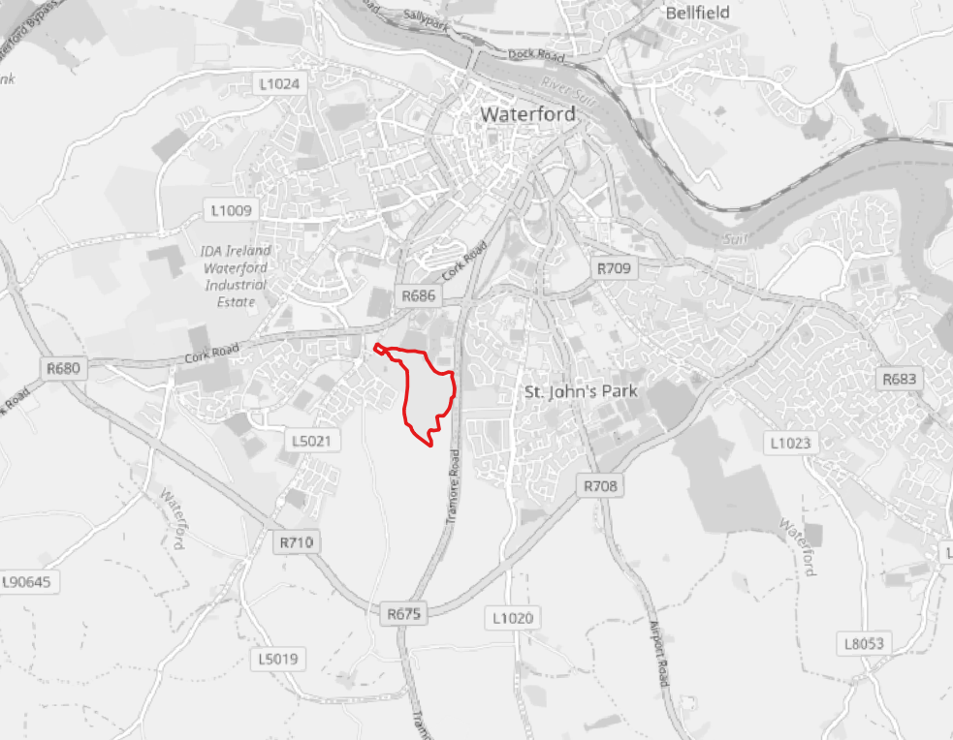
Kilbarry Closed Landfill site
Figure 1.1: Site Location (Kilbarry)

Summary of required works
The aim of the Kilbarry Landfill Site Investigation is to complete 5no. proposed leachate monitoring well installations to a maximum of 30mbgl, to standard.
The purpose of the boreholes is to accurate identify and locate the waste body material and subsequent leachate beneath the waste body. The drilling method requires sufficient recovery of the waste body material to be classified by the on-site supervisor consultant for WCCC, McCloy Consulting. The Method proposed must not mask water or leachate strikes, to ensure this can be accurately identified when drilling.

Borehole Locations
A borehole location plan provided at Appendix A.

Expected Geological Conditions

Kilbarry Closed Landfill Site

Overview; general ground conditions
The general geological succession encountered during previous site investigations across the area and anticipated lithology as follows:
- Made ground (including main waste body)
- PEAT
- SILT
- SAND and GRAVEL (discontinuous)
- CLAY

The purpose of the proposed leachate boreholes is to monitor the leachate beneath the waste body at the former landfill, so will have to go through the entire waste body until native material is encountered with sufficient water to establish a leachate monitoring well depth.

SPECIFICATION of the Works

Kilbarry Closed Landfill

Overview
The site investigation will comprise:
- Drilling and installation of 5no. leachate monitoring wells to a maximum of 30mbgl.
- Sufficient recovery of the material encountered to allow for classification by WCCC’s on-site consultant (McCloy Consulting Ltd) down to depth.

Borehole Installation Details
Leachate installations to be installed as follows:
- Monitoring well cover installed as follows:
  - 150mm Steel lockable well cap (0.50m)
  - Cement/Bentonite Grout to seal lockable well cap into place
  - Concrete Plinth (0.3m)
  - Lockable enclosure over the well cap as per drawing Monitoring Well Headworks Design(Schematic Diagram)

Other Requirements

Particular Requirements
- The contractor shall allow in their tender for all necessary plant and equipment, water supply, materials, power supplies required to execute and complete the works as described in this tender specification document. The contractor is required to have available a spare drilling rig, compatible with the proposed method statement to allow continuation of the project in case of breakdown.
- The contractor shall include in their tender for all subsidence and overnight stays associated with the works, which is expected to be a continuous until the work is completed, outside of external delays.
- The contractor is responsible for the disposal of all excess spoil arising from the site works in accordance with the current relevant duty of care legislation for waste.
- The contractor is responsible for locating any existing services onsite and shall be responsible for any damage caused by the works to underground services during the works and the costs to reinstate said services.
- The Employer shall not be liable in any respect for any damages or compensation payable at Law in respect or in consequence of any injury to any workman or other person in the employment of the Contractor or any sub-contractor save and except an accident or injury resulting from any act or default of the Employer, his agents or servants.
- The Contractor shall indemnify and keep indemnified the Employer against all losses and claims for injuries or damage to any person or property whatsoever which may arise out of or in consequences of the execution of the works, and against all claims, demands, proceedings, damages, costs, charges and expenses thereof or in relation thereto; and shall execute insurance against all such risks to Third Parties and his Employees. Details of insurances should be submitted with the tender.
- The contractor shall establish the location and elevation of the ground at each borehole location
- The contract will be on a re-measurable basis in accordance with the rates submitted and final prices will depend on depths drilled.

Health and Safety Information
Tenderers are advised of the following:
- The successful contractor will adhere to current Covid guidelines and provide a Risk Assessment and Methodology Statement (RAMS), this will include measures to adhere to relevant current Covid guidance.
- It shall be the responsibility of the successful Contractor to identify any utilities and risks associated with their exposure or working in their proximity, and to identify safe systems of work accordingly.
- The nature of known ground conditions is as described previously. The potential for work which puts persons at work at risk of falling from a height, or exposing persons at work to the risk of drowning, or exposing persons at work to risks associated with ground instability is highlighted. It shall be the responsibility of the successful Contractor to identify safe systems of work accordingly.
Identification of risks at Tender stage is not exhaustive and is intended only to inform risk assessment for pre-submission site familiarisation, and to advise Tenderers of information known to the Employer for incorporation within their intended systems of work and to inform their submitted tender accordingly.

Declarations
Waterford City and County Council declaration documents regarding rates of pay and conditions of employment and appointment of project supervisor for construction stage project are provided at Appendix C; all requirements stated within these documents must be met.
The declaration forms must be signed and submitted with the tender return.

Insurances
The minimum thresholds for insurances are as follows:
Public Liability: €6.5m
Employer’s Liability: €13m
Professional Indemnity: €1m
Please provide a Confirmation of Insurance certificate detailing the level of public liability, employers liability, and professional indemnity held by the company.

Submission Format
Invited tenderers are requested to submit the following:
- completed Form of Tender
- A Schedule of Rates / Bill of Quantities / Quotation
- Quality Submission
- Evidence of current levels of Public Liability / Employers Liability / Professional Indemnity insurances
- Declarations return form
Submission of tenders shall be through the e-tenders portal. Please ensure that you leave adequate time to upload all the necessary documentation and submit the tender prior to the deadline as late tenders cannot be entertained

Submission Deadline
In all instance’s tenders are to be submitted not later than 15:00 on 30th November 2022.

Appendix A
Site Location Plan and Borehole Location Plan

