Year 3 of the scientific work to inform a system for the management of turf-cutting in designated blanket bog SACs and NHAs:
Applying Provisional Management Zones VOLUME 1 – SECOND DRAFT (Version 02a)

Simon J. Barron
Botanical, Environmental and Conservation Consultants Ltd., (BEC Consultants)
February 2018

Prepared for the Department of Culture, Heritage and the Gaeltacht

Contents
1 Introduction 1
1.1 Scope of this report 1
1.2 Outline of zonation options 1
1.3 Turf-cutting within SACs 2
1.4 Losses to the 7130 Blanket bog (* if active bog) resource 2
1.5 Compensating the losses to the 7130 Blanket bog (* if active bog) resource 3
1.6 Normal practices of implementing the Habitats Directive 4
1.7 Establishing buffers 4
2 Methodology 5
2.1 Impacts of management on the conservation condition of 7130 Blanket bog (* if active bog) 5
2.2 Management zones 10
2.2.1 Restoration priority 10
2.2.2 Retain: restore and maintain 11
2.2.3 Retain with remedial works 14
2.2.4 Explore turf-cutting 15
2.3 Applying the management options 17
2.4 Identifying potential compensation areas 18
2.5 Establishing buffers 18
3 Results 19
4 Discussion 22
4.1 Critical Review of Methodology 22
5 References 24
6 Appendix 1 25

Introduction

Scope of this report
A Turf-cutting Impact Review and Management System for SACs and NHAs selected for Blanket bog Conservation was initiated, in November 2014, by the then Department of Arts, Heritage and the Gaeltacht (DAHG). The objective of the project is to collate and analyse the scientific information required to devise a scientifically-based turf-cutting impact assessment methodology for turf-cutting in the SACs and NHAs selected for blanket bog. The project comprises two phases:
Phase 1: Desk study (literature review, methodology development) and pilot field survey
Proposed Phase 2: Survey and assessment of turf-cutting impacts in blanket bog SACs and NHAs
Reports have been prepared detailing the work conducted during Phase 1 of the project (Barron and Daly 2015) and the subsequent Turf-cutting GIS Review within the 50 SACs (Barron 2017). The Turf-cutting GIS Review was conducted as a desk-based extension to Phase 1 of the project, with the aims of:
- Investigating the scale and extent of turf-cutting within the 50 SACs designated for 7130 Blanket bog (* if active bog),
- Identifying areas which had been seriously damaged prior to 1995,
- Identifying areas where turf-cutting had extended or intensified since 1995, and
- Reviewing the turf-cutting areas against existing GIS datasets.
During the current stage of the project the information generated during the Turf-cutting GIS Review was assessed in relation to developing Provisional Management Zones for the turf-cutting areas within the 50 SACs.
It must be noted the methodology detailed here is an initial exploration of application of zones to the SACs and it has not been approved by Department of Culture, Heritage and the Gaeltacht (DCHG). It is however the methodology by which the Provisional Management Zones for the ten SACs listed below was developed. The reports and maps prepared for these SACs will obviously need redrafting once a revised methodology has been developed and approved.
Throughout this report ‘turf-cutting area’ refers to the areas identified during the Turf-cutting GIS Review as containing turf-cutting activities so refers collectively to all the turf-cutting categories.

Outline of zonation options
Following the guidance given in the Roadmap to Compliance (DAHG, 2014), the zonation was based on identifying areas:
- Where turf-cutting must cease,
- Requiring restoration,
- Where turf-cutting may not impact negatively on the conservation condition of each SAC.
In addition, in order to be compliant with the Habitats Directive it was considered necessary in some locations where turf-cutting was to cease that remedial works would be required to ameliorate on-going impacts to adjacent habitat or features. Additionally remedial works were considered necessary for some areas adjacent to those being considered for a continuation of turf-cutting to contain impacts. For each area of turf-cutting identified during the Turf-cutting GIS Review there were, therefore, up to four Provisional Management Zone options:
- Restoration Priority,
- Retain: Restore and Maintain
- Retain with Remedial Works,
- Explore Turf-cutting (not an option for all categories).
The methodology was developed through pilot assessments of the information available for Ox Mountains Bog SAC, Magheradrumman Bog SAC and West of Ardara/Maas Road SAC. The approach was then applied to a further seven SACs: Dunragh Loughs/Pettigo Plateau SAC, Bellacorrick Bog Complex SAC, Gannivegil Bog SAC, Mount Brandon SAC, Slieve Fyagh SAC, Glanmore Bog SAC and Glenamoy Bog Complex SAC. Site summaries and maps for these ten SACs have been prepared.
This report is presented in two volumes. Volume 1 contains the methodology used for the development of the Provisional Management Zones, a summary of the results to date, and a discussion of these, including consideration of how the data can best be utilised. Volume 2 contains site summaries for the ten SACs, developing further the site summaries submitted as part of the Turf-cutting GIS Review. The summaries include the data presented previously, together with more detailed consideration of the rare plants within each SAC, tabulated information on the Provisional Management Zones which have been assigned and consideration of the restoration obligations and possibilities at each of the SACs. A series of maps for each SAC has also been produced and should be viewed in conjunction with the site summaries.

Turf-cutting within SACs
Part of the programme for Turf-cutting Impact Review and Management System for SACs and NHAs selected for Blanket bog Conservation is to investigate where turf-cutting might occur within the SACs without it amounting to an adverse impact on the integrity of the SAC. The Turf-cutting GIS Review has quantified the amount of turf-cutting occurring within the SACs and gives a broad indication as to the time when this turf-cutting has occurred. Areas which were seriously impacted in 1995 and in 2011 (Category 1 bog) have been identified and it has been posited that these areas were not contributing to the resource of 7130 Blanket bog (* if active bog) at the time that the EU Habitats Directive was transposed into Irish national law in 1997. Category 1 bog has been proposed as the category of bog where the feasibility of continued turf-cutting is the most appropriate to explore. It will be necessary to establish that turf-cutting within these locations would not have an adverse impact on surrounding habitats and features including deep peat, pool systems, quaking bog, rare flora and fauna, aquatic habitats and other Annex I habitats. Turf-cutting in many Category 1 bog areas will need to cease due to adverse impacts on these habitats and features.

Losses to the 7130 Blanket bog (* if active bog) resource
It is also a component of the programme to identify areas where restoration or rehabilitation of 7130 Blanket bog (* if active bog) is necessary. There are indeed obligations for providing recompense for losses to the 7130 Blanket bog (* if active bog) resource and restoring habitat due to:
- Impacts which have occurred since the time that the EU Habitats Directive was transposed into Irish national law,
- The reduction in the Area and Range of 7130 Blanket bog (* if active bog) within the Natura 2000 network resulting from the recognition that seriously impacted bog was not contributing to the conservation resource at the time that the EU Habitats Directive was transposed into Irish national law,
- The normal practices of implementing the Habitats Directive.

Compensating the losses to the 7130 Blanket bog (* if active bog) resource
Measures are required to restore the Area and Range of 7130 Blanket bog (* if active bog) to the levels within the SACs at the time that the EU Habitats Directive was transposed into Irish national law. The losses to the 7130 Blanket bog (* if active bog) resource between 1995 and 2011 have been quantified in the Turf-cutting GIS Review. The extension or intensification of turf-cutting since 1995 has been recorded under three categories:
- Category 3 (partially impacted 1995, seriously impacted 2011)
- Category 5 bog (unimpacted 1995, partially impacted 2011) and
- Category 6 bog (unimpacted 1995, seriously impacted 2011)
The combined area of habitat recorded under these three categories is 2,213.49ha. Of this, 571.86ha is Category 5 bog, which has incurred impacts to Structure and Function but Area and Range remain stable. These areas could, therefore, be compensated through restoring degraded bog within the SAC. The area of seriously impacted bog recorded under Categories 3 and 6 is 1,641.36ha. For these areas of bog Area, Range and Structure and Function will have been adversely impacted.
For the purposes of this methodology it was considered that the recognition that Category 1 bog (seriously impacted bog in 1996 and 2011) was not contributing to the conservation resource at the time that the EU Habitats Directive was transposed into Irish national law would result in a reduction in Area of 5,781.98ha of 7130 Blanket bog (* if active bog) from the Natura 2000 network. It was considered that this loss of Area would need to be addressed through compensation measures. It should however be noted DCHG have not approved this approach.
To compensate for the losses to Area and Range of ~7,500ha of 7130 Blanket bog (* if active bog) and to bring these back to the levels recognised as occurring within the SACs at the time that the EU Habitats Directive was transposed into Irish national law, it is considered necessary to bring additional habitat into the Natura 2000 network. The restoration of partially impacted bog habitat within the SACs (e.g. Category 8 bog, partially impacted bog with particular potential for restoration or Category 2 bog partially impacted in 1995 and 2011) would not restore the Area and Range parameters of an SAC as these areas, though degraded, are already contributing to the Area and Range of the habitat within the SAC. Similarly, the removal from an SAC of forestry plantation that was planted since the time the EU Habitats Directive was transposed into Irish national law and restoration of this to 7130 Blanket bog (* if active bog) habitat would not address Area and Range requirements. Suitable compensatory measures would be:
- The designation of an equivalent or larger area of intact 7130 Blanket bog (* if active bog) habitat.
- The designation and restoration of an equivalent or larger area of degraded blanket bog habitat.
- The removal of forestry from an equivalent or larger area of blanket bog and restoration of this to 7130 Blanket bog (* if active bog) and designation of this area as SAC.
- The restoration to 7130 Blanket bog (* if active bog) of an area of forestry plantation within the SAC which was planted prior to the time the EU Habitats Directive was transposed into Irish national law in 1997.
There are SACs that contain 7130 Blanket bog (* if active bog) that is not listed as a Qualifying Interest (QI) but it is questionable as to whether the addition of 7130 Blanket bog (* if active bog) to the QI list of such SACs would, in the absence of other measures, be considered sufficient rectification. As stated in Managing NATURA 2000 Sites (EU 2000) “all Annex I habitat types present on a site…should be mentioned in the appropriate place on the data form”. This includes those which are considered non-significant and therefore not requiring conservation measures. It may not be viewed favourably to recognise an Annex I habitat as “significant” at this juncture, in lieu of alternative, more difficult measures when this should already have been done. However redressing the status of 7130 Blanket bog (* if active bog) at some existing SACs is likely to be welcomed if presented as a component of an overall package of measures; where 7130 Blanket bog (* if active bog) is added as a QI it would then benefit from the protection provided by the Habitats Directive and this contributes to the objectives of the Directive. It must be noted that these SACs will bring their own issues of turf-cutting and drainage into the equation which will need to be addressed.

Normal practices of implementing the Habitats Directive
In addition to the rectification measures noted above, restoration measures are a standard obligation of the Habitats Directive. The conservation status of 7130 Blanket bog (* if active bog) in Ireland is unfavourable and there is, therefore, an obligation to improve its status. Managing Natura 2000 Sites (EU 2000) states: “If a Member State is obliged to propose the classification of habitats in an unfavourable conservation status, it is only logical to assume that it will set a restoration target for these habitats so as to ensure their sustainability”. Restoration targets for 7130 Blanket bog (* if active bog) are therefore required and restoration measures are a requirement outside of the turf-cutting issue. The restoration of Category 8 bog (partially impacted with particular potential for restoration) can contribute to restoration targets.

Establishing buffers
Buffer areas were incorporated where an area proposed for Exploring Turf-cutting was adjacent to bog habitat which may be indirectly impacted by the turf-cutting. The buffer area was composed of bog that had not been directly impacted by turf-cutting and therefore had not been categorised through the Turf-cutting GIS Review. A buffer zone could be required, for example, if turf-cutting resulted in draining an area up-slope or on the same level as the turf-cutting area or diverted into drains surface flow which would have fed habitat down-slope of the turf-cut area. A gradual disimprovement in the habitat within the buffer zone would be expected, with the Structure and Function being negatively impacted. This is not the introduction of a new impact, but recognition that the impacts of turf-cutting go beyond the immediately cut area. Buffer zones could not contain more sensitive areas (e.g. deep peat, dystrophic pools, quaking bog, transition mires) or lead to impacts on aquatic habitats/species. It would be necessary for measures to readdress the impacts to Structure and Function through compensatory habitat.

Methodology

Impacts of management on the conservation condition of 7130 Blanket bog (* if active bog)
The eight bog categories developed and applied during the Turf-cutting GIS Review capture the management regime that has been carried out in these locations since 1995. Table 1 presents how these management regimes would have impacted on the conservation condition of 7130 Blanket bog (* if active bog) in these locations since 1995. It then goes on to consider the likely impacts of the various management zones on the future conservation condition of these areas. This will assist in determining the restoration targets for SACs and national requirements.
Exploring turf-cutting is primarily applied to Category 1 bog (seriously impacted in 1995 and 2011), though in some instances it can be applied to the other seriously impacted categories (Category 3 bog, partially impacted in 1995 and seriously impacted 2011, and Category 6 bog, unimpacted 1995, seriously impacted 2011). As outlined in Table 1, Category 4 bog (revegetated in 1995 and 2011) can be considered for the resumption of turf-cutting where the habitat appeared seriously impacted in 1995. Some Category 4 bog would have revegetated to such a degree that resumption of turf-cutting would not be desirable from an ecological viewpoint. The categorisation process does not distinguish between these and it is necessary to consider them on case-by-case basis. It is not proposed that all Category 4 bog which was seriously impacted in 1995 needs to be compensated as is the situation with Category 1 bog but any Category 4 bog proposed for the Explore Turf-cutting option is considered to require compensatory measures.

Table 1: How management will have impacted the conservation condition of 7130 Blanket bog (* if active bog) since 1995, the various management options available for these areas and the likely impacts of this management on the conservation status of the habitat
Category | Impacts on conservation condition since 1995 | Management options | Likely impacts of management on conservation status
1 Seriously impacted 1995 and 2011 | Category 1 bog is being considered to have not been contributing to the resource of 7130 at the time that the EU Habitats Directive was transposed into Irish national law in 1997. Turf-cutting within these areas since 1995 will have had a neutral impact on the conservation status of 7130. There is however a deficit in the amount of 7130 within the Natura 2000 network, with Area and Range having been reduced. | 1.1, Cessation of turf-cutting with in situ restoration | Restored areas within Category 1 bog would contribute positively to the resource of 7130, once restoration is complete. These areas would positively contribute to the Area and Range of 7130. Structure and Function of these areas would be improved. This would contribute to the compensation requirements of the SAC.
 |  | 1.2, Cessation of turf-cutting with compensation | Turf-cutting is ceased but it is decided in situ restoration is not feasible. Compensation through the restoration of an area which was not contributing to the resource of 7130 at the time that the EU Habitats Directive was transposed into Irish national law will be required. The negative impacts to Area, Range and Structure and Function would be compensated; a neutral effect on Area, Range and Structure and Function with these returned to pre-impact levels.
 |  | 1.3, Cessation of turf-cutting with remedial works and compensation | Turf-cutting is ceased but it is decided in situ restoration is not feasible. Compensation through the restoration of an area which was not contributing to the resource of 7130 at the time that the EU Habitats Directive was transposed into Irish national law will be required. Remedial works are required to ameliorate impacts on nearby features or habitats. Assuming a stable situation, the negative impacts to Area, Range and Structure and Function would be compensated; a neutral effect on Area, Range and Structure and Function with these returned to pre-impact levels.
 |  | 1.4, Consideration for turf-cutting and compensation elsewhere | As the Category 1 bog areas were not contributing to the resource of 7130 at the time that the EU Habitats Directive was transposed into Irish national law in 1997, turf-cutting within them, which has been deemed acceptable, will have a neutral impact on the conservation status of 7130. There is however a deficit in the amount of 7130 within the Natura 2000 network with Area and Range having been reduced. Compensation through the restoration of an area which was not contributing to the resource of 7130 at the time that the EU Habitats Directive was transposed into Irish national law will be required. The negative impacts to Area and Range would be compensated, a neutral effect with these returned to pre-impact levels.
2 Partially impacted 1995 and 2011 | Partially impacted bog is likely to fail Structure and Function assessments. On the assumption that there were no gradual disimprovements (e.g. continual lowering of the water table, expansion of eroded areas) then there will have been a neutral impact on the conservation condition of 7130 since 1995. However, gradual on-going disimprovements are likely to have occurred and the trend for Structure and Function is likely to have been to disimprove accordingly. | 2.1, Restoration | Restoration of these areas would positively impact the Structure and Function assessments for these areas. Area and Range would be stable, a neutral effect with these returned to pre-impact levels.
 |  | 2.2, Retain | On the assumption that there are no gradual on-going disimprovements then retention of these areas will have a neutral impact on the conservation condition of 7130. However, gradual on-going disimprovements are likely in the medium to long-term and therefore the trend for Structure and Function will be to disimprove. Without restoration Area and Range may eventually be negatively impacted.
 |  | 2.3, Retain with Remedial Works | On the assumption that there are no gradual on-going disimprovements then retention of these areas will have a neutral impact on the conservation condition of 7130. However, even with remedial works gradual on-going disimprovements are likely in the medium to long-term and therefore the trend for Structure and Function will be to disimprove. Area and Range may eventually be negatively impacted without restoration.
3 Partially impacted 1995, seriously impacted 2011 | The conservation status of 7130 has been negatively impacted by an intensification of turf-cutting since 1995. This will have negatively impacted the Area and Range of 7130. Structure and Function would have been compromised in 1995 but there will have been additional negative impacts on Structure and Function subsequently. | 3.1, Cessation of turf-cutting and in situ restoration | Successful in situ restoration will restore the Area and Range to former conditions i.e. Area and Range would be stable, a neutral impact. There will be an improvement in Structure and Function for the area.
 |  | 3.2, Cessation of turf-cutting with compensation | Turf-cutting is ceased but it is decided in situ restoration is not feasible. Compensation through the restoration of an area which was not contributing to the resource of 7130 at the time that the EU Habitats Directive was transposed into Irish national law will be required e.g. an equivalent area of Category 1 bog where turf-cutting is being ceased, restoration of an area of afforested blanket bog or extension of the SAC boundary. The negative impacts to Area, Range and Structure and Function would be compensated: a neutral effect on Area, Range and Structure and Function with these returned to pre-impact levels.
 |  | 3.3, Cessation of turf-cutting with remedial works and compensation | Turf-cutting is ceased but it is decided in situ restoration is not feasible. Compensation through the restoration of an area which was not contributing to the resource of 7130 at the time that the EU Habitats Directive was transposed into Irish national law will be required e.g. an equivalent area of Category 1 bog where turf-cutting is being ceased, restoration of an area of afforested blanket bog or extension of the SAC boundary. Remedial works are required to ameliorate impacts on nearby features or habitats. Assuming a stable situation the negative impacts to Area, Range and Structure and Function would be compensated; a neutral effect on Area, Range and Structure and Function with these returned to pre-impact levels.
 |  | 3.4, Consideration for turf-cutting in situ with compensation | For pragmatic or logistic reasons a continuation of turf-cutting is proposed rather than in situ restoration. This will require suitable compensation through the restoration of an area which was not contributing to the resource of 7130 at the time that the EU Habitats Directive was transposed into Irish national law e.g. an equivalent area of Category 1 bog where turf-cutting is being ceased, restoration of an area of afforested blanket bog or extension of the SAC boundary. The negative impacts to Area, Range and Structure and Function would be compensated; a neutral effect on Area, Range and Structure and Function with these returned to pre-impact levels.
4 Revegetated 1995 and 2011 | Revegetated areas are likely to fail Structure and Function assessments. Impacts to these areas will have occurred before 1995. If the impact is serious then these areas, like Category 1 bog, can be considered to not have been contributing to the resource of 7130 at the time that the EU Habitats Directive was transposed into Irish national law and resumption of turf-cutting can be considered within them. This would however result in a deficit in the amount of 7130 within the Natura 2000 network with Area and Range having been reduced. | 4.1, Restoration | Restoration of these areas would positively impact the Structure and Function assessments for these areas. Whether restoration would positively impact Area and Range will depend on whether the area was seriously impacted in 1995 and therefore not contributing to the resource of 7130 at the time that the EU Habitats Directive was transposed into Irish national law.
 |  | 4.2, Retain | On the assumption that there are no gradual on-going disimprovements (e.g. continual lowering of the water table, expansion of eroded areas) then retention of these areas will have a neutral impact on conservation condition of 7130. If there are gradual on-going disimprovements then the Structure and Functions can be assumed to disimprove accordingly.
 |  | 4.3, Retain with Remedial Works | On the assumption that there are no gradual on-going disimprovements (e.g. continual lowering of the water table, expansion of eroded areas) then retention of these areas will have a neutral impact on conservation condition of 7130. If there are gradual on-going disimprovements then the Structure and Functions can be assumed to disimprove accordingly even with remedial works.
 |  | 4.4, Resumption of turf-cutting | Where impacts within a Category 4 bog were ‘serious’ in 1995 these areas can be considered for the resumption of turf-cutting as the area was not contributing to the resource of 7130 at the time that the EU Habitats Directive was transposed into Irish national law. If turf-cutting within these areas has been deemed acceptable then resumption of turf-cutting would have a neutral impact on the conservation condition of 7130. Compensation through the restoration of an area which was not contributing to the resource of 7130 at the time that the EU Habitats Directive was transposed into Irish national law will however be required. The negative impacts to Area and Range would be compensated, a neutral effect with these returned to pre-impact levels.
5 Un-impacted 1995, Partially impacted 2011 | This will have resulted in negative impacts on the Structure and Function of the area since 1995, and a neutral impact on the Area and Range parameters. Generally impacts here would be vehicle tracking or spread ground rather than actual turf-cutting. | 5.1, Cessation of turf-cutting activities and in situ restoration | In situ restoration will restore the Structure and Function to former conditions and have a neutral impact on conservation status of 7130.
 |  | 5.2, Cessation of turf-cutting activities with compensation elsewhere | In situ restoration is not feasible. Restoration of the Structure and Function of partially impacted bog elsewhere would be suitable compensation. A neutral impact on conservation status of 7130. If recovery of the bog without intervention is expected once the impacting activity ceases then compensation may not be required.
 |  | 5.3 Cessation of turf-cutting activities with remedial works and compensation elsewhere | In situ restoration is not feasible, remedial works area required. Restoration of the Structure and Function of partially impacted bog elsewhere would be suitable compensation. A neutral impact on conservation status of 7130. If recovery of the bog without intervention is expected once the impacting activity ceases then compensation may not be required.
 |  | 5.4, Consideration for continued turf-cutting activities and compensation elsewhere | Where cessation of turf-cutting activities is not considered feasible, compensation elsewhere will be required. Measures would be required to ensure intensification of turf-cutting activities do not occur (i.e. resulting in impacts to Area and Range) though this may prove difficult and it may be more realistic to assume future loss of Area and Range from these areas. If measures prevent intensification of turf-cutting activities then restoration of Category 8 or 2 bog would be suitable compensation. If Area and Range are lost, or expected to be lost, this will require suitable compensation through the restoration of an area which was not contributing to the resource of 7130 at the time that the EU Habitats Directive was transposed into Irish national law e.g. an equivalent area of Category 1 bog where turf-cutting is being ceased, restoration of an area of afforested blanket bog or extension of the SAC boundary. The negative impacts to Area, Range and Structure and Function would be compensated, a neutral impact.
6 Unimpacted 1995, seriously impacted 2011 | The conservation status of 7130 has been negatively impacted by the extension or introduction of turf-cutting since 1995. The Area, Range and Structure and Functions will have been negatively impacted. | 6.1, Cessation of turf-cutting and in situ restoration | Successful in situ restoration will restore the Area, Range and Structure and Function to former conditions, a neutral effect with these returned to pre-impact levels.
 |  | 6.2, Cessation of turf-cutting and compensation elsewhere | Turf-cutting is ceased but it is decided in situ restoration is not feasible. Compensation through the restoration of an area which was not contributing to the resource of 7130 at the time that the EU Habitats Directive was transposed into Irish national law will be required e.g. an equivalent area of Category 1 bog where turf-cutting is being ceased, restoration of an area of afforested blanket bog or extension of the SAC boundary. The negative impacts to Area, Range and Structure and Function would be compensated; a neutral effect on Area, Range and Structure and Function with these returned to pre-impact levels.
 |  | 6.3, Cessation of turf-cutting with compensation elsewhere and remedial works | Turf-cutting is ceased but it is decided in situ restoration is not feasible. Compensation through the restoration of an area which was not contributing to the resource of 7130 at the time that the EU Habitats Directive was transposed into Irish national law will be required e.g. an equivalent area of Category 1 bog where turf-cutting is being ceased, restoration of an area of afforested blanket bog or extension of the SAC boundary. Remedial works are required to ameliorate impacts on nearby features or habitats. Assuming a stable situation the negative impacts to Area, Range and Structure and Function would be compensated, a neutral effect with these returned to pre-impact levels.
 |  | 6.4, Consideration for turf-cutting with compensation elsewhere | A continuation of turf-cutting here will require suitable compensation through the restoration of an area which was not contributing to the resource of 7130 at the time that the EU Habitats Directive was transposed into Irish national law e.g. restoration of an equivalent area of Category 1 bog where turf-cutting is being ceased, restoration of an area of afforested blanket bog or extension of the SAC boundary. The negative impacts to Area, Range and Structure and Function would be compensated, a neutral effect with these returned to pre-impact levels.
7 Partially impacted 1995, Recovered 2011 | These areas may fail Structure and Function assessments. | 7.1, Restoration | Restoration of these areas would positively impact the Structure and Function assessments for these areas. Area and Range would be stable, a neutral effect with these returned to pre-impact levels.
 |  | 7.2, Retain | On the assumption that there are no gradual on-going disimprovements (e.g. continual lowering of the water table, expansion of eroded areas) then retention of these areas will have a neutral impact on conservation condition of 7130. If there are gradual on-going disimprovements then the Structure and Functions can be assumed to disimprove accordingly.
 |  | 7.3, Retain with Remedial Works | On the assumption that there are no gradual on-going disimprovements (e.g. continual lowering of the water table, expansion of eroded areas) then retention of these areas will have a neutral impact on conservation condition of 7130. If there are gradual on-going disimprovements then the Structure and Functions can be assumed to disimprove accordingly, even with remedial works.
8 Partially impacted particular potential for restoration | Partially impacted bog is likely to fail Structure and Function assessments. On the assumption that there were no gradual disimprovements (e.g. continual lowering of the water table, expansion of eroded areas) then there will have been a neutral impact on the conservation condition of 7130 since 1995. However, gradual on-going disimprovements are likely to have occurred and the trend for Structure and Function is likely to have been to disimprove accordingly. | 8.1, Restoration | Restoration of these areas would positively impact the Structure and Function assessments for these areas. Area and Range would be stable, a neutral effect with these returned to pre-impact levels.
 |  | 8.2, Retention | On the assumption that there are no gradual on-going disimprovements then retention of these areas will have a neutral impact on the conservation condition of 7130. However, gradual on-going disimprovements are likely in the medium to long-term and therefore the trend for Structure and Function will be to disimprove. Area and Range will eventually be negatively impacted if the on-going disimprovements are not remedied.
 |  | 8.3, Retain with Remedial Works | On the assumption that there are no gradual on-going disimprovements then retention of these areas will have a neutral impact on the conservation condition of 7130. However, even with remedial works gradual on-going disimprovements are likely in the medium to long-term and therefore the trend for Structure and Function will be to disimprove. Area and Range may eventually be negatively impacted without restoration.

Provisional Management Zones
The management options available to each category type identified during the Turf-cutting GIS Review are presented in Table 2 together with the four Provisional Management Zones that these equate to. Each Provisional Management Zone is described below with examples presented to illustrate them.
Table 2: Management options available to each category type and the Provisional Management Zone these equate to
Category | Management options | Provisional Management Zone
1 Seriously impacted 1995 and 2011 | 1.1, Cessation of turf-cutting and in situ restoration | Restoration Priority
 | 1.2, Cessation of turf-cutting* | Retain: Restore & Maintain
 | 1.3, Cessation of turf-cutting with remedial works* | Retain with Remedial Works
 | 1.4, Consideration for turf-cutting* | Explore Turf-cutting
2 Partially impacted 1995 and 2011 | 2.1, Restoration | Restoration Priority
 | 2.2, Retain | Retain: Restore & Maintain
 | 2.3, Retain with Remedial Works | Retain with Remedial Works
3 Partially impacted 1995, seriously impacted 2011 | 3.1, Cessation of turf-cutting and in situ restoration | Restoration Priority
 | 3.2, Cessation of turf-cutting* | Retain: Restore & Maintain
 | 3.3, Cessation of turf-cutting with remedial works* | Retain with Remedial Works
 | 3.4, Consideration for turf-cutting* | Explore Turf-cutting
4 Revegetated 1995 and 2011 | 4.1, Restoration | Restoration Priority
 | 4.2, Retain | Retain: Restore & Maintain
 | 4.3, Retain with Remedial Works | Retain with Remedial Works
 | 4.4, Resumption of turf-cutting | Explore Turf-cutting
5 Unimpacted 1995, Partially impacted 2011 | 5.1, Cessation of turf-cutting activities and in situ restoration | Restoration Priority
 | 5.2, Cessation of turf-cutting activities* | Retain: Restore & Maintain
 | 5.3 Cessation of turf-cutting activities with remedial works* | Retain with Remedial Works
 | 5.4, Consideration for continued turf-cutting activities* | Explore Turf-cutting
6 Unimpacted 1995, seriously impacted 2011 | 6.1, Cessation of turf-cutting and in situ restoration | Restoration Priority
 | 6.2, Cessation of turf-cutting* | Retain: Restore & Maintain
 | 6.3, Cessation of turf-cutting with remedial works* | Retain with Remedial Works
 | 6.4, Consideration for turf-cutting* | Explore Turf-cutting
7 Partially impacted 1995, Recovered 2011 | 7.1, Restoration | Restoration Priority
 | 7.2, Retain | Retain: Restore & Maintain
 | 7.3, Retain with Remedial Works | Retain with Remedial Works
8 Partially impacted particular potential for restoration | 8.1, Restore | Restoration Priority
 | 8.2, Retain | Retain: Restore & Maintain
 | 8.3, Retain with Remedial Works | Retain with Remedial Works
* Compensatory measures elsewhere will be required for areas managed through this option

Restoration Priority
This Provisional Management Zone can be applied to any of the eight categories. It is the preferred zone for Category 8 bog (partially impacted bog, with particular potential for restoration). Areas of Restoration Priority are proposed for areas where there is considered to be good opportunity for achieving restoration. They will therefore generally be away from areas proposed for Exploring Turf-cutting and from turf-cutting outside the SAC which might compromise restoration proposals. Large Restoration Priority zones are often based around Category 8 bog but will incorporate polygons from other categories which are in the general vicinity. In Fig. 1 the central area, southwest of the lake, was primarily composed of partially impacted bog (Categories 2 and 8), but also included Category 1 bog and recently impacted bog (Categories 3, 5 and 6).
Restoration Priority is also proposed for some smaller areas, generally isolated from other turf-cutting areas. These could be Category 1 bog (seriously impacted in 1995 and 2011) but is particularly suitable for areas which have been impacted since 1995. These are Category 3 bog (partially impacted in 1995, seriously impacted in 2011), Category 5 bog (unimpacted in 1995, partially impacted in 2011) and Category 6 bog (unimpacted in 1995, seriously impacted in 2011). Again nearby polygons are incorporated into the prescribed Provisional Management Zone. There would be a preference to restore in situ areas which have been impacted since 1995 as this restores the Range to the previous distribution, though in situ restoration is not always feasible. Fig. 2 presents an example of a small area proposed for Restoration Priority. The core of this area is Category 1 bog where turf-cutting is to cease due to the isolated nature of the area. The adjoining polygons are Category 2 bog.

Retain: Restore and Maintain
This Provisional Management Zone can be applied to any of the eight turf-cutting categories. It requires, in the short-term, the bog to be retained as it is, which will involve the cessation of turf-cutting in areas where it has occurred recently (i.e. Categories 1, 3, 5 and 6). This would be the default option for some areas where turf-cutting has not occurred recently, i.e. Category 2 bog (partially impacted in 1995 and 2011), Category 4 bog (revegetated in 1995 and 2011) and Category 7 bog (impacted in 1995, recovered in 2011) as there is no immediate requirement to restore these areas under the current Turf-cutting Impact Review and Management System for SACs. There is, however, a broader obligation under the normal practices of implementing the Habitats Directive to restore and maintain 7130 Blanket bog (* if active bog habitat) within the SACs where it is in unfavourable condition. These areas are therefore zoned as having the medium to long-term aim of restoring the habitat to favourable condition and maintaining it as such. In addition to the turf-cut areas this would be the Provisional Management Zone applied to 7130 Blanket bog (* if active bog) which has not been impacted by turf-cutting. Examples of bog from Categories 1, 3, 5 and 6 which are assigned to this category will additionally require compensatory habitat elsewhere. Fig. 3 presents examples of this Provisional Management Zone. The majority of these polygons were originally classified as Category 4 bog (revegetated 1995 and 2011), but there are also small areas of Category 1 bog (seriously impacted in 1995 and 2011), Category 2 and Category 7 bog (impacted in 1995, recovered in 2011).

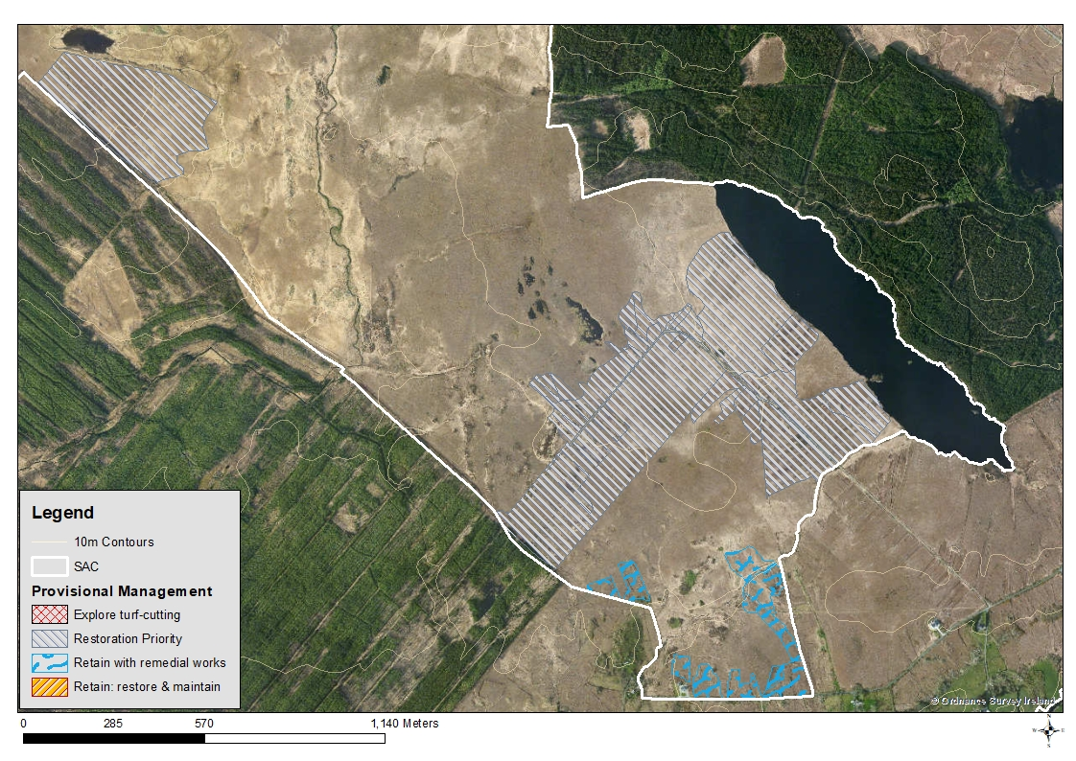
Figure 1. Restoration Priority areas, West of Ardara/Mass Road SAC.

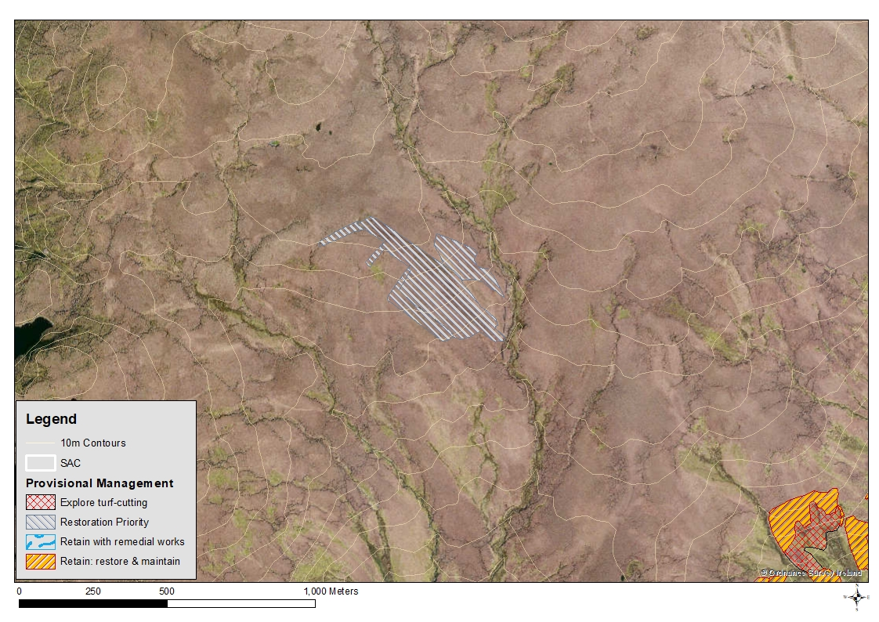
Figure 2. Restoration Priority areas, Ox Mountains Bog SAC.

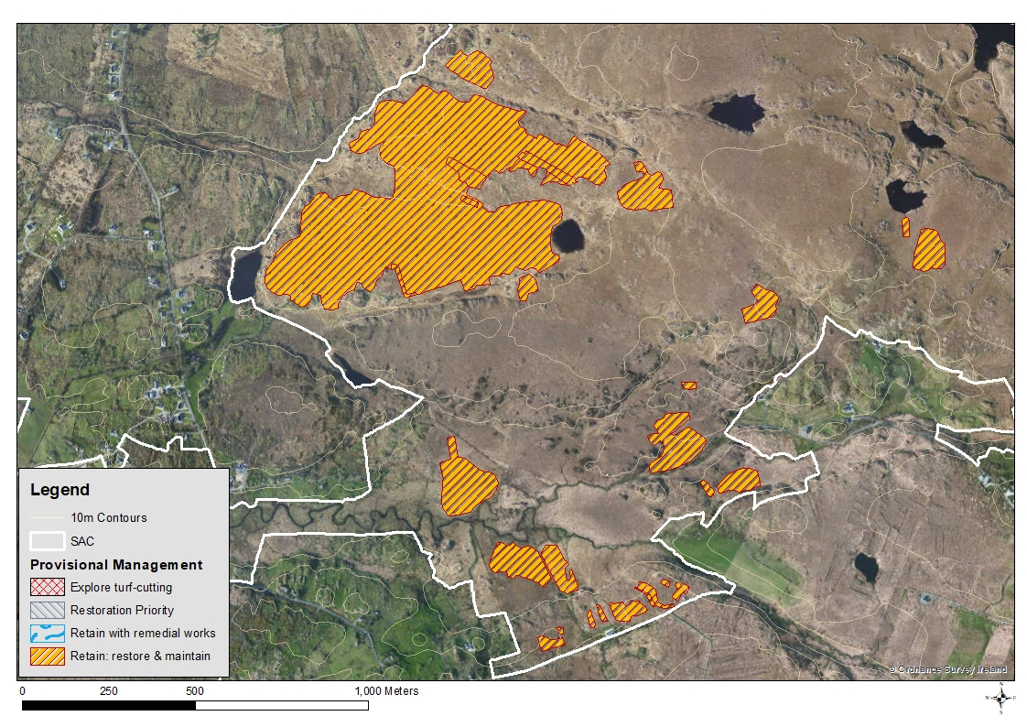
Figure 3. Retain: Restore and Maintain areas, West of Ardara/Maas Road SAC.

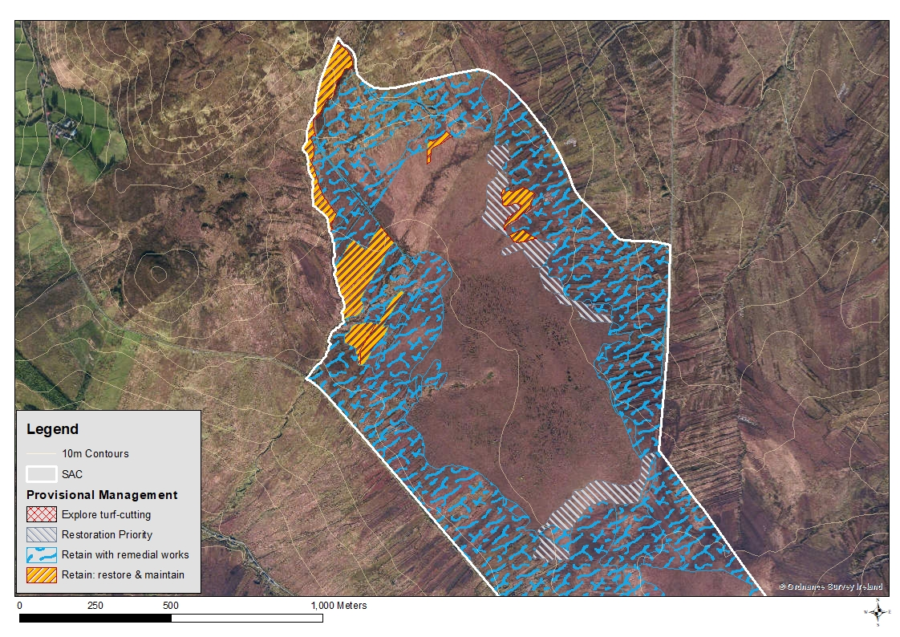
Figure 4. Retain with Remedial Works example from Magheradrumman Bog SAC.

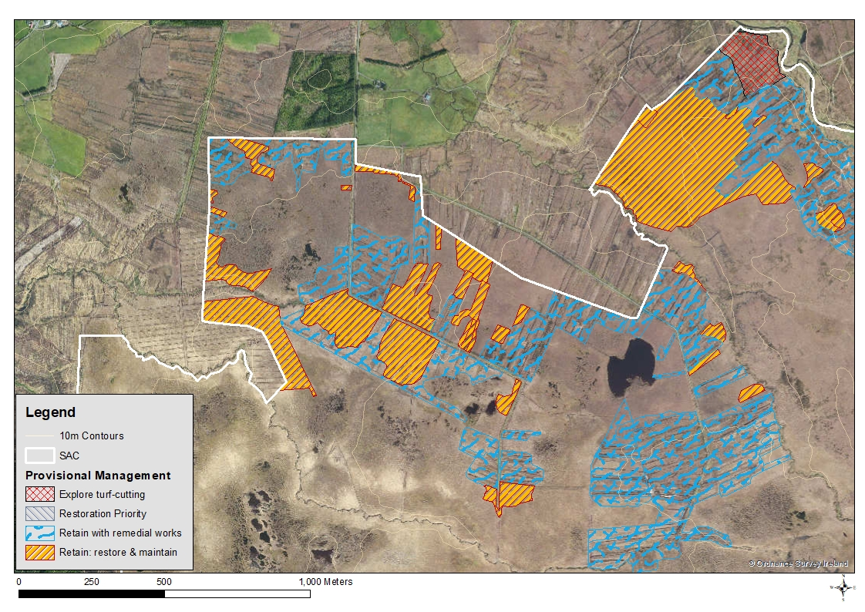
Figure 5. Retain with Remedial Works example from Ox Mountains Bog SAC.

Retain with Remedial Works
This Provisional Management Zone can be applied to any of the eight categories. It differs from ‘Retain: Restore and Maintain’ in that remedial works are considered necessary to ameliorate current or future negative impacts on 7130 Blanket bog (* if active bog) or other features of interest. Scenarios where remedial works are likely to be required include areas where it is necessary to avoid impacts on:
- Nearby intact blanket bog,
- Dystrophic pools,
- Other aquatic habitats (streams and lakes),
- Catchments designated for their importance to Freshwater Pearl Mussels.
Restoration of the 7130 Blanket bog (* if active bog) in these locations might be problematic due to, for example, proximity to severely impacted bog, impacting activities outside the boundary of the SAC, areas being proposed for Explore Turf-cutting zones, or the extent of impact within the actual polygon being considered. As such the stated aim of the remedial works is not the restoration of the 7130 Blanket bog (* if active bog) but the amelioration of current or future negative effects. Following consideration of each situation it may transpire that restoration is feasible or alternatively that the remedial works do actually constitute restoration. This can be determined on a case-by-case basis. Examples of bog from Categories 1, 3, 5 and 6 which are assigned to this category will additionally require compensatory habitat elsewhere.
Examples of areas identified for Retain with Remedial Works are presented in Fig. 4. In this example the dystrophic pool systems can be seen through the centre of the SAC area. Turf-cutting is encroaching from the perimeter of the SAC onto the remaining area of intact bog and impacting the deep peat. The majority of the turf-cutting here was classified as Category 1 bog (seriously impacted in 1995 and 2011) and the cessation of turf-cutting with remedial works to ameliorate the on-going impacts of drainage on the remaining deep peat and dystrophic pool systems was considered necessary. Additional examples of this can be seen in Fig. 5. Again in these locations cessation of turf-cutting without remedial works would likely result in on-going drainage of the dystrophic pool systems and destabilisation and drainage of the deep peat.

Explore Turf-cutting
This Provisional Management Zone would primarily be applied to Category 1 bog (seriously impacted bog 1995 and 2011), but it can be applied to bog from Category 3 (partially impacted bog 1995, seriously impacted 2011), Category 4 (revegetated bog 1995 and 2011) and Category 6 (unimpacted 1995, seriously impacted 2011). It is possible to apply it to Category 5 (unimpacted 1995, partially impacted 2011) bog but as continued turf-cutting activities are likely to result in the deterioration of the habitat from its current state of ‘partially’ impacted to ‘seriously’ impacted, there would be problems associated with this as an option. This option has not been utilised to date and could be removed.
Some Category 4 bog was also seriously impacted in 1995 and if necessary these areas can also be considered as Explore Turf-cutting zones.
For pragmatic reasons it is considered feasible for Explore Turf-cutting to be applied to Category 3 and Category 6 bog when the surrounding areas are proposed for turf-cutting and retaining/restoring these areas would be unviable. Turf-cutting in areas which were not severely impacted in 1995 may not be compliant with the requirements of the Habitats Directive and whether this is allowable would depend on the level of pragmatism with which the Directive is applied. Examples of bog from Categories 1, 3, 4, 5 or 6 which are assigned to this category would require compensatory habitat.
Examples of areas identified as Explore Turf-cutting are presented in Figs. 6, 7 and 8. In Fig. 6 an area of Category 1 bog has been split, with the section along the northern perimeter of the SAC being selected for an Explore Turf-cutting zone while areas to the south, closer to the deep peat and dystrophic pool systems, have been identified as Retain with Remedial Works. Measures can therefore be put in to hydrologically isolate the Explore Turf-cutting area from the deep peat and dystrophic pools. In Fig. 7 dry bog which is removed from the deep peat and dystrophic pool systems to the north has been proposed for Explore Turf-cutting. Areas proposed for Retain with Remedial Works have again been incorporated to isolate the turf-cutting areas from aquatic systems and deep peat. In Fig. 8 areas of Category 1 bog which are on the periphery of the 7130 Blanket bog (* if active bog) habitat have been proposed for Explore Turf-cutting. Other areas of turf-cutting in the locality which have been classified as Category 2 bog (partially impacted in 1995 and 2011) and Category 4 bog (revegetated 1995 and 2011) have been zoned as Retain: Restore and Maintain.
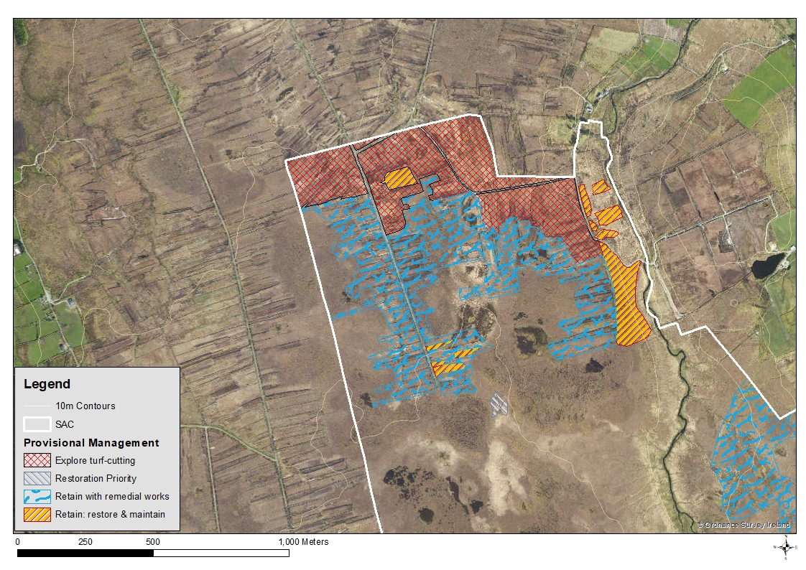
Figure 6. Explore Turf-cutting example from Ox Mountains Bog SAC.

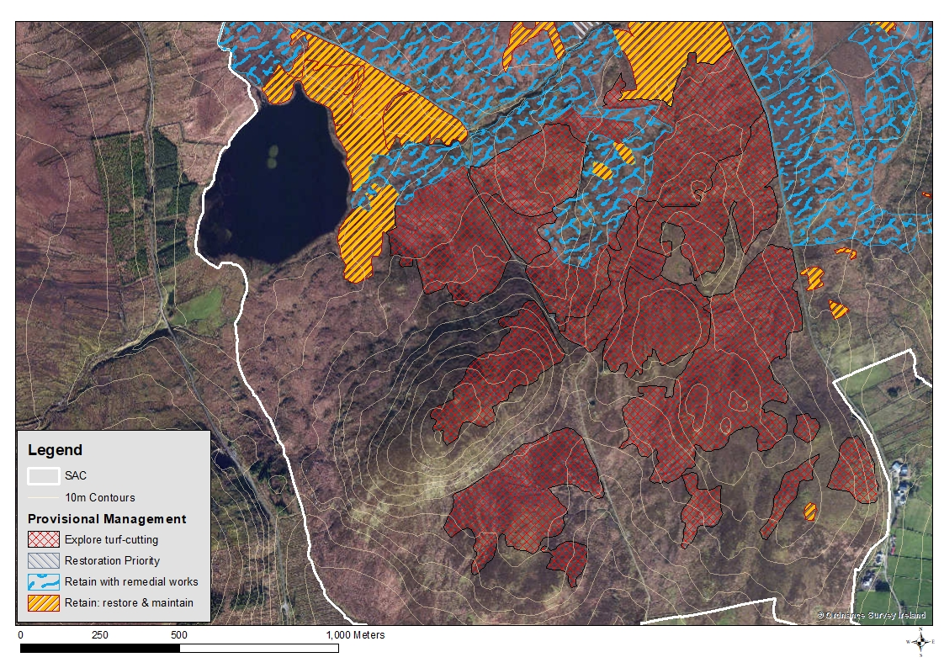
Figure 7. Explore Turf-cutting example from Magheradrumman Bog SAC.

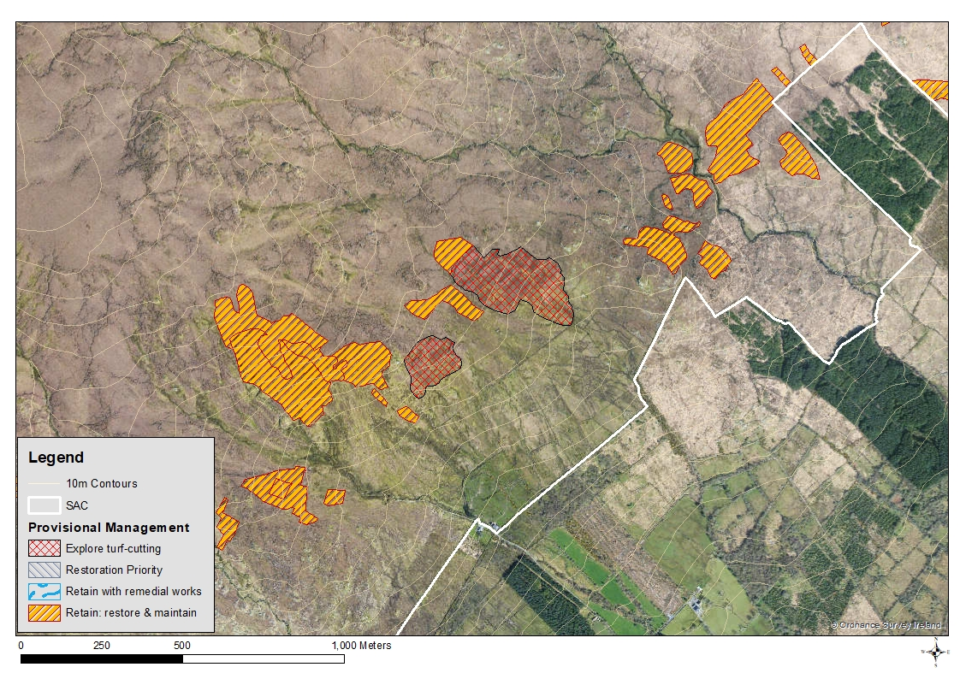
Figure 8. Explore Turf-cutting example from Ox Mountains Bog SAC.

Applying the Provisional Management Zones
When considering if turf-cutting could be considered within a particular area each Category 1 bog (seriously impacted in 1995 and 2011) polygon was reviewed in relation to the following GIS datasets:
- Rare plant records SHAPEFILE NAME
- Freshwater Pearl Mussel catchments SHAPEFILE NAME
- River sub-basin catchments (WFD_RiverSubBasins.shp available from www.EPA.ie)
- Sub-basin catchments (WFD_RiverSubBasins.shp available from www.EPA.ie)
- 10m contours
The following questions were considered in relation to each of the Category 1 bog polygons:
- Does there appear to be deep peat within or near the polygon?
- Is the polygon near a dystrophic pool or pool system?
- Is there adjacent bog which may be impacted by turf-cutting?
- Is the polygon near aquatic habitats: streams and lakes?
- Is the polygon in a core location of the SAC as opposed to being on or near the SAC boundary or on the periphery of the bog habitat?
- Is the polygon small and/or isolated from other turf-cutting?
- Would turf-cutting within the polygon contribute to fragmentation of habitat within the SAC?
- Is the polygon within a catchment of SAC populations of Freshwater Pearl Mussels?
- Is there potential for turf-cutting to impact rare plants?
A Yes/No record was made in response to each of the questions within the attribute table of the GIS shapefile. To save time this was only conducted for Category 1 bog (seriously impacted in 1995 and 2011). A decision was then made as to whether turf-cutting can be further explored within the polygon, based on the responses to these questions. If the polygon is within a catchment of SAC populations of Freshwater Pearl Mussels or there is potential for turf-cutting to impact rare plants, then cessation of turf-cutting is automatically prescribed. It was sometimes possible to modify the shape of the Category 1 polygon in order to reduce the risk of impact to adjacent bog or other habitats. A decision was made based on the answers to the above questions and in many instances expert judgement was applied. Notes were made, where necessary, within the attributes table of the GIS to record the reasons behind the decision.
Areas which could be considered for restoration were identified. These were often based around an area of Category 8 bog (partially impacted bog, with particular potential for restoration) but would necessarily incorporate examples of other categories such that there was not a conflict of proposed landuse (i.e. Explore Turf-cutting and Restoration Priority) within the same sub-catchment.
Areas proposed for Retain: Restore and Maintain, or Retain with Remedial Works were then applied as required. The Provisional Management Zones were then viewed in the GIS to ensure coherent blocks of zonation had been applied, particularly in relation to Explore Turf-cutting and Restoration Priority, as this will facilitate management and administration of the proposals.

Identifying potential compensation areas
Potential compensation areas were identified through review of recent satellite images. These areas could potentially be assimilated into the SAC if restoration targets require additional habitat to be brought into the SAC network. The potential compensation areas identified comprise afforested blanket bog both within and near the SACs and areas of 7130 Blanket bog (* if active bog) and associated habitat which is either adjacent to the SAC or near to it.
Areas of forestry within the SAC are identified and investigated as to whether they were planted before or after 1995, whether the forestry occurs on blanket bog habitat and whether restoration appears possible. This was carried out by considering the density of the canopy and longevity of the planting, with an open canopy on recently planted areas considered to have the highest likelihood of successful restoration. Forestry plantation outside the boundary of the SAC was also considered and highlighted if restoration appeared feasible.
Areas of 7130 Blanket bog (* if active bog) and associated habitat adjacent, or near to, the boundary of the SAC were identified. These comprised areas that appeared intact, in addition to areas requiring restoration. Areas outside the SAC requiring restoration were often contiguous with areas inside the SAC requiring restoration. If opportunities for compensation adjacent or close to the SAC were limited then the search area was extended, e.g. at Maheradrumman Bog SAC an area some 2km from the SAC was highlighted as having potential as a compensation area.

Establishing buffers
In general areas have been selected for Explore Turf-cutting zones which are on the edge of the SAC, on the periphery of the bog habitat, or buffered from intact 7130 Blanket bog (* if active bog) by habitat which is already compromised (identified during the Turf-cutting GIS Review). The need for a buffer area has therefore largely been avoided. When the need for a buffer was identified it was digitised and added to the revised Turf-cutting GIS Review shapefile.

Results
The results for this element of the project are presented in full in the individual site reports for ten of the 50 SACs which are listed for 7130 Blanket bog (* if active bog). These reports, together with the accompanying maps for each SAC, make up Volume 2 of this report. The GIS for this element of the project contains the Provisional Management Zones for the turf-cutting areas identified within these ten SACs. These data are intended as a framework for the consideration of where turf-cutting might occur without it amounting to an adverse impact on the integrity of the SAC. The GIS also contains areas identified for potential restoration, areas to be retained as they are and areas to be retained which also require some remedial works.
A summary of the amount of turf-cutting areas assigned to each of the four Provisional Management Zones within the ten sites is presented in Table 3. These are presented in hectares and also as a percentage of the overall turf-cutting area for the SAC. The percentage of the 7130 Blanket bog (* if active bog) occurring, or estimated to occur, within the SAC which is being proposed for Explore Turf-cutting is presented.
The percentage of the turf-cutting area that has been assigned for Restoration Priority varies considerably across the sites from 1.6% at Ox Mountains Bog SAC through to 98.8% at Glanmore Bog SAC averaging at 73.2% for all SACs. The amount of the turf-cutting area proposed for Restoration Priority depended on how suitable the bog within the SAC was for restoration. It was also influenced by the occurrence of catchments designated for their importance to Freshwater Pearl Mussels with a greater tendency to propose Restoration Priority within these catchments. The turf-cutting within Glanmore Bog SAC is within a catchment designated for its importance to Freshwater Pearl Mussel and it has the highest percentage of turf-cut areas proposed as Restoration Priority. However, West of Ardara/Maas Road SAC and Mount Brandon both have catchments designated for their importance for Freshwater Pearl Mussels but have much lower percentages proposed for Restoration Priority.
The percentage of the turf-cutting area assigned to Explore Turf-cutting also varies considerably, from zero at Glanmore Bog SAC through to 32.7% at Magheradrumman Bog SAC, with an average of 7.9%. The decision-making process at Glanmore Bog SAC was strongly influenced by the occurrence of the catchment designated for its importance to Freshwater Pearl Mussel, while the estimated area of 7130 Blanket bog (* if active bog) at Magheradrumman Bog SAC does not take into account turf-cutting which has occurred on wet heath so the figures are less reliable.
The figures for the area of Explore Turf-cutting as a percentage of the area estimate for 7130 Blanket bog (* if active bog) occurring at the site indicate the extent of the Explore Turf-cutting area at each of the SAC is a relatively low percentage, averaging at less than 1%, but this does not represent the full area of impact as there would also be indirect impacts. The figure for Magheradrumman Bog SAC is likely to be an anomaly for the reasons indicated above.
Table 4 considers in more detail the Category 1 bog (seriously impacted in 1995 and 2011) for the ten SACs and how these areas have been allocated to Provisional Management Zones. The totals for each column indicate that the majority of Category 1 bog (65.6%) has been assigned for the Cessation of turf-cutting with remedial works (option 1.3). Just under one fifth (19.8%) of Category 1 bog has been assigned for Explore Turf-cutting (option 1.4) and 9.9% has been assigned for Restoration Priority (option 1.1). The remainder (4.7%) were assigned for Cessation of turf-cutting.

Table 3: Summary of how turf-cutting areas of the SACs have been zoned
SAC code | SAC name | Standard Data Form estimate of 7130 habitat (ha) | Total area impacted by turf-cutting (ha) | Restoration Priority (ha) | Restoration Priority as a % of turf-cutting at the SAC | Retain: Restore & Maintain (ha) | Retain: Restore & Maintain as a % of turf-cutting at the SAC | Retain with Remedial Works (ha) | Retain with Remedial Works as a % of turf-cutting at the SAC | Explore Turf-cutting (ha) | Explore Turf-cutting as a % of turf-cutting at the SAC | Explore Turf-cutting area as a percentage of 7130 area
1922 | Bellacorick Bog Complex | 6,285.73 | 821.35 | 226.21 | 27.5 | 204.24 | 24.9 | 323.52 | 39.4 | 67.4 | 8.2 | 1.07
1125 | Dunragh Loughs… /Pettigo Plateau | 1,072.38 | 136.97 | 91.82 | 67.0 | 17.18 | 12.5 | 11.50 | 8.4 | 16.43 | 12.0 | 1.53
0142 | Gannivegil Bog | 1,162.97 | 274.80 | 68.55 | 24.9 | 66.12 | 24.1 | 132.15 | 48.1 | 8.01 | 2.9 | 0.69
1879 | Glanmore Bog | 103.34 | 32.92 | 32.53 | 98.8 | 0.39 | 1.18 | 0 | 0 | 0 | 0 | 0
0500 | Glenamoy Bog Complex | 7,612.06 | 815.89 | 2658.95 | 32.1 | 61.31 | 7.4 | 444.02 | 53.5 | 58.57 | 7.1 | 0.8
0168 | Magheradrumman Bog | 558.71 | 501.66 | 19.72 | 6.2 | 43.59 | 16.2 | 336.76 | 105.17 | 104.58 | 32.7 | 18.72
0375 | Mount Brandon † | 1,877.20 | 1,121.72 | 279.23 | 24.9 | 652.03 | 58.1 | 155.42 | 13.86 | 35.04 | 3.1 | 1.87
2006 | Ox Mountains Bogs † | 7,795.20 | 655.07 | 10.59 | 1.6 | 371.57 | 56.7 | 128.22 | 33.31 | 54.68 | 8.3 | 0.70
0542 | Slieve Fyagh Bog | 2,224.44 | 95.71 | 38.85 | 40.6 | 14.11 | 14.74 | 39.46 | 41.23 | 3.28 | 3.43 | 0.15
0197 | West of Ardara/Maas… Road | 876.08 | 348.19 | 91.63 | 26.3 | 161.72 | 46.45 | 65.82 | 18.82 | 30.02 | 8.6 | 3.43
 | Total | 29,568.11 | 4,804.28 | 3518.08 | 73.2 | 1592.26 | 33.1 | 1636.87 | 34.1 | 378.01 | 7.9 | 0.2

Table 4: Breakdown of how Category 1 bog (seriously impacted in 1995 and 2012) within the ten SACs has been zoned
SAC code | SAC name | Area of Category 1 (ha) | Category 1 area as a percentage of the 7130 area estimate | 1.1 Cessation of turf-cutting with in situ restoration | 1.1 as a percentage of Category 1 | 1.2 Cessation of turf-cutting | 1.2 as a percentage of Category 1 | 1.3 Cessation of turf-cutting with remedial works | 1.3 as a percentage of Category 1 | 1.4 Explore Turf-cutting | 1.4 as a percentage of Category 1
1922 | Bellacorick Bog Complex | 333.0 | 5.3 | 24.91 | 7.5 | 9.27 | 2.8 | 231.8 | 69.7 | 67.03 | 20.13
1125 | Dunragh Loughs… /Pettigo Plateau | 30.20 | 2.8 | 1.48 | 4.9 | 2.39 | 7.9 | 9.9 | 32.8 | 16.43 | 54.4
0142 | Gannivegil Bog | 76.22 | 6.6 | 7.0 | 9.2 | 3.0 | 3.8 | 58.7 | 77.0 | 7.63 | 10.0
1879 | Glanmore Bog | 6.32 | 6.1 | 6.32 | 100 | 0 | 0 | 0 | 0 | 0 | 0
0500 | Glenamoy Bog Complex | 336.83 | 4.4 | 37.43 | 11.1 | 7.1 | 2.1 | 236.1 | 70.1 | 56.2 | 16.7
0168 | Magheradrumman Bog | 277.92 | 49.74 | 0.42 | 0.2 | 0.54 | 0.2 | 247.93 | 89.2 | 29.03 | 10.5
0375 | Mount Brandon † | 83.94 | 4.5 | 42.81 | 51 | 0.65 | 0.8 | 5.44 | 6.5 | 35.04 | 41.74
2006 | Ox Mountains Bogs † | 209.31 | 2.7 | 6.4 | 3.1 | 27.51 | 13.1 | 120.72 | 57.7 | 54.68 | 26.12
0542 | Slieve Fyagh Bog | 31.69 | 1.4 | 0 | 0 | 0 | 0 | 28.4 | 89.62 | 3.28 | 10.4
0197 | West of Ardara/Maas Road | 107.40 | 12.3 | 21.07 | 19.6 | 18.94 | 17.6 | 40.9 | 38.1 | 26.45 | 24.6
 | Total | 1492.83 |  | 147.84 | 9.9 | 69.4 | 4.7 | 979.89 | 65.6 | 295.77 | 19.8

Discussion
Any results presented here only pertain to the methodology detailed in this report and as the approach has not been approved by DCHG they must be considered provisional. The approach identifies approximately 20% of Category 1 bog (seriously impacted in 1995 and 2011) Explore Turf-cutting zones with the majority of the Category 1 bog (65.6%) being identified as for the cessation of turf-cutting with remedial works. These remedial works would be aimed at either ameliorating on-going impacts to adjacent habitats or features, or containing the indirect impacts of turf-cutting within adjacent areas being considered as Explore Turf-cutting zones.

Critical Review of Methodology
The methodology for the Turf-cutting GIS Review, the data for which is utilised by this stage of the project, is based on the subjective review of aerial images.
The recent satellite images available to the project are from 2011 so are 6-7 years out of date. Any extensions or intensification to turf-cutting that have occurred subsequent to these images being captured will not have been recorded in the GIS for this project. There will need to be measures in the methodology to record any extensions in turf-cutting areas or intensification of turf-cutting. This would be a time-consuming field task which could be completed much more time-effectively with more recent imagery.
Applying the current methodology is time-consuming and is a step in an iterative process. It should however be viewed in relation to the scale and complexity of the issue, the number of sites and the limited resources which have been working towards a resolution.
The zones being developed are provisional and many of them need fieldwork to confirm the zonation applied or to amend them as required.
The methodology is based on a subjective decision-making process. This is partly a reflection of the variation within the SACs and the turf-cutting areas and the reliance on satellite images and aerial photographs. This makes applying a more objective approach difficult. The current methodology can be viewed as a pragmatic approach to a complex issue.
Some seriously impacted areas of bog will have been exhausted of harvestable peat but will be proposed as Explore Turf-cutting zones. It was not considered within the remit of the Scientific Underpinning to identify and remove these areas, and would not be possible as part of a desktop survey.
A numbering system for the Provisional Management Zone blocks will be required.
The approach identifies significant areas as “Retain: Restore and Maintain”. In general these areas are unlikely to require field assessment. As such, large portions of turf-cutting areas will not require field survey, though without viewing more recent imagery it will not be known if turf-cutting has occurred in these areas since 2011.
Many of the Explore Turf-cutting zones identified rely on the implementation of remedial measures in nearby or adjacent polygons to mitigate the potential for impact. Without these measures turf-cutting in many Explore Turf-cutting zones may result in indirect negative impacts to surrounding habitat and features. The current methodology does not record the nature of the remedial work that may be required.
The entire approach may leave turf-cutting areas vulnerable to other development, e.g. wind-farms or forestry, unless measures are put in to safeguard against this. It may be possible to incorporate into the Turf-cutting Regulations and SSCOs a requirement for facilitating post turf-cutting rehabilitation of the site. This may be a technically straightforward process of ensuring banks are left battered rather than vertical, drains are blocked and bunds of peat are left to impede drainage. A realistic and enforced rehabilitation programme may reduce the requirement for alternative compensation areas.
More sensitive areas such as deep peat, dystrophic pools, quaking bog and transition mires have not been systematically mapped through the current methodology. Digitising polygons for these features would be a time-consuming and, at times, speculative task. A less time-consuming approach would be to indicate more sensitive areas with a point. This avoids the need for speculation as to where, for example, the edge of an area of deep peat is, but would serve to highlight the presence of a more sensitive area influencing a management decision.

References
Barron S.J. (2017) Phase 1 of the scientific work to inform a system for the management of turf-cutting in designated blanket bog SACs and NHAs: Turf-cutting GIS Review Volume 1 – DRAFT. Unpublished draft report to National Parks and Wildlife Service, Department of Arts, Heritage and the Gaeltacht, Dublin.
Barron S.J. & Daly O.H. (2015) Phase 1 of the scientific work to inform a system for the management of turf-cutting in designated blanket bog SACs and NHAs: Phase 1 Over-arching report – DRAFT. Unpublished draft report to National Parks and Wildlife Service, Department of Arts, Heritage and the Gaeltacht, Dublin.
DAHG (2014) Regulation of Turf-Cutting within Blanket Bog Sites of Community Importance and Natural Heritage Areas Roadmap to Compliance with Article 6 of the Habitats Directive & EIA Directive – DRAFT. Unpublished report prepared by Department of Arts, Heritage and the Gaeltacht.
European Commission (2000) Managing Natura 2000 Sites: The provisions of Article 6 of the ‘Habitats’ Directive 92/43/EEC. Office for Official Publications for the European Communities, Luxembourg.

Appendix 1
Information on the shapefiles produced through this part of the project and some of the applications of the GIS data are detailed below.
  - Provisional Management Zones
The Provisional Management Zones applied to the turf-cutting areas of ten SACs are contained within the GIS shapefile Provisional_Managment_01a.shp. This shapefile is based on the GIS data from the Turf-cutting GIS Review which was submitted in March 2017 (SABB14_Turf-cutting_GIS_Review_01a.shp). Provisional_Management_01a.shp records the Provisional Management Zones applied to the turf-cutting areas together with a record of the decision-making process. A number of columns were added and the shapefile has the following columns in the attribute table:
SITECODE
SAC site code.
SITE_NAME
SAC site name.
COUNTY
County which the SAC occurs within.
HA
Area of the polygon in hectares.
CATEGORY
Turf-cutting bog category applied during the Turf-cutting GIS Review (Barron 2017).
PMZ_CODE
Numeric code for the Provisional Management Zone (see Table 2 of this report)
PMZ
Name for Provisional Management Zones (see Table 2 of this report)
DEEP_PEAT
Records, for Category 1 polygons, whether deep peat is apparent within the polygon, based on viewing the aerial images.
DYST_POOL
Records, for Category 1 polygons, whether dystrophic pools are evident within or near to the polygon, based on viewing the aerial images.
ADJ_BOG
Records for Category 1 polygons, whether there are adjacent areas of intact bog, based on viewing the aerial images.
AQUA_HAB
Records for Category 1 polygons, whether streams, rivers or lakes are evident within or near to the polygon, based on viewing the aerial images.
CORE_SAC
Records for Category 1 polygons, whether the polygon is away from the boundary of the SAC, based on viewing the aerial images together with the SAC boundary.
SMAL_ISOL
Records for Category 1 polygons whether the polygon is small and isolated from other turf-cutting areas. This was based on viewing the aerial images.
FRAGM
Records for Category 1 polygons whether continued turf-cutting within the polygon would contribute to fragmentation of habitats within the SAC.
FPM
Records for Category 1 polygons whether they occur within a catchment of SAC populations listed in S.I. 296 of 2009. This was based on intersecting the Category 1 bog polygons and the Margaritifera_sensitive_areas_2014_v06.shp. Additional information is given below.
RARE_PLANT
Records for Category 1 polygons whether the polygon intersects with a rare plant record. Based on intersecting Category 1 bog polygons and the rare plants shapefile. Additional information is given below.
SPAW_SALM
Records for Category 1 polygons whether the polygon intersects with a catchment with spawning Salmon records. Based on intersecting Category 1 bog polygons and the catchments containing spawning Salmon shapefile. Additional information is given below.
SAUSAG_CUT
Identifies polygons where turf-cutting appears to have been conducted using a sausage extrusion machine. Based on viewing the aerial images and is likely to be an incomplete record.
NOTES
Notes were added as required.
The methodology for applying the Provisional Management Zones is detailed in section 2.3 of this report.
Assigning the turf-cutting areas to categories during the Turf-cutting GIS Review was a subjective process and when these areas were looked at again as part of the current stage of the project some amendments were made with polygons being re-categorised and in some instances turf-cutting areas extended. The amended results are presented in the spreadsheet SABB14_TC_GIS_Review_Summary_spreadsheet_02a which is an updated version of the spreadsheet submitted in March 2017.
  - Rare plants
A shapefile was created by NPWS containing records of rare and threatened species from the 50 SACs, plus a 1km buffer. As this contained almost 12,000 records it was necessary to streamline these data to the most pertinent records. These were plant species listed on Annex II of the Habitats Directive (excluding Luronium natans), Flora (Protection) Order 2015 species, rare and endangered mosses (REFERENCE). This reduced the number of records to 2,458. The accuracy of these data ranged from 10-figure GPS reference points to 10km grid square records. These were viewed together with the Annex II FPO records, all of which were 10-figure GPS reference points.
An intersect was performed between the Rare Plant records and the Category 1 bog (seriously impacted in 1995 and 2011) polygons and where they intersected is recorded in the attributes table of the Provisional_Management_01a.shp. However, records with 10km grid square accuracy have a disproportionally high possibility of intersecting with turf-cutting polygons, while very accurate records have a low possibility of intersecting; therefore, accurate records very close to turf-cutting and potentially indirectly impacted by turf-cutting would not be highlighted using this approach. Rather than applying buffers to the data it was decided to view rare plant records for each SAC prior to applying Provisional Management Zones to assess the likelihood of potential impacts. Where there are particular concerns, these are highlighted in the site reports.
  - Freshwater Pearl Mussels
The Margaritifera_Geodatabase.gdb was downloaded from the NPWS website. This identifies catchments which are considered of importance for Freshwater Pearl Mussels. Within the shapefile Margaritifera_sensitive_areas_2014_v06.shp, catchments are identified according to three levels:
- Catchments of SAC populations listed in S.I. 296 of 2009,
- Catchments of other extant populations,
- Catchments with previous records.
In the Draft Provisional Management Plan reports, the area of Category 1 bog (seriously impacted in 1995 and 2011) for the SAC occurring within each of these catchment types is noted. Only the catchments of populations listed in S.I. 296 of 2009 affect the decision-making process, with no future turf-cutting being considered for these catchments and a preference for Restoration Priority. In the attributes table of the Provisional_Management_01a.shp it is noted where Category 1 bog occurs within a catchment of populations listed in S.I. 296 of 2009.
  - Spawning Salmon
Spawning Salmon records were available as a number of polyline shapefiles. A line was taken to indicate a stretch of river where spawning Salmon have been recorded. These shapefiles were amalgamated into a single shapefile which was then intersected with the EPA catchments available in the WFD_RiverSubBasins.shp to create catchments with records of spawning Salmon. An intersect was then performed between the Category 1 bog (seriously impacted in 1995 and 2011) polygons and the catchments with spawning Salmon records. It is noted in the attributes table of the Provisional_Management_01a.shp where Category 1 bog occurs within a catchment with spawning Salmon records. Unlike the Freshwater Pearl Mussel catchments, the spawning Salmon catchments did not automatically affect the decision-making process. The amalgam of the spawning Salmon records were viewed in relation to turf-cutting areas and consideration was given to the proximity of turf-cutting to the spawning Salmon records. There was a preference for cessation of turf-cutting and Retain with Remedial Works to be assigned to areas of turf-cutting close to spawning Salmon records.

  - Sub-sites
SACs were divided into sub-sites to compartmentalise the turf-cutting areas within them. Sub-site boundaries were influenced by the catchment boundaries indicated in the EPA shapefile WFD_RiverSubBasins.shp to emphasise the need for considering management of turf-cutting on a catchment basis, though the sub-basin catchments were not strictly adhered to. For instance, where turf-cutting occurred on the watershed the sub-site boundary would be digitised around the turf-cutting to avoid splitting turf-cutting areas. Catchments were merged as necessary to give a meaningful compartment with which to consider and display the Provisional Management Zonation. The sub-site shapefile was created by taking the SAC boundary (SAC_ITM_2017_01.shp) and splitting the polygon using the ‘cut polygons tool’. The whole of the SAC was assigned to a sub-site, not just the areas with turf-cutting present. Sub-sites were named after a feature within the sub-site (a named summit, river or lake) or the townland which comprised the majority of the sub-site.
  - Potential Compensation Areas
Potential Compensation Areas were identified and digitised to highlight areas where forested areas might be restored to blanket bog, or where consideration could be given to expansion of the SAC in order to meet restoration targets. The shapefile was created by taking the SAC boundary (SAC_ITM_2017_01.shp) and either splitting areas within the SAC polygon for areas within the SAC or adding adjacent polygons using the ‘autocomplete polygon function’. On completion the SAC boundary was deleted, retaining just the newly created polygons.

