Appeal and Complaint Resolution Procedure – Soil Association Certification Ltd - Forestry Team

1. Policy and Scope

Soil Association Certification Ltd aims to address any expression of dissatisfaction, including comments, complaints and appeals received in relation to its certification activities, providing timely resolution, fairness and transparency in its activities.

This document is a summary of information about the procedures for submitting and handling complaints and appeals for certification activities related to the Forestry Team, Climate and Landscape team excluded.

NOTE: This process is separate from the stakeholder consultation process for forest management (FM) certification which is described in IP-FM-006 Consultation Policy and Guidelines (IP-FM-006 is publicly available at: https://www.soilassociation.org/certification/forestry/forest-management-certification/consulting-stakeholders/)

Prior to lodging an appeal or complaint, Soil Association Certification encourages all stakeholders with concerns in relation to forest management or controlled wood certification to engage fully with both the stakeholder consultation process of the certificate holder and the stakeholder consultation process conducted by Soil Association. If you would like your comment to be considered as stakeholder consultation feedback, please e-mail:
ForestryConsultation@soilassociation.org
Alternatively, please contact our Head Office. Regional contact details are found on our website.

2. Fairness and confidentiality

Soil Association Certification recognises the value of external feedback as a potential benefit for the improvement of the services provided. Since the health and well-being of our staff is a priority, no abuse of the complaints and appeals mechanism, or any abusive comments or disrespectful, insulting or threatening language against any of our staff or Agent colleagues will be tolerated.

In handling any expression of dissatisfaction, Soil Association Certification requires the submitting stakeholder to maintain and understand confidentiality. Stakeholders should refrain from commenting publicly on the complaint or appeal until a decision has been made. Moreover, Soil Association Certification reserves the right not to disclose with the submitter any evidence gathered as part of the complaint or appeal resolution process which is not already publicly available.

3. Summary of Soil Association Certification’s Appeal and Complaint Resolution Procedure

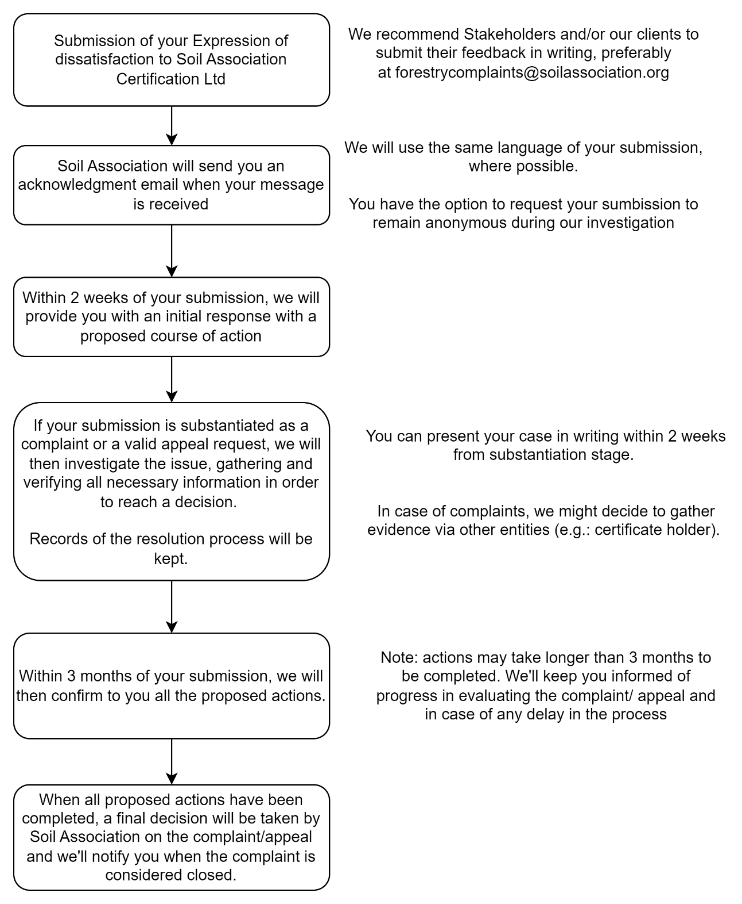

Further Resolution
In the case of appeals, further information is available on request in the Soil Association Guidance on appeals process for licensees’ (C277fm). A secondary appeal may be heard by the Certification Scrutiny Committee.

If you are not satisfied with Soil Association Certification’s decision:

For Forest Stewardship Council® (FSC®) certification issues, you can take your complaint to
Assurance Services International GmbH (ASI)
Phone: +49 (228) 227 237 0
Email: asi-info@asi-assurance.org
Website: asi-assurance.org

Soil Association Certification’s FSC License Code is FSC® A000525.

As the ultimate step the complaint may be referred to FSC International
Phone: +49 (0) 228 367 66 0
Email: info@fsc.org
Website: fsc.org/en

For Programme of Endorsement of Forest Certification (PEFC) certification issues, you can take your complaint to the PEFC National Office or to PEFC International
Phone: +41 (22) 799 4540
Email: info@pefc.org
Website: pefc.org

Soil Association Certification’s PEFC Licence code is PEFC/ 16-44-917.

4. Contacting Us

Should you require any further information, please contact us at:

Soil Association Certification - Forestry Team
Spear House, 51 Victoria Street, Bristol, BS1 6AD
Email: forestry@soilassociation.org
Phone: +44 (0)117 914 2435
Website: www.soilassociation.org/forestry

