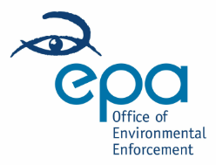 | SITE VISIT REPORT

Purpose of Site Visit: | Peat Extraction in Clooncunny, Co Galway
Site Address: | Clooncunny, Co Galway
Date of Visit: | 16/04/24
Times of Visit: | 2000 to 2030
Visit Criteria: | Peat extraction investigation
EPA Attendees: | Simon Buckley

Summary: The purpose of the visit was to scertain whether peat extraction activities were being/had been carried out at Clooncunny, Co Galway.

Findings of site visit of 16/04/24

The following was noted during the visit:
- No peat harvesting was noted in the northern end of the peatland.
- Machinery associated with peat extraction were identified in the south east end of the peatland.
- An area beside the machinery appears to have been milled
- No peat extraction was taking place during the visit.

Report prepared by: | Simon Buckley | Signed: | 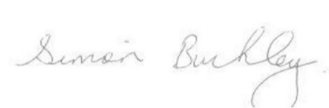
 |  | Date: | 25/04/2024

Appendix 1

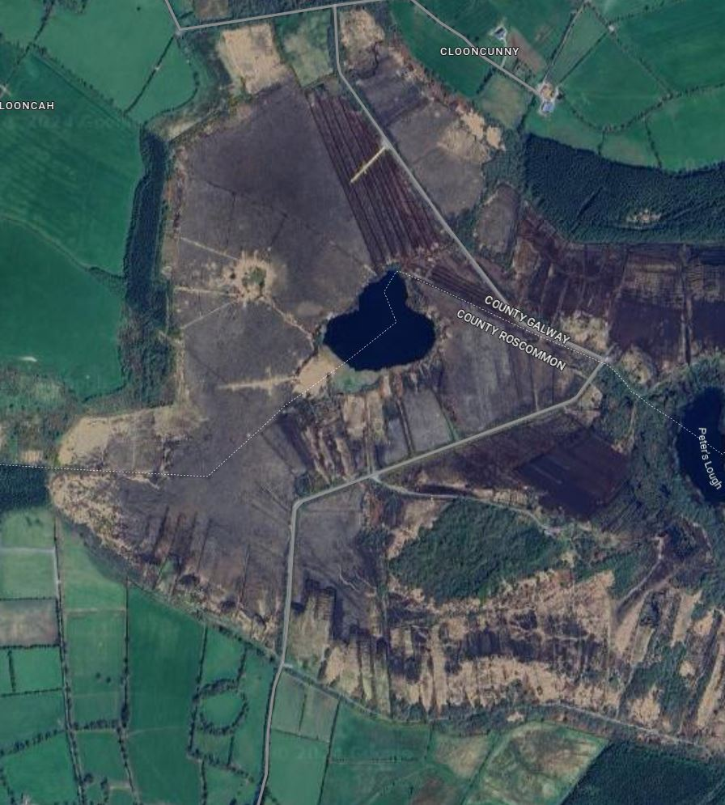

Appendix 2
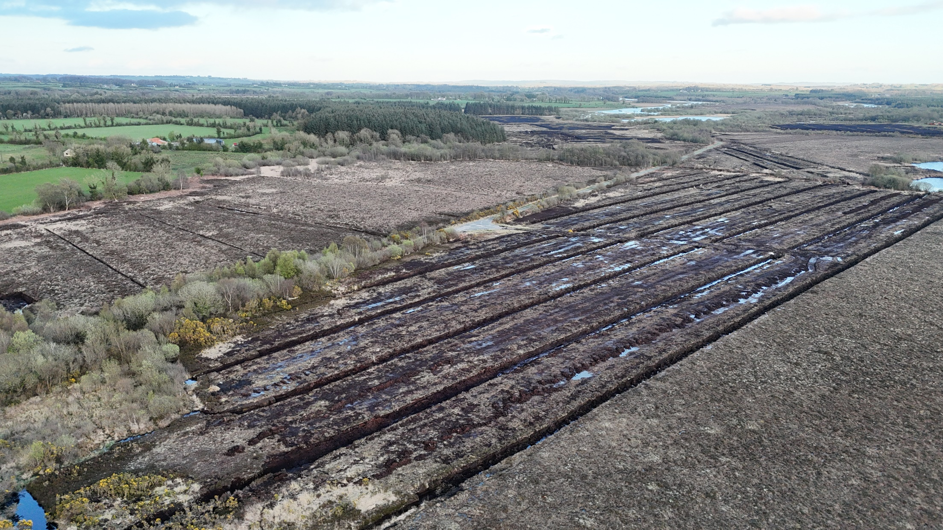
Photo 1: General overview of the north end of the peatland.
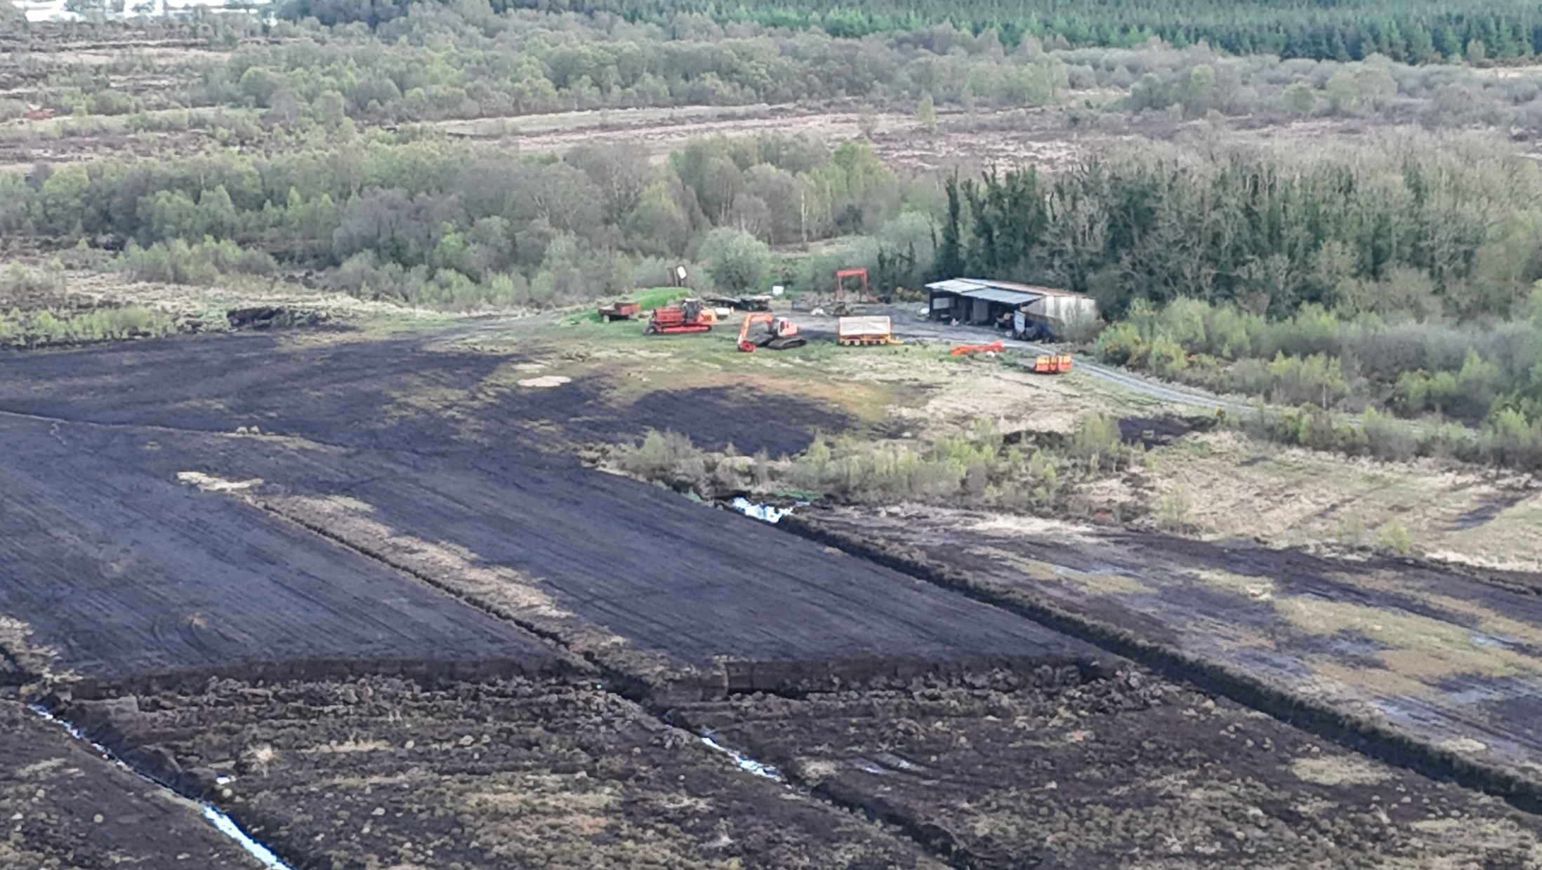
Photo 2: Peat harvesting equipment in the Southeast end of the peatland.
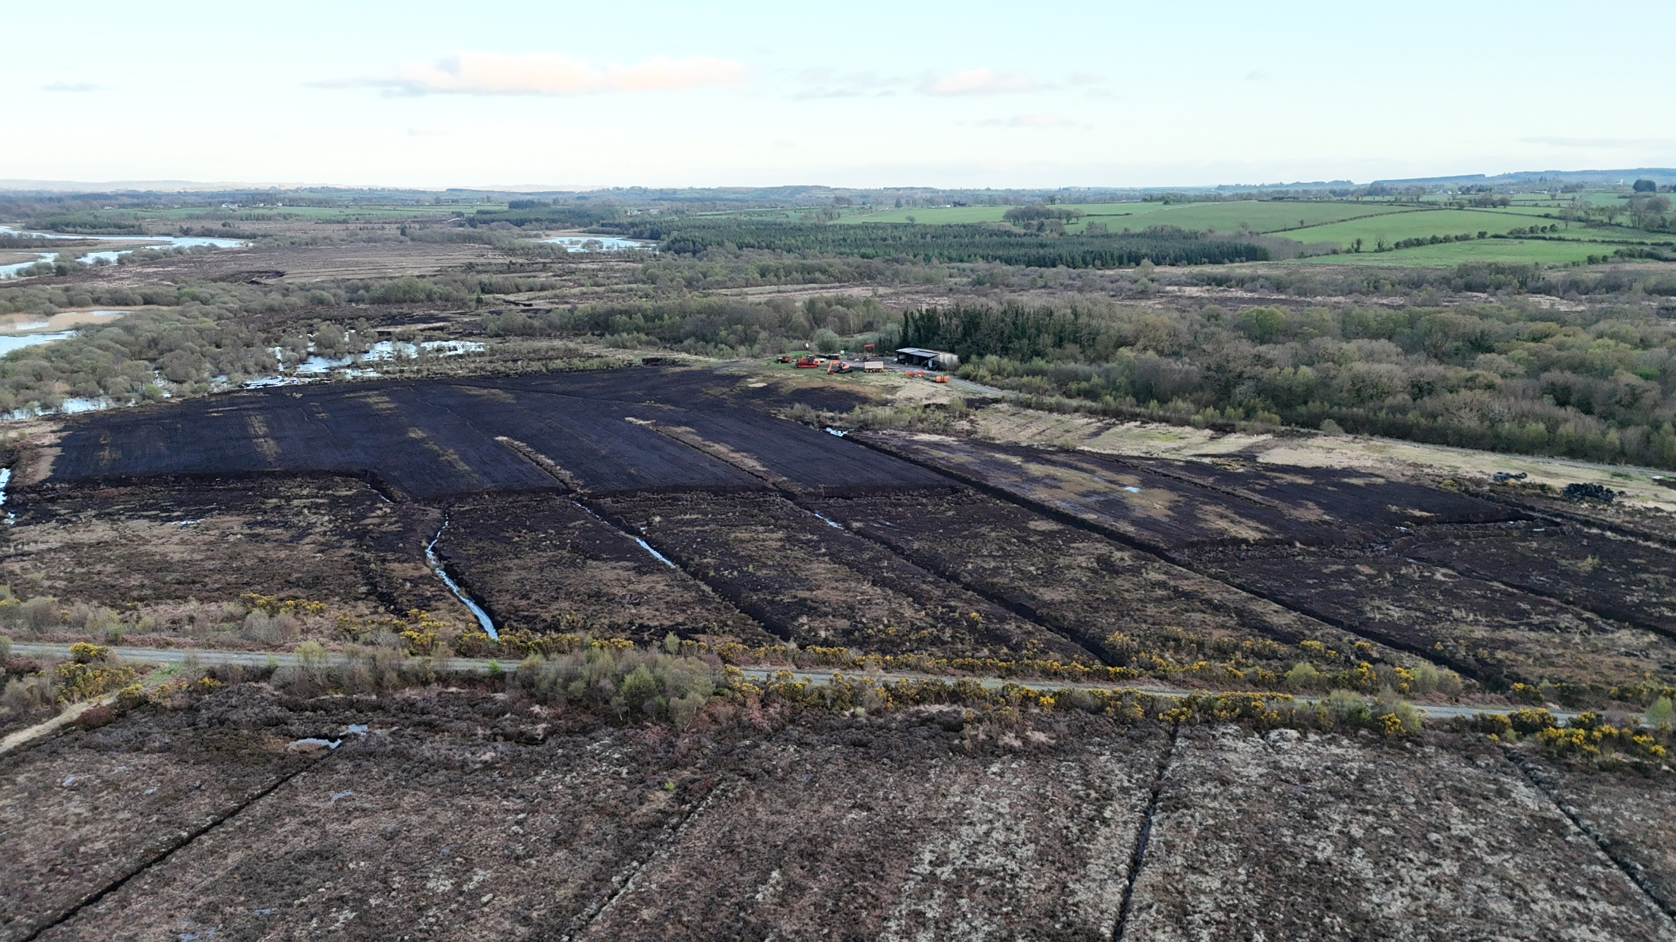
Photo 3: General overview of the southeast end of the peatland.

