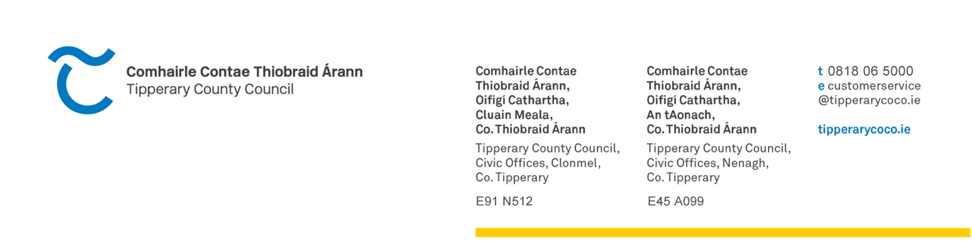

requests@righttoknow.ie 18th December 2024

Re: AIE Request – 30/24
Dear A Chara,
In relation to your request under the Access to Information on the Environment Regulations 2007–2018, received on 6th November 2024. The timeframe for response was extended up to 5th January 2025 in accordance with Article 7(2)(b) due to the volume/complexity of information requested.
I am pleased to inform you that LAWPRO can now respond to your request.
“LAWPRO forestry related referrals for 2023-2024YTD
Please include Protect and Restore referrals and any written responses from the notified bodies (eg DAFM Forest Service, Coillte, private forestry companies etc)
RTK would like to amend the recent AIE 29/24 based on new information in the recent LAWPRO Annual Report that gives a more comprehensive breakdown of non-ASSAP referrals
RTK wish to amend the AIE to include "Referrals to Others", not just forestry referrals
For example the Annual Report notes 81 of these referrals to "*Environmental Protection Agency, Local Authorities, Forest Service, Coillte, Irish Water, etc"
New text
LAWPRO non-ASSAP referrals for 2023-2024YTD
Please include Protect and Restore referrals and any written responses from the notified bodies (eg DAFM Forest Service, Coillte, private forestry companies, EPA, LAs, IW etc)”.
All available records related to your request have been sent to you via secure link for you to download. If possible, please confirm receipt of said files by email to awalsh@watereip.ie by 1.00 pm on Friday 20th December as I will be on Annual Leave thereafter until 6th January 2025.

Mise le meas,
Alan Walsh,
Decision Maker
0818 06 5000
awalsh@watereip.ie

