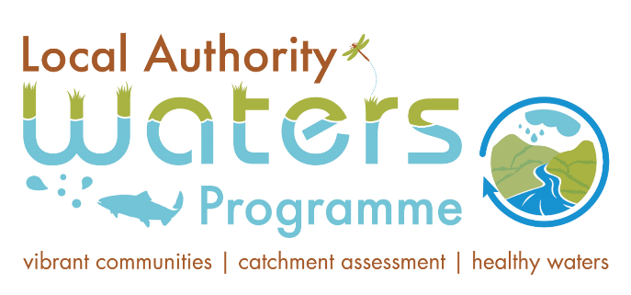
Jiggy (Hind)_010
Roscommon Town Urban Run-off - Misconnections
Referral Report

Jiggy (Hind) Priority Area for Action

Document Control Sheet
LAWPRO Office | Western Region
Document Title | Jiggy (Hind)_010 RFL01_ Roscommon Town Urban Run-off Referral Report
Document No. | F01
For the attention of: | Roscommon County Council
Date | 18th July 2024

Contents | No. of Pages | No. of Appendices
Contents | 13 | 1

Table of Contents
1 Introduction 1
1.1 Desk Study Assessment 1
1.2 Desk Study Findings 1
1.3 Significant pressure from initial characterisation 1
1.4 EPA Hydrochemistry and Physio-Chemical Data 1
2 Fieldwork 2
3 Other significant pressures in the Jiggy (Hind)_010 12
4 Conclusion 13
5 Appendix 1- EPA Hydrochemistry- 2016 to 2023 14

List of Figures
Figure 1 Roscommon Urban Agglomeration and LAWPRO’s LCA Sampling Locations 3
Figure 2 Referral area 5
Figure 3 Looking Upstream at Site 1.1.1 on the 12th of May 2022 5
Figure 4 EPA Operational Monitoring Station (May 2022 and August 2022) 6
Figure 5 BOD Results 2016 to 2023 14
Figure 6 Ortho-Phosphate Results 2016 to 2023 15
Figure 7 Ammonia Results 2016 to 2023 16
Figure 8 Dissolved Oxygen % Saturation 2016 to 2023 17

List of Tables
Table 1 LCA Results for February 2022 7
Table 2 LCA Results for May 2022 8
Table 3 LCA Results for August 2022 9
Table 4 LCA Results for April 2023 10
Table 5 LCA Results for October 2023 11

Introduction
This report details the findings from the local catchment assessment (LCA) carried out in the Jiggy (Hind)_010 (waterbody Code IE_SH_26J010090), which is part of the Jiggy (Hind) Priority Area for Action, and evidence gathered to indicate urban run-off as a significant pressure on this waterbody.

Desk Study Assessment

Desk Study Findings
- The Jiggy (Hind)_010 is At Risk of not achieving its WFD objectives.
- The current ecological status is Poor. A Q-Value of 3 was recorded in 2020 at “Br S.W. of Old Workhouse”, the EPA’s Operational Monitoring Station for the Jiggy (Hind)_010. The Ecological status and Q-Values have not changed since the completion of the Desk Study and the writing of the Referral Report.
- The EPA Operational Monitoring Station has never achieved Good Status since the start of monitoring in 1987. From 1987 until 2013, the Q-Value varied between Q1-2 and Q2. Since 2014, the Q value has been at a Q3.
- Nutrient pollution, organic pollution, sediment, altered habitats due to morphological changes and altered habitats due to hydrological changes are the significant issues identified for this waterbody.

Significant pressure from initial characterisation
- The EPA have identified Urban Wastewater (Combined Sewer Overflows), Urban Run-off (Diffuse sources run-off), Waste (EPA Licensed Activity) and Hydromorphology as the significant pressures for the waterbody.

EPA Hydrochemistry and Physio-Chemical Data
There have been frequent exceedances in both the annual average and temporal concentrations of ammonia, Biochemical Oxygen Demand (BOD), and orthophosphate since 2016 at the Br S.W. of Old Workhouse station (Appendix 1: Figure 5, Figure 6 and Figure 7).
Rainfall data was assessed against the EPA hydrochemistry sample dates for the previous seven days (Inclusive of the day of sampling). The exceedances did not correlate to either dry weather flow or storm events. There is no hydrometric station which measures water flow in the Jiggy Hind PAA therefore it was not possible to assess the exceedances against the water flow to estimate nutrient loading.
Dissolved oxygen is frequently below the Good Status EQS (80% Saturation) (Appendix 1 Figure 8).

Fieldwork
A fieldwork plan for the Jiggy (Hind)_010 waterbody identified sites throughout the waterbody to confirm the significant pressure and issues (Figure 1). LCA involved water chemistry sampling and physico-chemical parameters (dissolved oxygen (DO), conductivity, pH and temperature). Due to low water levels in May 2019, it was possible to collect one biological sample using the Small Streams Impact Score (SSIS) at the Br S.W. of Old Workhouse. However, since then, the lack of suitable habitat and silt deposition have made it impractical.
Chemistry sampling for nutrients (Ammonia, Orthophosphate and Nitrate), physio-chemical and visual assessments were also carried out at the Br S.W. of Old Workhouse on eight occasions between 2019 and 2023. The results at the monitoring station and upstream locations are displayed in Table 1, Table 2 Table 3, Table 4 and Table 5.

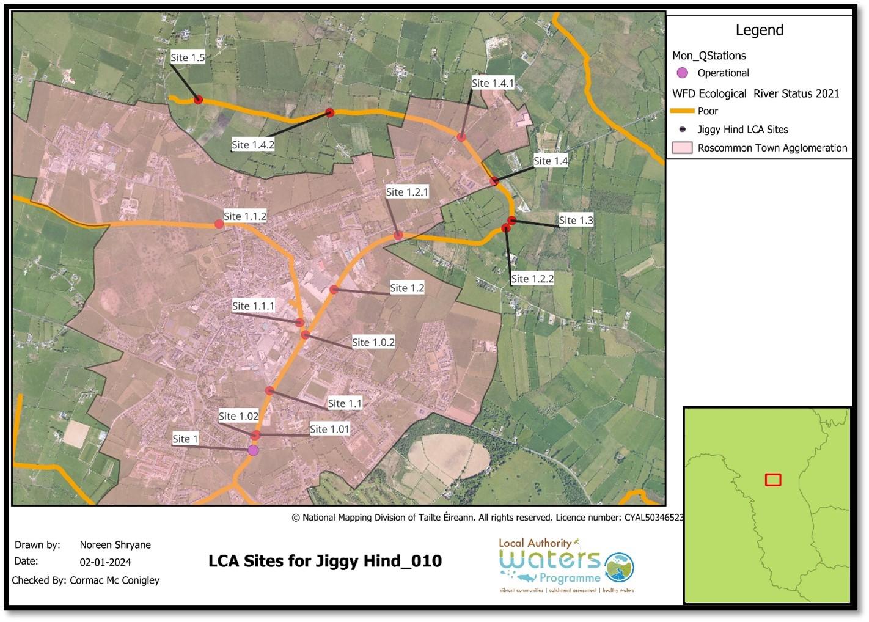
Figure 1 Roscommon Urban Agglomeration and LAWPRO’s LCA Sampling Locations

The tables below illustrate the nutrient exceedances at the Br S.W. of Old Workhouse (Site 1) upstream to Site 1.1.2 on the western tributary and Site 1.0.2 on the eastern tributary.
The dissolved oxygen is consistently below the Good Status EQS (80% Saturation) at most sites throughout the referral area. Ammonia is a significant issue at the Br S.W. of Old Workhouse and upstream with sporadic exceedances in BOD and Orthophosphate.
It was noted during LCA that the Br S.W. of Old Workhouse had frequent filamentous green algae cover. The presence of Potamogeton crispus and Callitriche Spp. was noted, and these can be indicators of slow, nutrient rich waters (Figure 4). The SSIS result in May 2019 was Probably Impacted (Score of 1.6). There were no sensitive taxa present with a notable absence of Baetidae which are particularly sensitive to sediment as they are unable to dig themselves out of thick layers of deposited sediment. The sample was dominated by pollution tolerant taxa including Tubificidae, Chironomidae and leeches.
LCA site 1.1.1, located approximately 1.1km upstream of Br S.W. of Old Workhouse, had the highest Ammonia exceedances reaching concentrations of 4.21 mg/l in August 2022. A foul smell has been noted at this site on occasion and the riverbed is obscured by a blue-grey hue (Error! Reference source not found.).
Site 1.1.2, located approximately 1.2km upstream of Site 1.1.1 in a rural area outside Roscommon town, had no nutrient exceedances when assessed in April and October 2023. On the same dates, site 1.1.1 had ammonia exceedances of 0.098 mg/l and 0.079 mg/l, respectively. Therefore, there is a significant source of ammonia is entering the Jiggy (Hind)_010 between site 1.1.2 and site 1.1.1. It was not possible to access the channel to identify the source of ammonia but based on the urban environment, misconnections are a likely significant pressure.
The data also indicates that there are additional pressures downstream of site 1.1.1. Increases in ammonia concentrations were recorded between sites 1.02 and 1 in May 2022 and, sites 1.1 and 1 in August 2022, the latter of which was a significant increase from 0.025 mg/l to 0.076 mg/l. As sections of the river are still within the urban extent of Roscommon town, misconnections may also be the source of the ammonia exceedances between these sites also. The referral area therefore stretches from Site 1 to Site 1.1.2, approximately 2.2km of the Jiggy (Hind)_010 channel.
The surface water monitoring undertaken by LAWPRO at the upstream and downstream compliance monitoring sites for the landfill indicated no nutrient exceedances (LAWPRO Site 1.4 and Site 1.2.1 respectively) therefore the landfill has been eliminated as a significant pressure.
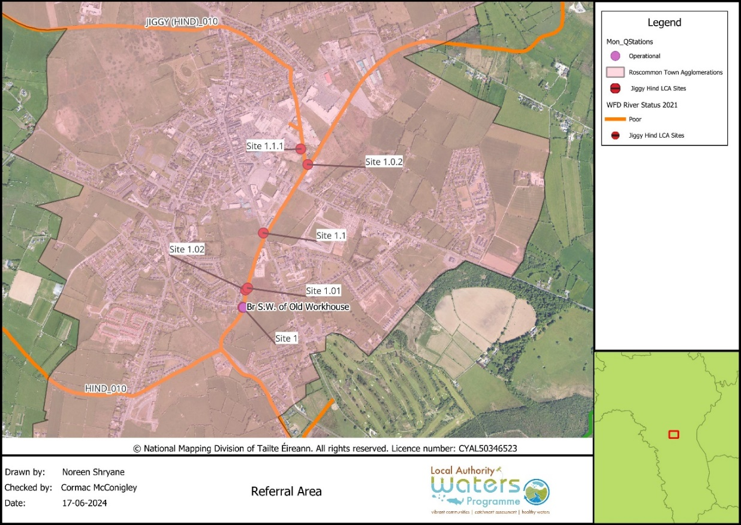
Figure 2 Referral area

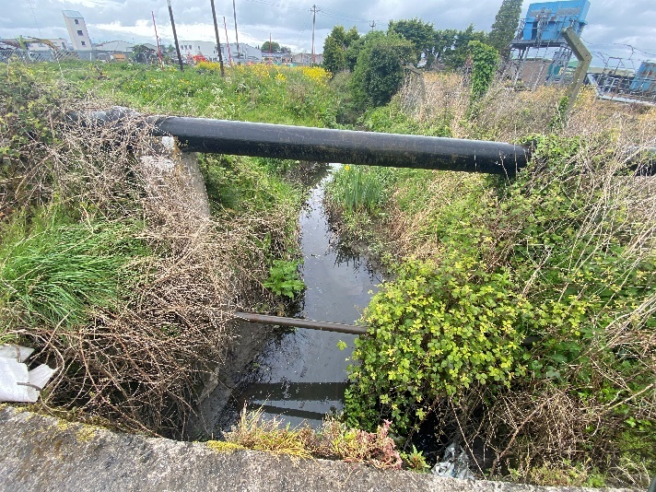 | 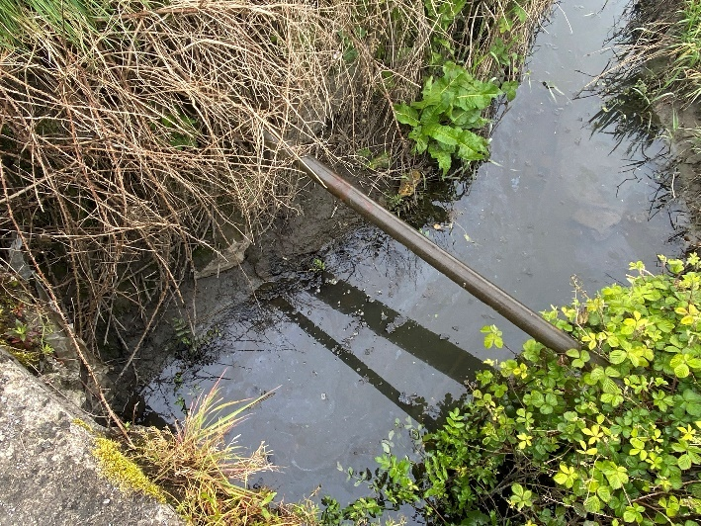
Figure 3 Looking Upstream at Site 1.1.1 on the 12th of May 2022

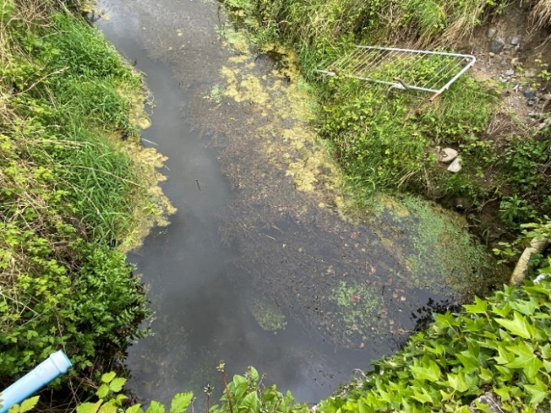 | 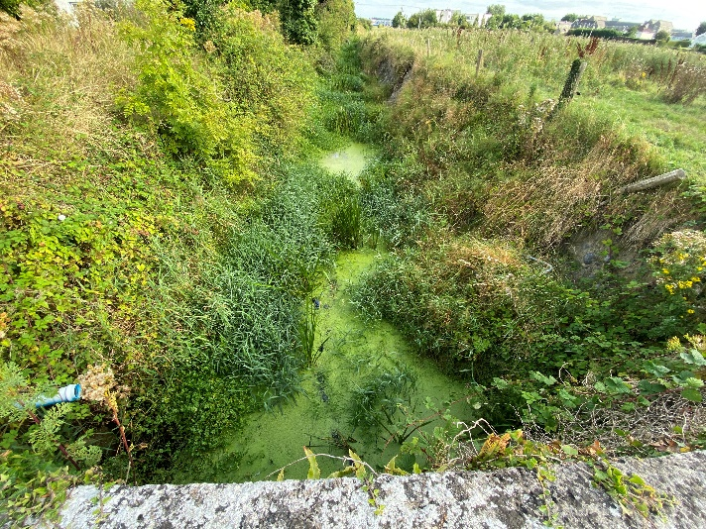
Figure 4 EPA Operational Monitoring Station (May 2022 and August 2022)

Table 1 LCA Results for February 2022
Location Code | Site 1.1.1 | Site 1.1 | Site 1
Location Description | 590m u/s of Site 1.1 on Western Trib | 470m u/s of Site 1 | Br S.W. of Old Workhouse EPA Monitoring Station
Date | 9th Feb 2022 | 9th Feb 2022 | 9th Feb 2022
DO% | 78.3% | 69.7% | 71.6%
pH | 7.32 | 7.33 | 7.23
Cond | 628 | 623 | 623
Temp | 7.9 | 7.7 | 7.8
BOD | <1 | <1 | <1
Ortho-P | 0.012 | 0.022 | 0.025
Ammonia | 0.072 | 0.067 | 0.061
Nitrate | 1.949 | 1.938 | 1.909

Table 2 LCA Results for May 2022
Location Code | Site 1.1.1 | Site 1.1 | Site 1.01 | Site 1.02 | Site 1
Location Description | 590m u/s of Site 1.1 on Western Trib | 470m u/s of Site 1 | Drain on Left bank 120m u/s of Site 1 | Drain on Right bank 120m u/s of Site 1 | Br S.W. of Old Workhouse EPA Monitoring Station
Date | 12th May 2022 | 12th May 2022 | 12th May 2022 | 12th May 2022 | 12th May 2022
DO% | 50.4% | 97.5% | 65.6% | 105.4% | 79.3%
pH | 7.23 | 7.37 | 7.24 | 7.56 | 6.97
Cond | 856 | 706 | 743 | 358 | 687
Temp | 13.5 | 12.9 | 13.5 | 13.9 | 13.3
BOD | 2.7 | <1 | <1 | 3.3 | <1
Ortho-P | 0.071 | 0.02 | 0.006 | 0.057 | 0.022
Ammonia | 0.812 | 0.102 | <0.02 | <0.02 | 0.043
Nitrate | 0.538 | 0.506 | <0.032 | <0.032 | 0.47

Table 3 LCA Results for August 2022
Location Code | Site 1.1.1 | Site 1.1 | Site 1
Location Description | 590m u/s of Site 1.1 on Western Trib | 470m u/s of Site 1 | Br S.W. of Old Workhouse EPA Monitoring Station
Date | 31st Aug 2022 | 31st Aug 2022 | 31st Aug 2022
DO% | 3.6% | 24.5% | 50%
pH | 7.21 | 7.48 | 7.34
Cond | 724 | 802 | 810
Temp | 15.2 | 16 | 15.9
BOD | 4.7 | 1.3 | 1.6
Ortho-P | 0.182 | 0.046 | 0.043
Ammonia | 4.21 | 0.025 | 0.076
Nitrate | 0.045 | 0.276 | 0.131

Table 4 LCA Results for April 2023
Location Code | Site 1.1.2 | Site 1.1.1 | Site 1.1 | Site 1
Location Description | Headwaters of the Western Trib prior to culvert | 590m u/s of Site 1.1 on Western Trib | 470m u/s of Site 1 | Br S.W. of Old Workhouse EPA Monitoring Station
Date | 21st April 2023 | 21st April 2023 | 21st April 2023 | 21st April 2023
DO% | 42.9% | 63.7% | 70.9% | 76.5%
pH | 7.27 | 7.23 | 7.33 | 7.24
Cond | 620 | 638 | 703 | 675
Temp | 10.2 | 11.4 | 14.4 | 12.3
BOD | <1 | 2.8 | <1 | <1
Ortho-P | 0.012 | 0.013 | 0.009 | 0.011
Ammonia | 0.045 | 0.098 | 0.063 | 0.05
Nitrate | 0.685 | 0.815 | 0.933 | 0.674

Table 5 LCA Results for October 2023
Location Code | Site 1.1.2 | Site 1.1.1 | Site 1.0.2 | Site 1.1 | Site 1
Location Description | Headwaters of the Western Trib prior to culvert | 590m u/s of Site 1.1 on Western Trib | 523m u/s of Site 1.1 | 470m u/s of Site 1 | Br S.W. of Old Workhouse EPA Monitoring Station
Date | 5th October 2023 | 5th October 2023 | 5th October 2023 | 5th October 2023 | 5th October 2023
DO% | 27.5% | 59.3% | 52.6% | 56.4% | 59.5%
pH | 8.21 | 8.34 | 8.41 | 8.17 | 8.37
Cond | 714 | 627 | 716 | 645 | 662
Temp | 14.2 | 14.1 | 14.8 | 14.4 | 14.5
BOD | <1 | 1.3 | 1.1 | 1.2 | 1.1
Ortho-P | <0.006 | <0.006 | 0.02 | 0.012 | 0.024
Ammonia | 0.025 | 0.079 | 0.111 | 0.086 | 0.084
Nitrate | 0.407 | 0.421 | 0.616 | 0.567 | 0.615

Other significant pressures in the Jiggy (Hind)_010
The LCAs have confirmed that Urban Waste Water and Hydromorphology are also significant pressures on the Jiggy (Hind)_010.
Urban Waste Water (Combined Sewer Overflows): have been identified as a significant pressure with nutrients in particular ammonia, as a significant issue due to discharges from Combined Sewer Overflows. A referral was issued to Uisce Éireann.
Hydromorphology (Channelisation) has been identified as a significant pressure with sediment, altered habitat due to hydrological changes and altered habitat due to morphological changes as significant issues at the EPA Monitoring station and throughout the waterbody upstream. A hydromorphology referral is being drafted by LAWPRO.

Conclusion
The sampling and analysis of nutrients, in particular ammonia, by LAWPRO indicates that the elevated concentrations of ammonia recorded from the Br S.W. of Old Workhouse to upstream of Site 1.1.1 is due, in part, to urban run-off, suspected misconnections along the 2.2km stretch of the Jiggy (Hind)_010 that is the focus of this referral.

Appendix 1- EPA Hydrochemistry- 2016 to 2023

Figure 5 BOD Results 2016 to 2023

Figure 6 Ortho-Phosphate Results 2016 to 2023

Figure 7 Ammonia Results 2016 to 2023

Figure 8 Dissolved Oxygen % Saturation 2016 to 2023

