Referral to Wexford County Council – Banoge_020 Referral_01
Date: 07.06.2024
Waterbody code: IE_SE_11B020200
High Status Objective Waterbody: No
Referral summary:
This referral relates to a point discharge flowing into the Banoge_020 between the 100 and 90 LCA sampling points shown in the map below. The point discharge is identified as 100_drainLB on the map.
The discharge point is located at 52.660827, -6.289852 (https://maps.app.goo.gl/GLvwEAj2Ki3U9v5z6)
Background information:
Ballyedmond_0200 is classified as At Risk of failing to meet its WFD objective of good status. It has been at Poor ecological status since 1982. Urban Waste Water and Urban Run-off (Diffuse Sources Run-off) are considered a significant pressure in this waterbody.
Referral evidence:
During LCA a discharge with from an old stone drain was observed at the 100_drainLB location shown in the map. The drain had evidence of sewage fungus indicating high nutrient levels. It was not possible to get a sample from the drain at the time however samples taken above and below the drain show an increase in Nitrate (increasing from 4.6 to 46. Mg N/l), Orthophosphate (increasing from <0.02 to 0.022 mg P/l) and BOD (increasing from 1.8 to 2.0 mg O₂/l) and Nitrite (increasing from 0.034 to 0.037 mg N/l). Although in absolute terms these are small increases, given the low flow in the drain and the dilution factor of the river at this point, it nevertheless suggests the point source has high nutrient concentration.
There is also a possibility that discharge may be substantially higher at other times.
Recommendations:
Tracing the origin of these point sources and taking appropriate remedial action to reduce the load they discharge into the Ballyedmond_010 is considered necessary if we are to restore environmental conditions which support good ecological status within the river.

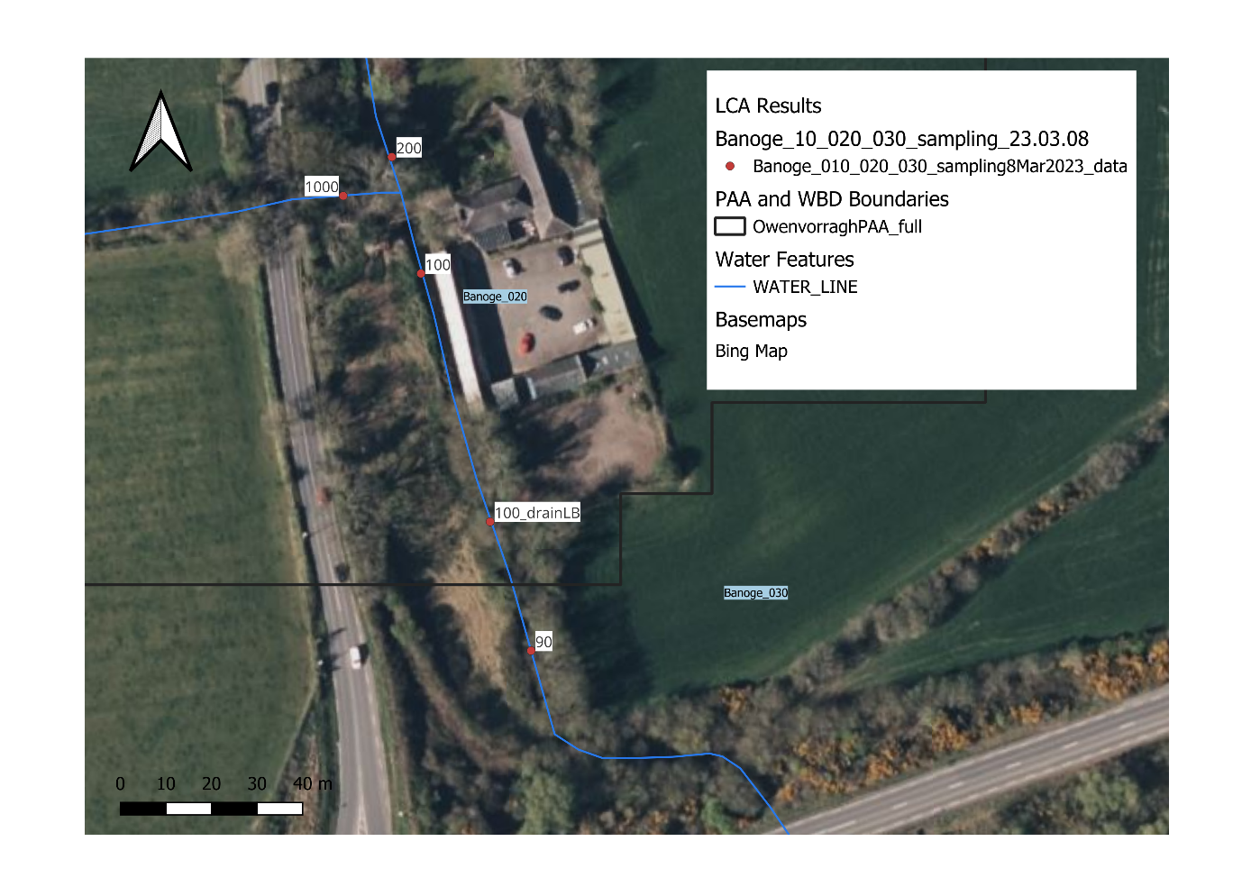
Figure 1. Map showing the locations where water chemistry samples were collected on the 08.03.202

