Awbeg (Buttevant)(West)_010
(Awbeg (Buttevant)(West) Priority Area for Action)
Fieldwork and Referral Report

Document Control Sheet
LAWPRO Office | South West
Document Title | Awbeg (Buttevant)(West)_010 LCA and Referral Report
Document No. | D01

Contents | No. of Pages | No. of Appendices
Contents | 9 | 1
Date | Version | Status | Author |  | Reviewer
03/04/2023 | D01 | Draft | David Hegarty | 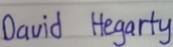

Table of Contents
Introduction 2
1 Desktop Assessment Findings 2
1.1 The issues and pressures in the Awbeg (Buttevant)(West)_010 identified by the initial characterisation and deskstudy. 2
1.2 Was COA identified as a significant pressure in the initial characterisation? 2
1.3 What is the estimated pollution risk posed by the COA from the assimilative capacity calculations? 3
2 Local Catchment Assessment Findings 4
2.1 Assessments Upstream and Downstream of Liscarroll COA 4
2.2 Assessment at the WFD monitoring point 4
3 Significant Issues and pressures in Awbeg (Buttevant) (West)_010 7
3.1 Urban Wastewater 7
3.2 Agriculture 10
Appendix: 11
Assimilative Capacity 11

List of Figures
Figure 1 Liscarroll COA and LCA Sampling Locations in Awbeg (Buttevant)(West)_010 9
Figure 2 Size of the Awbeg (Buttevant)(West)_010 river in low flow conditions 11
Figure 3 Plume/aftermath in the Awbeg (Buttevant)(West)_010 river from the discharge 12
List of Tables
Table 1 LCA results at upstream and downstream of Liscarroll COA 4
Table 2 LCA results at Br SE of Sunfort 5

Introduction
This report details the findings from the local catchment assessment (LCA) carried out in Awbeg (Buttevant)(West)_010 which is part of the Awbeg (Buttevant)(West) Priority Area for Action (AFA0013). Local catchment assessment is the culmination of LAWPRO’s desk study and fieldwork findings.
The EPA App characterised the sole significant pressure as agriculture in this waterbody. However, Liscarroll Certificate of Authorisation (COA) was identified as a potential point source of nutrient/organic pollution in the LAWPRO’s desk study. Liscarroll COA is assessed below under the LAWPRO desktop assessment methodology. The LCA outcomes in relation to the specific pressure of Urban Waste Water (Liscarroll – A0323-01) are contained in this report.

Deskstudy Assessment Findings

The issues and pressures in the Awbeg (Buttevant)(West)_010 identified by the initial characterisation and deskstudy.
- The Awbeg (Buttevant)(West)_010 is At Risk of not achieving its WFD objectives.
- Ecological status, driven by invertebrate status, has been Poor since 2012. However, a Q-Value of 3-4 (Moderate) was recorded in 2021 at the Br SE of Sunfort (Operational monitoring point).
- The Awbeg (Buttevant)(West)_010 discharges into the Awbeg (Buttevant)(West)_020.
- The Awbeg river was selected as a PAA because of its value as a trout river and because it is failing to meet protected area objectives for crayfish; the lower section of Awbeg (Buttevant)(West)_020) falls within the Munster Blackwater (Cork/Waterford) SAC (Site Code 002170).
- The operational monitoring point for the waterbody is located at a Bridge South East of Sunfort. There are no chemistry data available for the Br SE of Sunfort, RS18A090300 station on Awbeg (Buttevant)(West)_010.
- The WFD app lists agriculture as the sole significant pressure on Awbeg (Buttevant) (West)_010. Liscarroll wastewater treatment plant (CoA) also needed to be assessed as a potential point source of phosphate and other nutrients; the initial characterisation storyboard for Awbeg (Buttevant)(West)_010 included comments from the EPA biologist in relation “Liscarroll COA is operating under capacity, but biology was poor in previous cycles and receiving waterbody has deteriorated to poor status”. As there are no water chemistry data available, it is difficult to know which pollutant is impacting the invertebrates here.

Was COA identified as a significant pressure in the initial characterisation?
No. The WFD app lists agriculture as the sole significant pressure on Awbeg (Buttevant) (West)_010. However, Liscarroll wastewater treatment plant (CoA) also needed to be assessed as a potential significant pressure (point source of phosphate and other nutrients); the initial characterisation storyboard for Awbeg (Buttevant)(West)_010 included comments from the EPA biologist in relation to observed issues with the plant.

What is the estimated pollution risk posed by the COA from the assimilative capacity calculations?
We estimated the pollution risk from Liscarroll COA at the WFD monitoring point, Br SE of Sunfort, using 95%ile flow, *estimated effluent data and notional clean background upstream water quality data. In this modelled scenario the discharge consumed 100% of the available headroom for Ortho-phosphate and 230% of the available headroom for Total Ammonia (Appendix) at 95%ile flow. At mean flow 30%ile the CoA uses <50% of the headroom for both ortho-phosphate and ammonia at 12% and 28% respectively using a notionally clean background.
Based on this assessment, at low flow conditions, Liscarroll COA is using all of the available headroom capacity for both Ortho-phosphate and Total Ammonia at the nearest WFD monitoring point. However, the effluent discharge from the COA is unlikely to be a significantly impacting at the monitoring site (Br SE of Sunfort) during meanflow conditions.
(*there are no nutrient discharge data available for Liscarroll CoA)
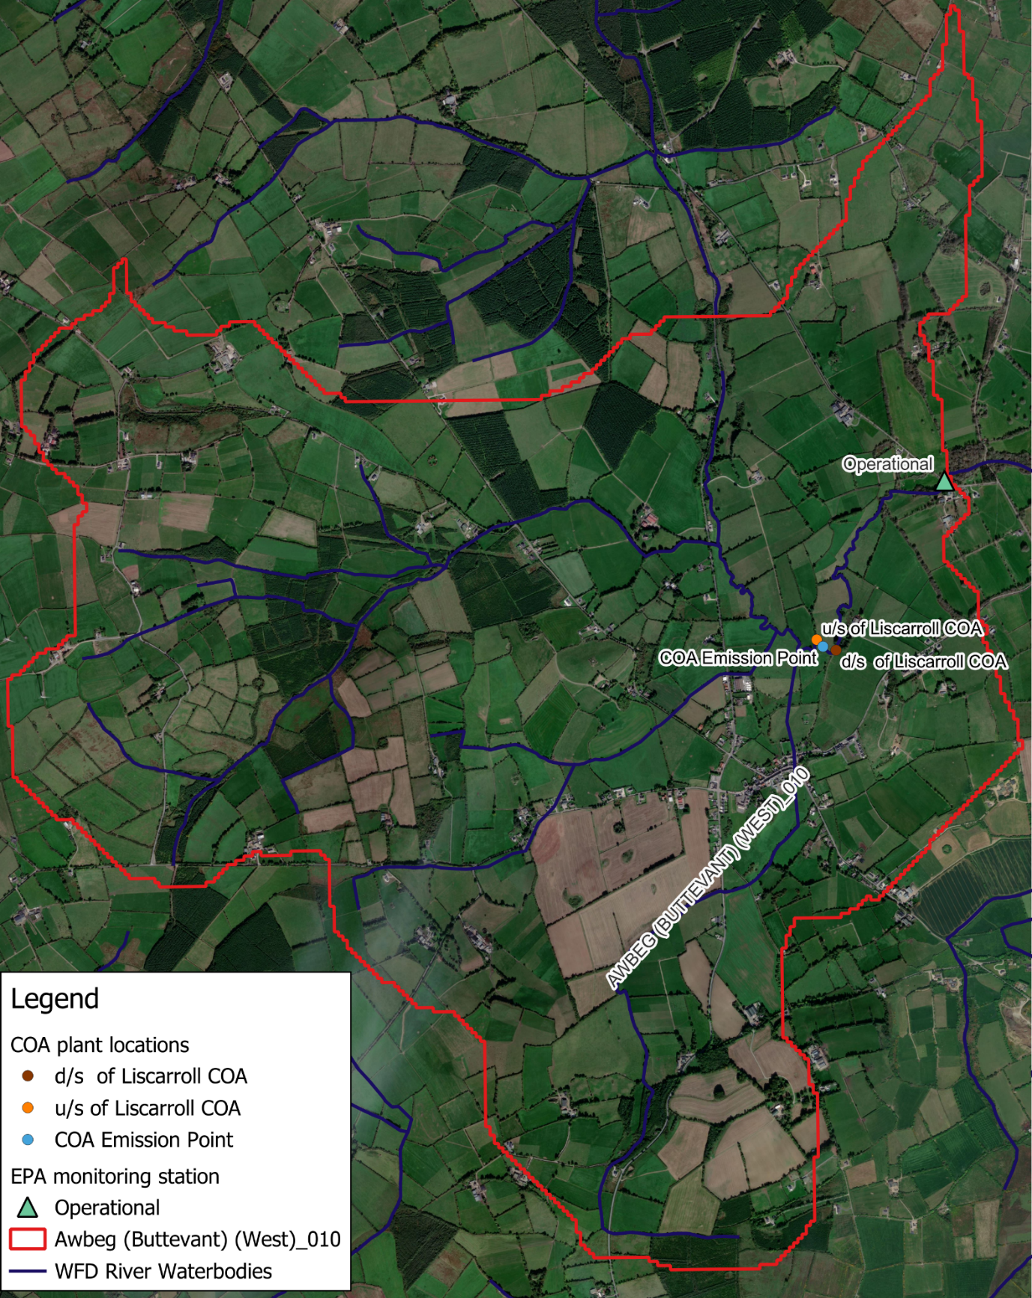Figure 1 Liscarroll COA and LCA Sampling Locations in Awbeg (Buttevant)(West)_010

Local Catchment Assessment Findings

Assessments Upstream and Downstream of Liscarroll COA
SSIS was carried out upstream and downstream of the primary discharge point of the COA plant on two occasions. It was not possible to determine whether the discharge from the COA plant in Liscarroll was having a significant impact using SISS due to historical hydromorphological impacts.
Table 1 LCA results at upstream and downstream of Liscarroll COA
Water chemistry samples were taken upstream and downstream of the primary discharge emission point on 29th of September 2020, 4th of March 2021 and 7th April 2021. The March and April results show significant increases in ammonia levels between u/s and d/s of the discharge point with the April result showing a fourfold increase. These are attributed to the Liscarroll COA discharge.
The Liscarroll COA discharges approximately 1.3km upstream of the monitoring point (Br SE of Sunfort). There are no contributing tributaries between the discharge and the monitoring point (Br SE of Sunfort). There is a proximity issue here and a risk that if the plant malfunctions it will cause problems at the monitoring point. Chemistry sample results are indicative of impact downstream of the discharge.

Assessment at the WFD monitoring point
Assessments were carried out at the Awbeg (Buttevant)(West)_010 operational monitoring point on six occasions between 2019 and 2021 (Table 2). The SSIS results in June 2019 and August 2021 were both Probably Impacted. Water chemistry sampling found Ortho-phosphate in exceedance of the Good Status EQS in September 2020 and January 2021 and both Ortho-phosphate and Total Ammonia in exceedance in March 2021.
Table 2 LCA results at Br SE of Sunfort
The results from the LCA showed that Awbeg (Buttevant)(West)_010 was impacted at the monitoring point with Ortho-phosphate and Total Ammonia being significant issues. Water chemistry results also indicate that the elevated concentrations of these nutrients recorded at the monitoring point may be due to the emission from Liscarroll COA.

Significant Issues and pressures in Awbeg (Buttevant) (West)_010

Urban Wastewater
The COA plant in Liscarroll has been identified as a significant pressure in Awbeg (Buttevant)(West)_010. LCA field assessment found nutrients levels significantly higher downstream of the primary discharge point from Liscarroll CoA compared with upstream, particularly for ammonia in the March and April samples. This along with assimilative capacity calculations to assess risk of impact at the MP, indicates that the discharge from Liscarroll CoA is having an impact on the water quality of Awbeg (Buttevant)(West)_010 particularly in low flow conditions for ortho-phosphate and ammonia (see Appendix).The size of the river can be seen in figure 2 in low flow and figure 3 shows the plume/aftermath in the river from the discharge.
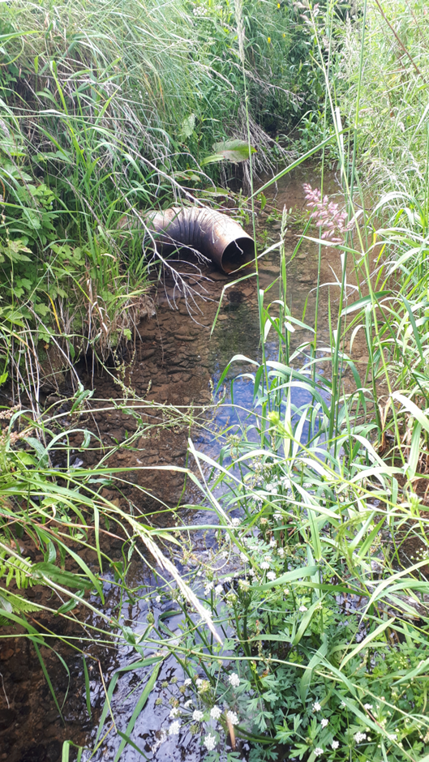
Figure 2 Size of the Awbeg (Buttevant)(West)_010 river in low flow conditions
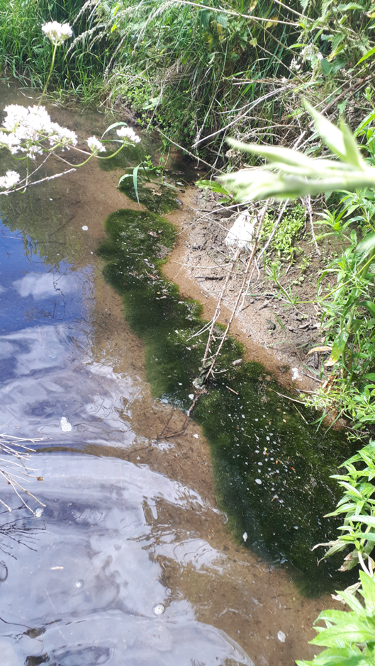
Figure 3 Plume/aftermath in the Awbeg (Buttevant)(West)_010 river from the discharge

Agriculture
LCA fieldwork upstream of the primary discharge point from Liscaroll CoA found that nutrients are a significant issue coming from agricultural diffuse and point sources. Referrals to ASSAP have been made in respect of the agricultural pressure.

Conclusion
The Liscarroll CoA is having a direct impact on water quality in Awbeg (Buttevant)(West)_010. Although, there are significant nutrient issues associated with agriculture upstream of the CoA, the LCA has shown that Liscarroll CoA is contributing to the elevated concentrations of phosphate and ammonia at the monitoring point Br SE of Sunfort in low flow and potentially impacting the biological quality driving status for Awbeg (Buttevant)(West)_010.

Appendix:

Assimilative Capacity

