Office Notes
(Different coloured font indicated a different note)

From: Dunne, Seamus <Seamus.Dunne@agriculture.gov.ie>
Sent: 21 February 2024 16:17
To: ForestryInspectors <ForestryInspectors@agriculture.gov.ie>
Subject: Office Note 21/02/2024 Policy in relation to Refusal of Applications

To all staff
Forestry Inspectorate

Under the current Forest Programme, there are a range of ineligible areas such as Special Protection Areas, High Likelihood Nesting Areas, Curlew 1.5km buffer, Top 8 Freshwater Pearl Mussel areas. There will also be some ineligible areas as a result of the new environmental considerations regarding peat, High Nature Value Farmland, Breeding Waders, hen harrier, etc.

Consequently, there will be instances where an application will have to be refused in its entirety.

In such cases, where an application is deemed ineligible, only the specific report detailing the refusal is required, no other assessment is required to be undertaken.

So for example if the entire application is to be refused because of peat, the file stops there and it certified recommended for refusal due to the peat issue and is not sent for further assessment. And likewise if the file is referred to ecology and the entire area is deemed ineligible due to a breeding wader concern, no other ecological assessments are carried out.

Note that it is policy that non grant aided licence applications must adhere to the same rules as grant aided applications.

Séamus

Séamus Dunne
Head of Forestry Inspectorate

An Roinn Talmhaíochta, Bia agus Mara
Department of Agriculture, Food and the Marine

An Teach Talmhaíochta, Sráid Chill Dara, Baile Átha Cliath 2, D02 WK12
Agriculture House, Kildare Street, Dublin 2, D02 WK12

M +353 (0)87 2515524 T +353 (0)1 607 2275

gov.ie - Department of Agriculture, Food and the Marine (www.gov.ie)

Please note that I may send emails out of hours at times that suit me and I do not expect anyone to respond to these outside of their own working hours.

From: Dunne, Seamus <Seamus.Dunne@agriculture.gov.ie>
Sent: 14 February 2024 18:18
Subject: Office Note 14/02/2024 - Relying on Information from the applicant

To all staff
Forestry inspectorate

In order to grant a licence we must be satisfied that the information provided by the Applicant, including by the Registered Forester as their agent, and supplemented by any required maps and reports, such as habitat maps, biodiversity maps, harvest plans or ecology reports etc. are up to standard and can be relied upon.

Where they are not up to standard or otherwise cannot be relied upon, a decision cannot be made until this information gap is filled either by us carrying out the necessary work to fill this gap or by way of seeking this information from the Applicant or their agent.

Where the information provided –

- accords with the details prescribed in the Forestry Act 2014 and the Forestry Regulations 2017 (as amended) and where these requirements are expanded upon or further clarified in relevant SOPs, Circulars and/or policy or scheme documents; and
- is otherwise up to standard, of good quality and can be relied upon,

a field inspection may be carried out to verify that the information received is accurate, but it is not a requirement and such files can be processed in the absence of a field inspection.

Where a field inspection is not carried out it needs to be clear on the file that a field inspection was not carried out and any decision made was made based on an assessment of the information provided.

Where a file is being referred to Ecology having been screened in for Appropriate Assessment it is important to note on the file whether the file has received a field inspection. A field inspection is not a mandatory requirement where a file is being screened in for Appropriate Assessment, nor is it a mandatory requirement when the file is being screened out. Where a file is being referred to Ecology the information on the file must be deemed to be of good quality and complete by the District Inspector.

Regards

Séamus

Séamus Dunne
Head of Forestry Inspectorate

An Roinn Talmhaíochta, Bia agus Mara
Department of Agriculture, Food and the Marine

An Teach Talmhaíochta, Sráid Chill Dara, Baile Átha Cliath 2, D02 WK12
Agriculture House, Kildare Street, Dublin 2, D02 WK12

M +353 (0)87 2515524 T +353 (0)1 607 2275

gov.ie - Department of Agriculture, Food and the Marine (www.gov.ie)

Please note that I may send emails out of hours at times that suit me and I do not expect anyone to respond to these outside of their own working hours.

From: Dunne, Seamus <Seamus.Dunne@agriculture.gov.ie>
Sent: 13 February 2024 12:45
Subject: Office Note 13/2/2024 - Revised section ‘Other biodiversity considerations’ in the Environmental Requirements for Afforestation

To all staff
Forestry Inspectorate

Please note the following revision of the ‘Other biodiversity considerations’ section on page 13 of the Environmental Requirements for Afforestation (v.31Aug23). This revised text replaces that section in its entirety, and is introduced with immediate effect. It will be included in the next published version of the Environment Requirements document. A circular to the trade will issue shortly.

In advance of an updated document being made public please send any queries or suggestions regarding any aspect of the Requirements document, to Kevin Collins, cc-ing your Line Manager and Grade 1.

Regards,

Séamus

REVISED TEXT:

Other biodiversity considerations
Other biodiversity issues can arise that are not directly addressed by the Environmental Considerations and that may, in some cases, require a specific report. For example:
- If applications are within the range of the Marsh Fritillary butterfly and a field assessment identifies that an area may be potential habitat, a survey for Marsh Fritillary is required. Potential habitat is indicated by the presence of Devil’s Bit Scabious between ankle and knee height. If larval webs are found, the area is excluded from the application.
- If applications are within the range of the Kerry Slug (sandstone geology in West Cork or Kerry) and a field assessment identifies that an area may be potential habitat, a survey for Kerry slug is required. If the species is found to be present, a derogation licence from NPWS will be required.
- If applications contain old buildings or underground places such as souterrains, caves and mines, they may be potential bat habitats. This should be considered and incorporated into the project design. Other features within applications that may be utilised by bats, either as roosting, foraging or for commuting, include existing mature trees, areas of scrub, hedgerows, and aquatic zones and their associated setbacks. The Afforestation Scheme includes provisions to retain/enhance these features, and this will also prove beneficial to bats. The design of the proposed afforestation project should look to increase connectivity within the project area, where possible e.g. linkage of open areas both within the project area itself and to areas outside, or enhanced setbacks along hedgerows.
- In relation to aquatic habitats and aquatic species, or species that depend on aquatic habitats (some of which may be protected under Annex II or Annex IV of the Habitats Directive), measures to protect water quality will also provide protection to these species and habitats. As such, a specific ecology report is not required to be submitted with the application.
- If there is a population of a species protected under the Flora (Protection) Order 2022 (S.I. of 2022) known to be present within the application, then an Ecology survey may be required. See the NPWS Flora Protection Order (FPO) Map Viewer for more information (Maps and Data | National Parks & Wildlife Service (npws.ie))

end

Séamus Dunne
Head of Forestry Inspectorate

An Roinn Talmhaíochta, Bia agus Mara
Department of Agriculture, Food and the Marine

An Teach Talmhaíochta, Sráid Chill Dara, Baile Átha Cliath 2, D02 WK12
Agriculture House, Kildare Street, Dublin 2, D02 WK12

M +353 (0)87 2515524 T +353 (0)1 607 2275

gov.ie - Department of Agriculture, Food and the Marine (www.gov.ie)

Please note that I may send emails out of hours at times that suit me and I do not expect anyone to respond to these outside of their own working hours.

From: Dunne, Seamus <Seamus.Dunne@agriculture.gov.ie>
Sent: 13 February 2024 17:16
Subject: Office Note 13/02/2024 (2) Revision of screening procedures for District Inspectors

To all staff
Forestry Inspectorate
In order to increase efficiencies and decrease duplication of effort, there is a change, with immediate effect, to the procedure applied by District Inspectors in relation to screening for Appropriate Assessment.
To date, District Inspectors were required to screen all European sites within a 15 km radius of the project and any other European sites further afield, as appropriate. Taking each site in turn, the DI screens it in or out, based on the likelihood of a significant effect arising from the project, alone and / or in combination with other plans and projects.
Under the new procedure, the DI commences the screening procedure as before. However, if the DI encounters a European Site where the likelihood of a significant effect cannot be ruled out, when considering the project alone, the DI’s involvement in the screening process ceases and the DI refers the file to Ecology without the need for an in-combination report or any further screening of any of the remaining European Sites. In this case, there will be one European Site ‘Screened In’ based solely on the ‘alone’ finding. Assuming this occurred for the first European Site looked at, the remaining European Sites will be labelled ‘On Hold’.
In light of this change and to maximise efficiency, DIs must first look at those European Sites where onsite and project-specific issues are most likely to arise that would trigger a screening in decision based solely on the ‘alone’ finding (e.g. based on hydrological connectivity). If the first European site screened does not screen in alone, the DI proceeds to screen the next European Site most likely to be screened in solely based on the ‘alone’ finding, and so on, until s/he either:
- encounters a European Site where the likelihood of a significant effect cannot be ruled out, when considering the project alone (and the application is referred to Ecology); or
- rules out the likelihood of a significant effect on each successive European Site, both alone and in-combination, and concludes with a screen out decision for all of the European Sites involved, and hence, the project itself.
In relation to the in-combination report:
- In the case where a European Site screens in ‘alone’ and the file is to be referred to Ecology, DIs do not request an in-combination statement.
- The only time a DI requests the screening-stage in-combination report(*) is when s/he has ruled out the likelihood of a significant effect alone, for all of the European Sites. Once the report is received and assuming no issues arise from the information therein, the likelihood of a significant effect in-combination can be ruled out for each European Site. With the alone and in-combination elements in place, the DI can then screen out each European Site and hence, the project itself.
(* Note, a DI should never request an AA-stage in-combination report. This report will only ever be requested by Ecology.)
Finally:
- If the DI screens out all European Sites, the DI can continue to process the file towards a final certification.
- As before, if a file is referred to Ecology, Ecology completes the screening and undertakes the AA, if required. Once returned to the DI after Ecology has finished its assessment, the output from Ecology must be incorporated into the onward processing of the file, and any mitigations specified by Ecology must be incorporated into the conditions of approval (if the project is approved).
Changes to iFORIS will be going live on the 28th of February to allow DIs to certify files off their worklist where the screening for some European sites is ON HOLD but where the relevant AA documentation is on file from Ecology.
Should you have any queries or suggestions regarding the above, please e-mail Kevin Collins, cc-ing your Line Manager.
Séamus

Séamus Dunne
Head of Forestry Inspectorate

An Roinn Talmhaíochta, Bia agus Mara
Department of Agriculture, Food and the Marine

An Teach Talmhaíochta, Sráid Chill Dara, Baile Átha Cliath 2, D02 WK12
Agriculture House, Kildare Street, Dublin 2, D02 WK12

M +353 (0)87 2515524 T +353 (0)1 607 2275

gov.ie - Department of Agriculture, Food and the Marine (www.gov.ie)

Please note that I may send emails out of hours at times that suit me and I do not expect anyone to respond to these outside of their own working hours.

From: Dunne, Seamus <Seamus.Dunne@agriculture.gov.ie>
Sent: 19 December 2024 18:27
Subject: Office Note 19/12/24 - Licence applications & Gas Network Referrals

To All staff
Forestry Inspectorate

Re: Licence applications & Gas Network Infrastructure referrals

As part of licence application assessment process, Forestry Inspectors are required to check any application area overlap with infrastructural installations including ESB or Gas Networks. In the case of Gas Networks, the iFORIS map viewer includes a spatial layer which identifies all gas pipelines making up Gas Networks Ireland infrastructure., see screenshot below.

If an application is adjoining (i.e. within 15 m) or overlaps a gas line, the application must be referred to Gas Networks Ireland (GNI). GNI will respond within 2 weeks. If no response is received from GNI within the 2 week referral period, Forestry Inspectors may proceed and process the file towards certification in the normal way etc .

Please ensure to screen all application areas for the presence of GNI infrastructure and initiate referrals (via request to admin colleagues) where appropriate as outlined above.

Note at the Spatial Analysis report for Felling, Afforestation and Forest Roads now identifies when an intersections with a 15 m buffer around the Gas Networks Pipeline and the project area occurs facilitating these checks.

Sincerely

Séamus Dunne

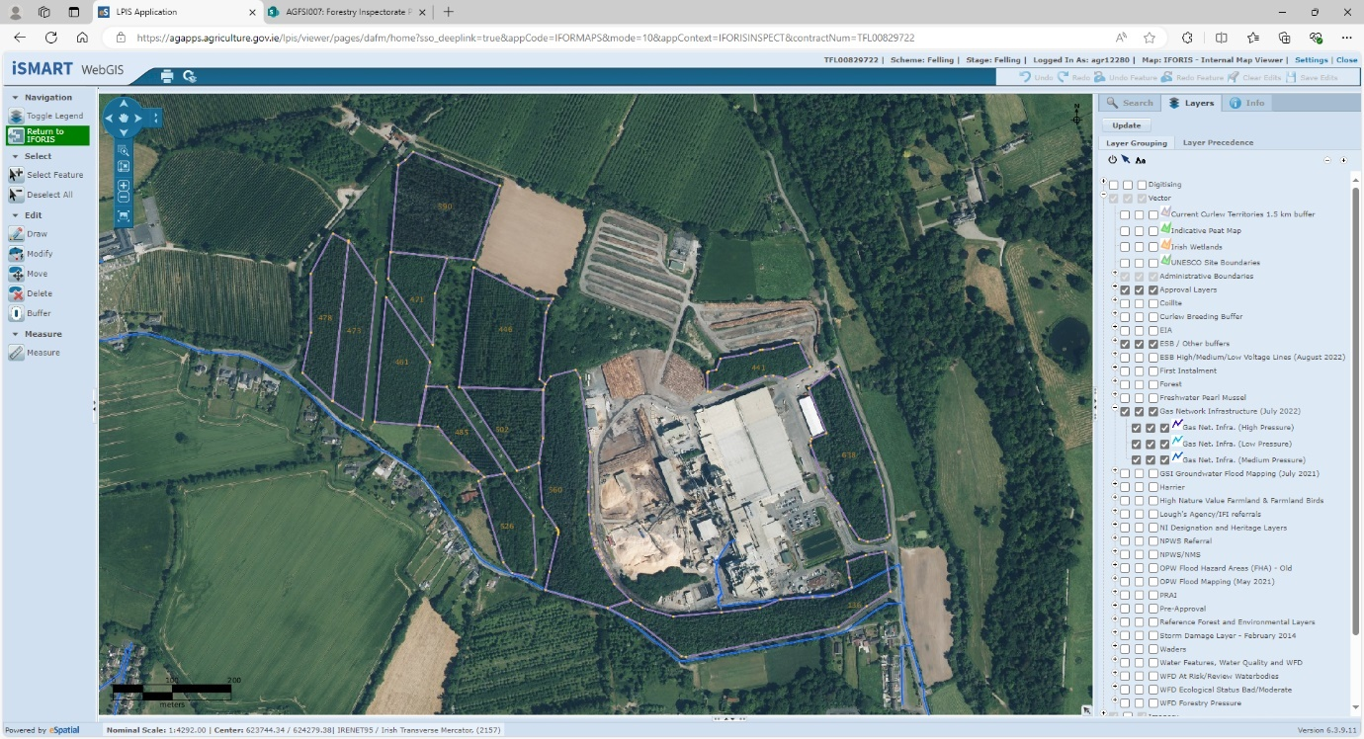

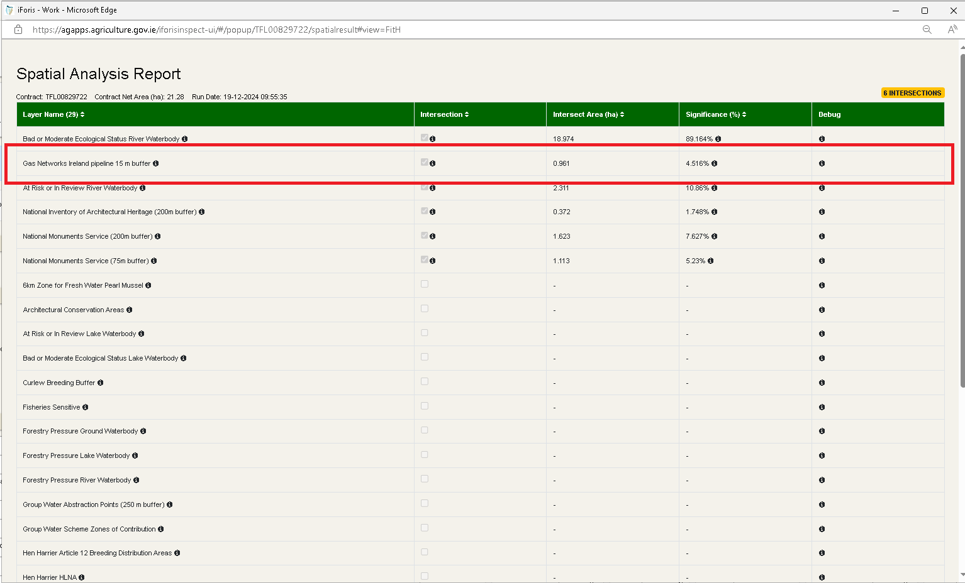

Séamus Dunne
Head of Forestry Inspectorate

An Roinn Talmhaíochta, Bia agus Mara
Department of Agriculture, Food and the Marine

An Teach Talmhaíochta, Sráid Chill Dara, Baile Átha Cliath 2, D02 WK12
Agriculture House, Kildare Street, Dublin 2, D02 WK12

M +353 (0)87 2515524 T +353 (0)1 607 2275

gov.ie - Department of Agriculture, Food and the Marine (www.gov.ie)

Please note that I may send emails out of hours at times that suit me and I do not expect anyone to respond to these outside of their own working hours.

From: Dunne, Seamus <Seamus.Dunne@agriculture.gov.ie>
Sent: 13 December 2024 19:00
Subject: Office Note 13 / 12 / 2024 - PQ Response - Ash dieback as special case - Conversion to agroforestry

To All staff Forestry inspectorate
Following a query raised at the Northern District Inspectors meeting yesterday about ash dieback being allowed to be converted to agroforestry and the Ministers position that he has no plans to extend this to other forest types being converted to agroforestry, please see below PQ response from Minister McConalogue. The Felling and reforestation policy document will be updated in due course, but this is current Department policy.
Séamus

PQ Ref: 52768/23 Michael Lowry TD
To ask the Minister for Agriculture; Food and the Marine why agroforestry is an acceptable forest type option for replanting ash dieback infected sites but is not an acceptable forest type option for forest owners with conifer plantations who wish to replant with agroforestry; and if he will make a statement on the matter.
Minister Charlie McConalogue PQ Response - Date of Reply to Oireachtas 29/11/2023
Agroforestry is a land use option that is positive for animal welfare, improves biodiversity, reduces on farm emissions, and can prevent nutrient runoff when situated in strategic locations. In addition, it is possible to grow timber with little impact on existing agricultural production. Agroforestry was first introduced to Ireland’s forestry support schemes in 2015 and the measure mainly targeted silvopastoral systems which combine forestry and pasture, including grazing and the growing of fodder.
The new forestry Programme provides for increased incentives for landowners to convert some of their agricultural land to agroforestry. However, the conversion of existing forest land to agroforestry is not a policy objective of my Department, nor is it a strategic action in my Departments Forestry Strategy Implementation Plan.
Owners of ash forests affected by ash dieback are treated as a special case and my Department has allowed, on a case by case basis, and in accordance with my Departments Felling and Reforestation Policy (2017), the conversion of ash forests devastated by ash dieback to be replanted under an agroforestry regime. There are no plans to extend this provision to other forest types.

end

