■■■■■■■■,
■■■■,
■■■■,
■■■■,
■■■■,
■■■■■■■■
Date 20/11/23

Re: Compliance with conditions attached to Section 4 discharge licence reference WPL 11: Garden Village, grant date 11th December 1991 issued under Local Government (Water Pollution) Act 1977 (as amended).

A chara,

A council inspection of the wastewater treatment plant serving Garden Village on the 24th October 2023 found the plant to be in a state of disrepair. The plant was not aerating and a sample of effluent could not be taken because the discharge pipe was broken. The effluent was instead flowing overland through forest undergrowth were access was not possible. The effluent was grey in appearance and had a septic odour and a grey plume was evident in the Ballyronan Stream along the bank where the effluent was seeping through the forest. A sample of from the river could not be taken due to poor access and waterlogged conditions downstream of the effluent seep through the forest.

We did not receive a response to our letter of 23/02/23 which also highlighted non-compliant effluent and looked for a response within one month of that date. We also requested that your compliance monitoring results be submitted as per the discharge licence conditions for this site. None have been received to date. The ongoing issues with treatment plant performance, broken discharge pipe, safe access to sample the Ballyronan Stream and the submission of your compliance monitoring data should receive your immediate attention to ensure the issues are resolved without delay and measures put in place to prevent a recurrence.

If the council does not receive a satisfactory response to these issues within 1 month of this notice the council will have no option but to commence legal proceedings under the water pollution act.

Is mise le meas,

_______________

Cc Brendan Fay at bfay@turbine.ie
Inl: Photos of grey effluent discharge to forest and river

Photo 1, taken 24/10/23: Broken Discharge pipe with grey effluent flowing through forest to river.
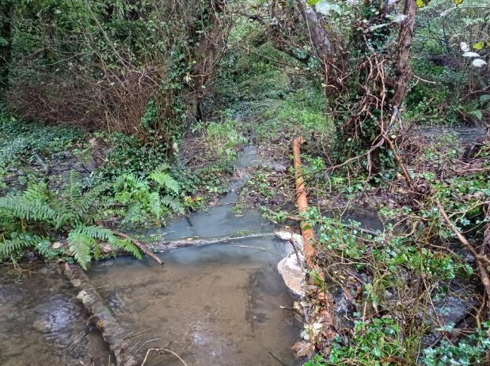

Photo 2, taken 24/10/23: A second effluent flow through the forest adjacent to the Ballynan Stream
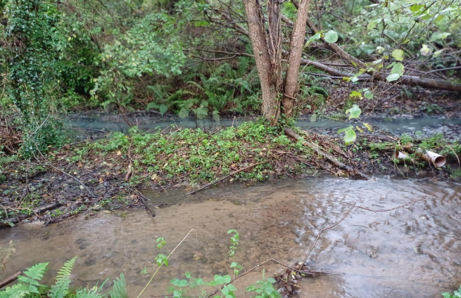

Photo 3, Taken 24/10/23: Second discharge of grey effluent from forest with grey plume in river.
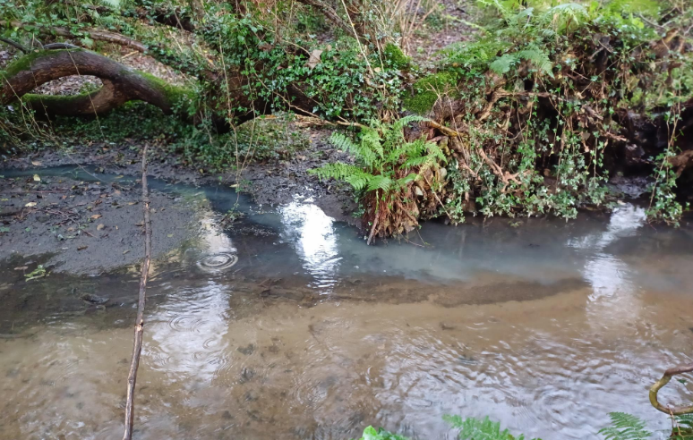

Photo 4, Taken 24/10/23 Grey plume of sewage effluent in river downstream of forest seep.
