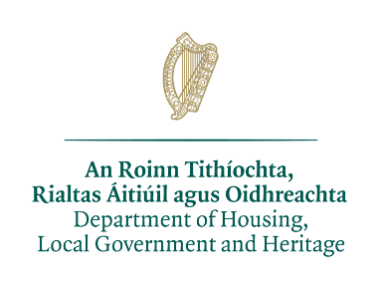

Date: 09/05/2022
Contract Number: CN90607

Reconstitution and Underplanting Scheme (Ash Dieback). Contract Number; CN90607 DRUMABODEN, TAWNEY LOWER.
A Chara,
On behalf of the Department of Housing, Local Government and Heritage, I refer to correspondence received from the Forest Service of the Department of Agriculture, Food and the Marine in connection with the above application.

The Department has reviewed the proposal and has the following comments to make on it.

It is noted that the location of the proposed Reconstitution and Underplanting Scheme is situated within/adjacent to/in a location likely to impact on Leannan River SAC Site Code (002176) and Lough Fern SPA Site Code (004060)

The Qualifying Interests for Leannan River SAC that may be impacted upon by the Reconstitution and Underplanting Scheme are “Ologotrophic Waters (3110); Margaritifera Margaritifera (1029); Salmo salar (1106); Najas flexilis (1833).

We consider that the information submitted does not allay our concerns in relation to
- the impact of Reconstitution and Underplanting Scheme on species of Flora and Fauna.
- the potential negative impact on fish, bat, bird, mammal and plant species

Therefore, it is not possible to adequately assess the impact of the proposed Reconstitution and Underplanting Scheme to Leannan River SAC. Accordingly, prior to making any decision, it is recommended that the applicant be requested to provide additional information in the form of a Full Environmental Impact Statement.

Andrew Speer – District Conservation Officer
Glenveagh National Park
An Roinn Tithíochta, Rialtais Áitiúil agus Oidhreachta
Department of Housing, Local Government and Heritage
An tSeirbhis Páirceanna Náisiúnta agus Fiadhúlra
National Parks & Wildlife Service
Glenveagh National Park, Churchill, Letterkenny, Co Donegal,
Rep of Ireland,
F92 XK02

