Fluvial Flood Forecasting System:
Met Éireann is seeking endorsement for use of the HYPE Fluvial Forecast Model, in conjunction with the FEWS integrator system as the operational fluvial flood forecasting system in the Flood Forecast Centre

Overview
The purpose of this document is to describe the HYPE Fluvial Forecast Model, and the FEWS integrator system which Met Éireann’s FFC is seeking endorsement to use as the operational fluvial flood forecasting system in the Flood Forecast Centre (FFC).

System Evaluation and Review
FFD was tasked with developing a National and Catchment scale hydrological model for the purposes of fluvial flood forecasting. Critical to providing accurate and timely forecasts is the selection of a hydrological model, which is both appropriate for Irish conditions and meets the operational requirements of the FFC. Through a tendering process, the International Marine and Dredging Consultants (IMDC; Antwerp) company were awarded a contract to identify the most appropriate hydrological model for the FFC. Following a rigorous evaluation process – which considered four vastly different hydrological models (HYPE, URBS, WRF-Hydro and wFlow) - completed in Q3 2020, IMDC identified the Hydrological Predictions for the Environment (HYPE) model as being the most suitable.
IMDC were also tasked with reviewing suitable integrator systems and making a recommendation on which system to use in the FFC. An Integrator is a software system designed to integrate various data sources and models to provide real-time flood forecasting and warning information. An initial Multi-Criteria Analysis (MCA) showed that two of the integrator systems (Delft FEWS and Mike Operations) are much more generic and suitable than the others. Therefore, it was decided to only include Delft FEWS and Mike Operations in further stages of the review. Delft FEWS was the highest scoring integrator system during the initial stages of the review. River discharge forecasts from FEWS are available to view by stakeholders on the Irish Flood Integrated Communication System (IFICS).
Through their evaluation process, IMDC set out a methodology for the development, calibration, and operational assessment of the HYPE model. Met Éireann in conjunction with IMDC built 36 Hydrometric Area models using the HYPE model. These models were calibrated using all available observations. The 36 models were then integrated into the FEWS model. It should be noted that the model is used internationally for operational flood forecasting in a number of countries including Sweden and Denmark. It is also used for operational flood forecasting at a global and continental scale.

Operational System Set Up
The HYPE model is hosted on the cloud (Microsoft Azure) and is managed using Deltares’ Delft-FEWS integrator system. Observed and forecast NWP meteorological data is input to the HYPE model. HYPE is set-up to use longer-range NWP data from the ECMWF model (7 days) alongside shorter-range (54hrs) NWP data using the higher resolution HARMONIE model. In addition, the system uses ensemble forecasts from both Met Éireann and ECMWF.

System Trial
Both the HYPE model and FEWS Integrator system were tested in the non-operational trial. The model was found to be very useful for a number of locations, but additional work is needed to improve the accuracy at other locations. Appendix 1 outlines the results of an evaluation study undertaken to assess the performance of the HYPE model during a trial of the system. This supplements a study undertaken by IMDC during the time of model development (Appendix 2 – IMDC summary report). The results of FEWS system trial is also included in Appendix 2. Several recommendations are made to improve the model and to gain more from the FEWS system. The FFC will produce a plan to address the various recommendations and implement them to improve the HYPE model and FEWS.

Preparations for the operational FFC
Met Éireann have now embedded the HYPE model into the FEWS system. It receives NWP data directly from the operational stream at ECMWF, while Harmonie data is directed from HQ.
The models are running on the cloud based FEWS system which includes geo-resilience. The forecast data from the HYPE model is now being sent directly to the IFICS and ANYWHERE systems. FFC staff have been trained in how to log on and troubleshoot issues with the FEWS. There is also a support contract from the FEWS Contractors.

Development and Maintenance
Both the IFICS and Delft-FEWS systems, which support flood forecasting communications and fluvial forecasting respectively, are cloud based, have back-up systems and are geo resilient. They are both supported by their respective contractors via an on-call facility. The IFICS and FEWS maintenance contracts will be managed and reprocured, as necessary, by the FFC.
Ongoing development work will be required to improve these systems and improve the performance of the forecasting models. Development work will be guided by performance reviews. These reviews will be conducted by Met Éireann through statistical verification and skill score analysis of the flood forecasting system over time at forecast points coinciding with the locations of reliable flow rated gauges. The HYPE model forecasts are archived to support performance assessments. It is noted that the HYPE model and the FEWS integrator system have large international user communities. The FFC will use opportunities to collaborate internationally with other users and the developers to help ensure HYPE and FEWS remain in-line with best international practices and standards.

Appendix 1: HYPE model performance during the non-operational trial
An evaluation of the HYPE hydrological model at gauged forecast points has been conducted using both observed and forecasted meteorological data. In the case of the former, the analysis provides an indication of model performance when run using observed data. This approach focuses on the hydrological model performance in isolation, without the influence of the NWP models and their associated errors and uncertainties. Conversely, assessing performance when the hydrological models are run using NWP data provides an indication of how the system performs in forecast mode - when the errors from the NWP are included along with their impact on overall performance. The latter is more relevant for the forecast information that stakeholders receive

Evaluation with observed meteorological data
Models were evaluated against observed discharge data from the OPW archive, in total 132 are used for the period 2016-2021. The performance of the model for each gauge location is best summarized using the Kling-Gupta Efficiency (KGE) criterion. However, it is important to note that a high KGE score does not necessarily mean that the model is perfect, and performance should be evaluated using multiple metrics and methods. In general, a KGE score of 0.8 or higher is considered ‘satisfactory,’ indicating a reasonable match between the modelled and observed data.
Figure 1 shows the KGE scores for all OPW gauges used in the model evaluation. Of the 132 gauged locations considered for modelling, only 23 (~20%) are classified as ‘Satisfactory’, with 72 (~55%) labelled ‘Fair’. The remaining 37 (~25%) are ‘Very Poor’ to ‘Marginal’. It is shown that several Hydrometric Areas (15) do not have gauges, which fall in either of these categories. This is due to a combination of the model not performing well for this area, and/or there may be no flow rated OPW gauges to calibrate and evaluate the model. There is an uneven distribution of well performing gauge locations, with most of the well performing gauged locations being in the Shannon, Boyne, Suir and Barrow.
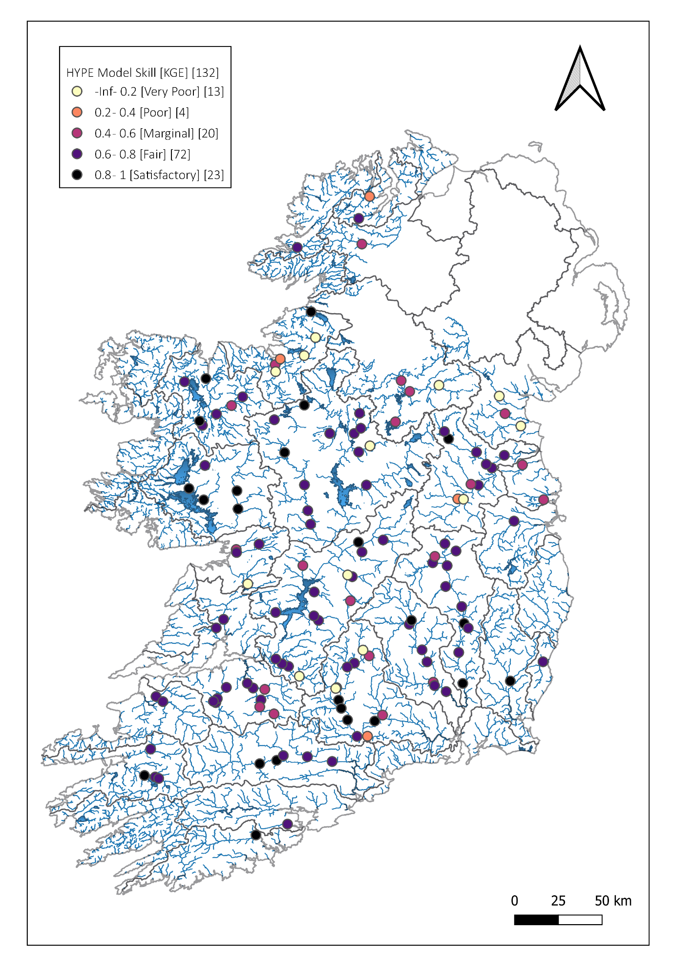
Figure 1 Kling-Gupta Efficiency (KGE) scores estimated for each gauge using observed and simulated discharge for the period 2016-2021. KGE values are calculated using the complete time series.

Verification with forecasted (NWP) meteorological data
The verification process involves comparing the predictions of the hydrological model, executed using real-time forecasts from NWP models, with historical flood events or observed data. This comparative analysis facilitates the assessment of the river flood forecasting system's overall performance when in forecast mode - in terms of reproducing the timing, magnitude, and spatial distribution of floods. This approach allows for a comprehensive evaluation of the system's effectiveness in capturing the dynamic interactions of weather events that lead to flooding.
During the trial period of the fluvial forecasting system, spanning from January 2022 to July 2023, the forecasted hydrological information was compared with observed river discharge. A dataset of 136 gauging stations obtained from the OPW archive was utilized for this evaluation. The modeling system's performance was specifically assessed when forced with real meteorological forecast data sourced from Met Éireann's Harmonie NWP model. This configuration provided a maximum lead time of 54 hours to anticipate potential flood events. For the purpose of this assessment, the modeling system's capability to forecast observed hourly river discharge within a 24-30 hour timeframe in advance was considered.
As above the performance of the system for each gauge location was summarized using the Kling-Gupta Efficiency (KGE) criterion. It is important to note that a high KGE score does not necessary indicate a high level of model precision. A diverse set of metrics is required to provide a good overall assessment of performance. It is also important to note that the verification is undertaken over a relatively short period of ~18 months, encompassing only one winter season when the majority of flood events occur. Hence there are limitations on the type of metrics which could be used and the magnitude of events considered.
Figure 2 shows the KGE scores for each of the OPW gauges used in the verification process. Of the 136 gauged locations included, 41 (~30%) are classified as ‘Satisfactory’, with 40 (~30%) labelled ‘Fair’. The remaining 37 (~40%) are ‘Very Poor’ to ‘Marginal’. Similar to the evaluation in section 5.5.1, it is evident that a number of Hydrometric Areas do not have gauges which fall in either the ‘Satisfactory’ or ‘Fair’ categories. It is evident that there are a number of areas for which better quality forecasts could be provided during the ~18 month trial period. Similar to the long term evaluation above, most of the well performing gauged locations are in the Shannon, Boyne, Suir and Barrow.
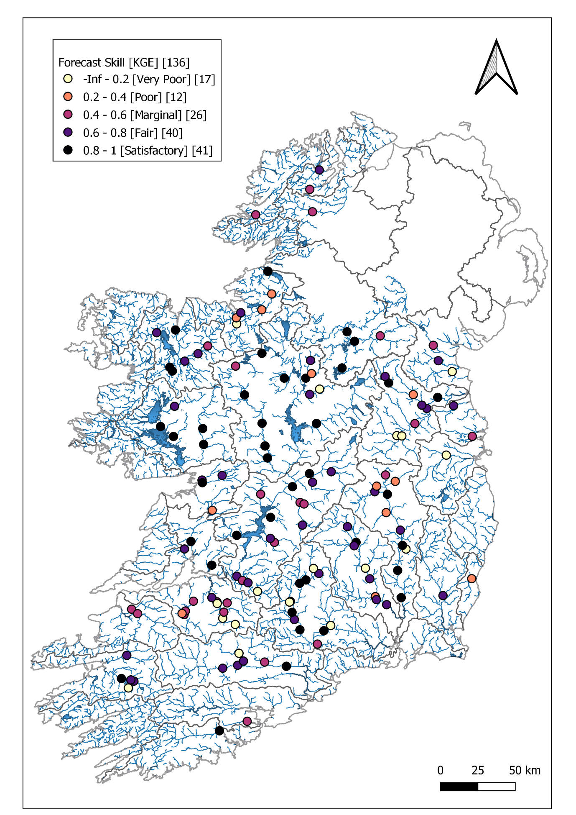
Figure 2 Kling-Gupta Efficiency (KGE) scores estimated for each gauge using observed and forecasted hourly discharge for the period January 2022 - July 2023. A comparison is made with model forecasts having a 24-30 hour lead time.

Conclusion & Recommendations
Significant progress has been made in the development of an operational national and catchment scale fluvial flood forecasting system. This includes the model selection process, the leveraging of existing observational networks, model calibration and the establishment of an operational ensemble-based system running on the cloud 24/7, capable of providing actionable forecast information to stakeholders.
It is recommended that Version II of the river forecast model is developed and continuous improvements are integrated. To provide a greater level of detail in the forecasts, it will be necessary to undertake iterative improvements to the overall forecasting system on an ongoing basis – this is the experience of the HYPE model developers (SMHI).

