Item 8 Draft Paper from MÉ for discussion

Paper to National Flood Forecast and Warning Service (NFFWS) Steering Committee: Pre-operational Phase of Met Éireann’s Flood Forecasting Centre

8 November 2023
Action for the National Flood Forecast and Warning Service (NFFWS) Steering Committee: To endorse Met Éireann’s Flood Forecasting Centre (FFC) moving to a pre-operational phase, noting that the FFC will move to an operational phase once operational staffing arrangements are finalised.
Background
In January 2016 the Government decided to establish a National Flood Forecast Warning Service (NFFWS) with an operational Flood Forecast Centre (FFC) based in Met Éireann and the OPW (Office of Public Works) providing guidance and standards via an Oversight Unit. It was decided to develop the NFFWS in a staged basis and, through the NFFWS Steering Group chaired by OPW, a Stage 1 Implementation plan was put in place. This plan set out steps for the development a Stage 1 NFFWS across a range of activities including developing forecasting capabilities and operational arrangements.
Progress to date
Met Éireann’s objectives of the Stage 1 Implementation plan have been achieved.
Met Éireann’s FFC has developed the first national scale river forecasting model for the state with capacity to model and monitor flood risk across 36 River catchments. Met Éireann successfully followed a rigorous procedure for selecting, trialling and testing these models, in line with well-established international practices and standards for national and catchment scale flood forecasting. Further technical details on this river flood forecasting system are provided in Appendix 1.
Met Éireann’s FFC has also assumed responsibility for a Tidal and Storm Surge Forecast (TSSF) Service and a related coastal flooding model previously developed by OPW. This was not operated as an operational model by OPW and required significant evaluation and development work from Met Éireann. Further details on this coastal flood forecasting system are provided in Appendix 2.
Met Éireann’s FFC have also carried out extensive engagement with identified priority stakeholders; the Local Authorities, Emergency Services, OPW and the National Directorate for Fire and Emergency Management (NDFEM), to develop and test suitable flood guidance and advisory services and products. Met Éireann have established a network of Severe Weather Liaison Managers across all local authorities and held training and engagement events focused on the development of flood guidance and advisory services. During the period Q4 2021 - Q3 2023 the FFC has undertaken a trial provision of services to priority stakeholders and continued with stakeholder training and feedback sessions.
Scope of planned pre-operational phase
Met Éireann has developed a service plan to ensure sufficiently resilient staffing arrangements to support an operational phase of the FFC. During the pre-operational phase Met Éireann will progress consultations with staff and unions to support the move to an operational phase.
During this pre-operational phase and continuing for the operational phases the FFC will maintain and operate river and coastal modelling systems and a flood information portal. The FFC will issue Daily Flood Guidance Statements, an example of which is provided in Figure 1 below, to the Local Authorities, Emergency Services, OPW and the National Directorate for Fire and Emergency Management. Additionally, when conditions require it, a River Flood Advisory or a High Tide Advisory may be issued. More detailed information on the services which the FFC will provide are outlined in a Statement of Services provided in Appendix 3.
Further Development Plans
Whilst the FFC’s forecast models have been developed and trialled in line with best international practice and standards, they have several limitations. For example, while the river models were found to be very accurate for a number of locations when trialed, the quality of river level observation records and the lack of river level observations for some areas of the country restricts the level of accuracy which can be achieved at this stage in the model development. Also, the current coastal flooding model does not incorporate wind generated swell and waves in the calculation of the total water level, rather it just combines tide effects with sea height increases resulting from low pressure levels. Awareness and understanding of these limitations is an important aspect of stakeholder training provided by the FFC.
Reviews and trials carried out to date are informing the development plans of the FCC which will focus on improving the FFC’s modelling capabilities and addressing known limitations. The evolution of the FFC’s development plans will be supported by ongoing analysis and formal annual reviews of the models’ performance.
Next Steps
FFC operational staffing arrangements will be finalised during the pre-operational phase and the FFC will then move to an operational phase.
Currently the NFFWS SG is drafting a report on Stage 1 of the NFFWS, the purpose which is to describe the progress made in Stage 1 and to identify areas for further development. A Stage 2 report is also being drafted by the NFFWS SG. This will outline a plan for the next stage in the development of the NFFWS. A memo to Government is envisaged to inform of the completion of Stage 1 and propose a Stage 2 for the NFFWS.

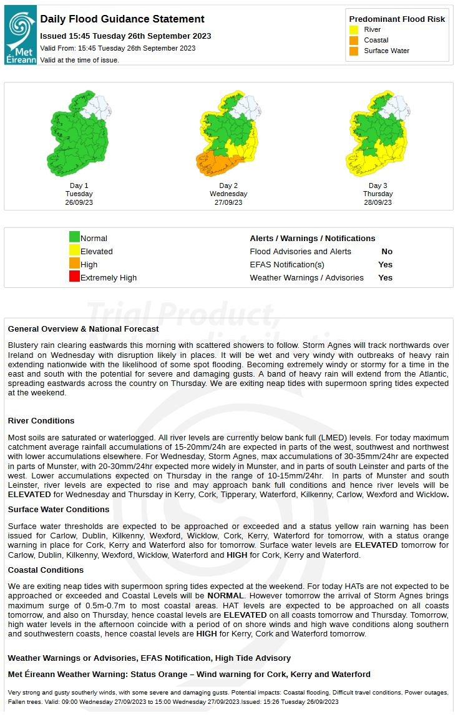
Figure 1 The Daily Flood Guidance Statement issued by the Flood Forecast Centre which gives an indication of flood risk for a 3-day period.

Appendices:
Appendix 1: River Flood Forecasting System
Appendix 2: Coastal Flood Forecasting System
Appendix 3: Statement of Services

Appendix 1: River (Fluvial) Flood Forecasting System:
Overview
The purpose of this document is to describe the HYPE Fluvial Forecast Model, and the FEWS integrator system which the FFC will use as the operational fluvial flood forecasting system in the Flood Forecast Centre (FFC).

- System Evaluation and Review
FFD was tasked with developing a National and Catchment scale hydrological model for the purposes of fluvial flood forecasting. Critical to providing accurate and timely forecasts is the selection of a hydrological model, which is both appropriate for Irish conditions and meets the operational requirements of the FFC. Through a tendering process, the International Marine and Dredging Consultants (IMDC; Antwerp) company were awarded a contract to identify the most appropriate hydrological model for the FFC. Following a rigorous evaluation process – which considered four vastly different hydrological models (HYPE, URBS, WRF-Hydro and wFlow) - completed in Q3 2020, IMDC identified the Hydrological Predictions for the Environment (HYPE) model as being the most suitable.
IMDC were also tasked with reviewing suitable integrator systems and making a recommendation on which system to use in the FFC. An Integrator is a software system designed to integrate various data sources and models to provide real-time flood forecasting and warning information. An initial Multi-Criteria Analysis (MCA) showed that two of the integrator systems (Delft FEWS and Mike Operations) are much more generic and suitable than the others. Therefore, it was decided to only include Delft FEWS and Mike Operations in further stages of the review. Delft FEWS was the highest scoring integrator system during the initial stages of the review. River discharge forecasts from FEWS are available to view by stakeholders on the Irish Flood Integrated Communication System (IFICS).
Through their evaluation process, IMDC set out a methodology for the development, calibration, and operational assessment of the HYPE model. The FFD in conjunction with IMDC built 36 Hydrometric Area models using the HYPE model. These models were calibrated using all available observations. The 36 models were then integrated into the FEWS model. It should be noted that the model is used internationally for operational flood forecasting in a number of countries including Sweden and Denmark. It is also used for operational flood forecasting at a global and continental scale.

- Operational System Set Up
The HYPE model is hosted on the cloud (Microsoft Azure) and is managed using Deltares’ Delft-FEWS integrator system. Observed and forecast NWP meteorological data is input to the HYPE model. HYPE is set-up to use longer-range NWP data from the ECMWF model (7 days) alongside shorter-range (54hrs) NWP data using the higher resolution HARMONIE model. In addition, the system uses ensemble forecasts from both Met Éireann and ECMWF.
- System Trial
Both the HYPE model and FEWS Integrator system were tested in the non-operational trial. The model was found to be very useful for a number of locations, but additional work is needed to improve the accuracy at other locations. Appendix 1.1 outlines the results of an evaluation study undertaken to assess the performance of the HYPE model during a trial of the system. This supplements a study undertaken by IMDC during the time of model development and a FEWS system trial. . Several recommendations are made to improve the model and to gain more from the FEWS system. The FFC will produce a plan to address the various recommendations and implement them to improve the HYPE model and FEWS.
- Preparations for the operational FFC
The FFD have now embedded the HYPE model into the FEWS system. It receives NWP data directly from the operational stream at ECMWF, while Harmonie data is directed from HQ.
The models are running on the cloud based FEWS system which includes geo-resilience. The forecast data from the HYPE model is now being sent directly to the IFICS and ANYWHERE systems. FFC staff have been trained in how to log on and troubleshoot issues with the FEWS. There is also a support contract from the FEWS Contractors.
- Development and Maintenance
Both the IFICS and Delft-FEWS systems, which support flood forecasting communications and fluvial forecasting respectively, are cloud based, have back-up systems and are geo resilient. They are both supported by their respective contractors via an on-call facility. The IFICS and FEWS maintenance contracts will be managed and reprocured, as necessary, by the FFC.
Ongoing development work will be required to improve these systems and improve the performance of the forecasting models. Development work will be guided by performance reviews. These reviews will be conducted by the FFD through statistical verification and skill score analysis of the flood forecasting system over time at forecast points coinciding with the locations of reliable flow rated gauges. The HYPE model forecasts are archived to support performance assessments. It is noted that the HYPE model and the FEWS integrator system have large international user communities. The FFC will use opportunities to collaborate internationally with other users and the developers to help ensure HYPE and FEWS remain in-line with best international practices and standards.
Appendix 1.1: HYPE model performance during the non-operational trial
An evaluation of the HYPE hydrological model at gauged forecast points has been conducted using both observed and forecasted meteorological data. In the case of the former, the analysis provides an indication of model performance when run using observed data. This approach focuses on the hydrological model performance in isolation, without the influence of the NWP models and their associated errors and uncertainties. Conversely, assessing performance when the hydrological models are run using NWP data provides an indication of how the system performs in forecast mode - when the errors from the NWP are included along with their impact on overall performance. The latter is more relevant for the forecast information that stakeholders receive
Evaluation with observed meteorological data
Models were evaluated against observed discharge data from the OPW archive, in total 132 are used for the period 2016-2021. The performance of the model for each gauge location is best summarized using the Kling-Gupta Efficiency (KGE) criterion. However, it is important to note that a high KGE score does not necessarily mean that the model is perfect, and performance should be evaluated using multiple metrics and methods. In general, a KGE score of 0.8 or higher is considered ‘satisfactory,’ indicating a reasonable match between the modelled and observed data.
Figure 1 shows the KGE scores for all OPW gauges used in the model evaluation. Of the 132 gauged locations considered for modelling, only 23 (~20%) are classified as ‘Satisfactory’, with 72 (~55%) labelled ‘Fair’. The remaining 37 (~25%) are ‘Very Poor’ to ‘Marginal’. It is shown that several Hydrometric Areas (15) do not have gauges, which fall in either of these categories. This is due to a combination of the model not performing well for this area, and/or there may be no flow rated OPW gauges to calibrate and evaluate the model. There is an uneven distribution of well performing gauge locations, with most of the well performing gauged locations being in the Shannon, Boyne, Suir and Barrow.
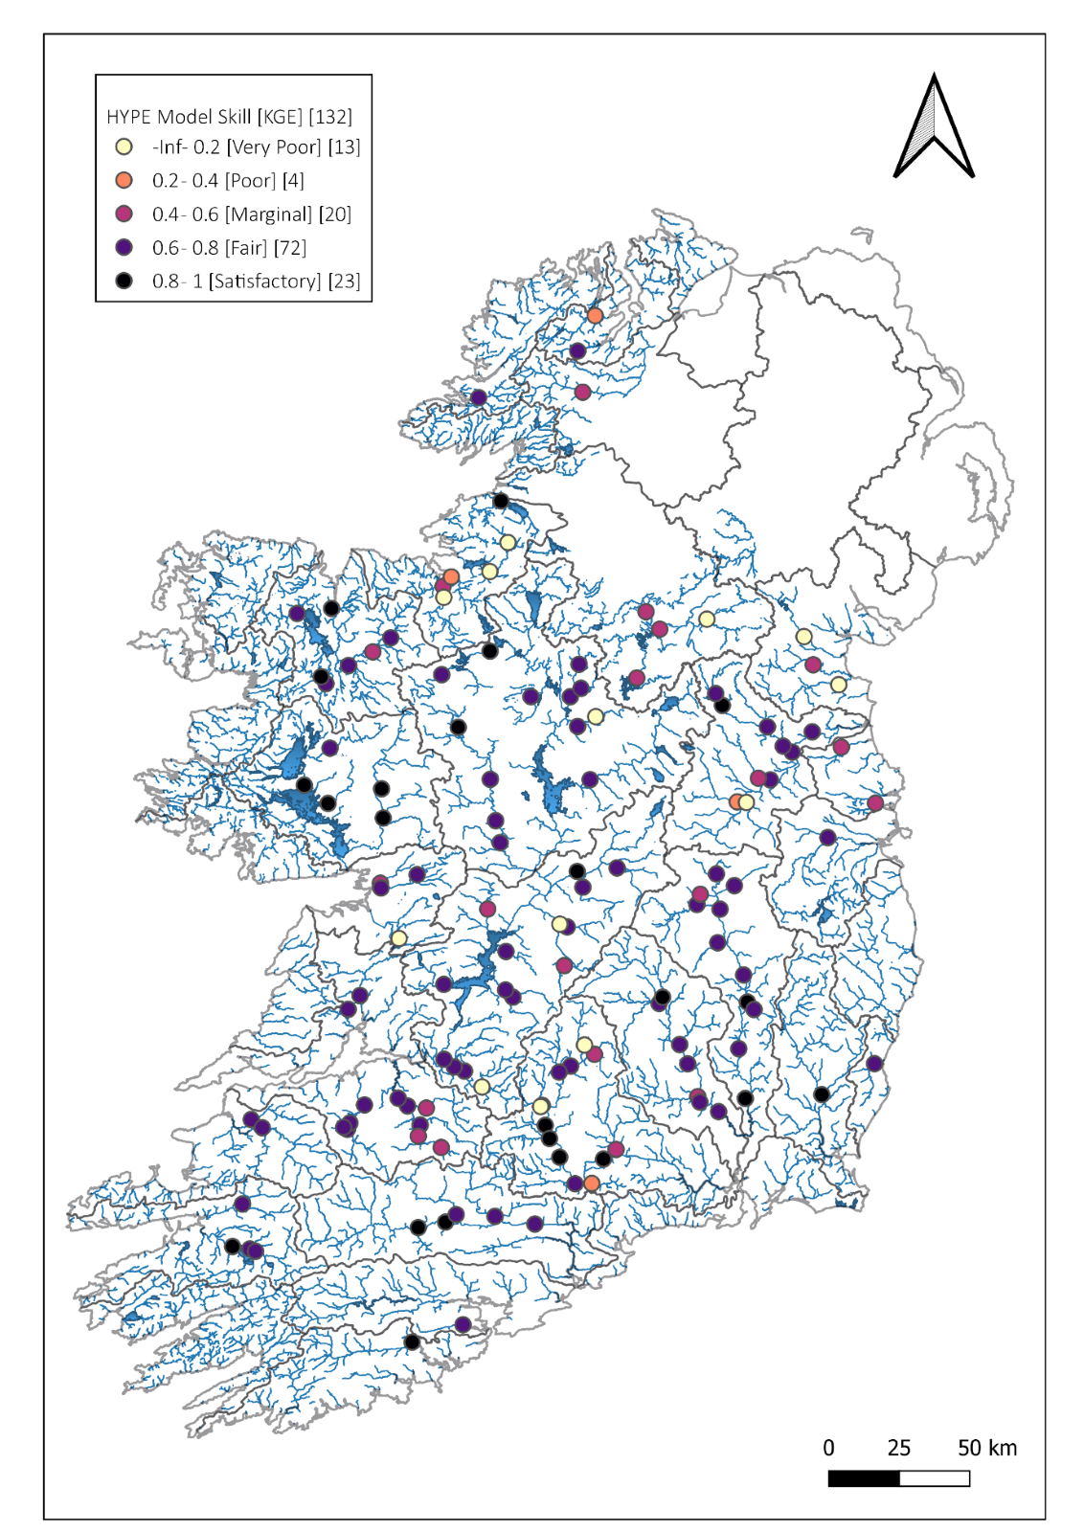
Figure 1 Kling-Gupta Efficiency (KGE) scores estimated for each gauge using observed and simulated discharge for the period 2016-2021. KGE values are calculated using the complete time series.

Verification with forecasted (NWP) meteorological data
The verification process involves comparing the predictions of the hydrological model, executed using real-time forecasts from NWP models, with historical flood events or observed data. This comparative analysis facilitates the assessment of the river flood forecasting system's overall performance when in forecast mode - in terms of reproducing the timing, magnitude, and spatial distribution of floods. This approach allows for a comprehensive evaluation of the system's effectiveness in capturing the dynamic interactions of weather events that lead to flooding.
During the trial period of the fluvial forecasting system, spanning from January 2022 to July 2023, the forecasted hydrological information was compared with observed river discharge. A dataset of 136 gauging stations obtained from the OPW archive was utilized for this evaluation. The modeling system's performance was specifically assessed when forced with real meteorological forecast data sourced from Met Éireann's Harmonie NWP model. This configuration provided a maximum lead time of 54 hours to anticipate potential flood events. For the purpose of this assessment, the modeling system's capability to forecast observed hourly river discharge within a 24-30 hour timeframe in advance was considered.
As above the performance of the system for each gauge location was summarized using the Kling-Gupta Efficiency (KGE) criterion. It is important to note that a high KGE score does not necessary indicate a high level of model precision. A diverse set of metrics is required to provide a good overall assessment of performance. It is also important to note that the verification is undertaken over a relatively short period of ~18 months, encompassing only one winter season when the majority of flood events occur. Hence there are limitations on the type of metrics which could be used and the magnitude of events considered.
Figure 2 shows the KGE scores for each of the OPW gauges used in the verification process. Of the 136 gauged locations included, 41 (~30%) are classified as ‘Satisfactory’, with 40 (~30%) labelled ‘Fair’. The remaining 37 (~40%) are ‘Very Poor’ to ‘Marginal’. Similar to the evaluation in section 5.5.1, it is evident that a number of Hydrometric Areas do not have gauges which fall in either the ‘Satisfactory’ or ‘Fair’ categories. It is evident that there are a number of areas for which better quality forecasts could be provided during the ~18 month trial period. Similar to the long term evaluation above, most of the well performing gauged locations are in the Shannon, Boyne, Suir and Barrow.
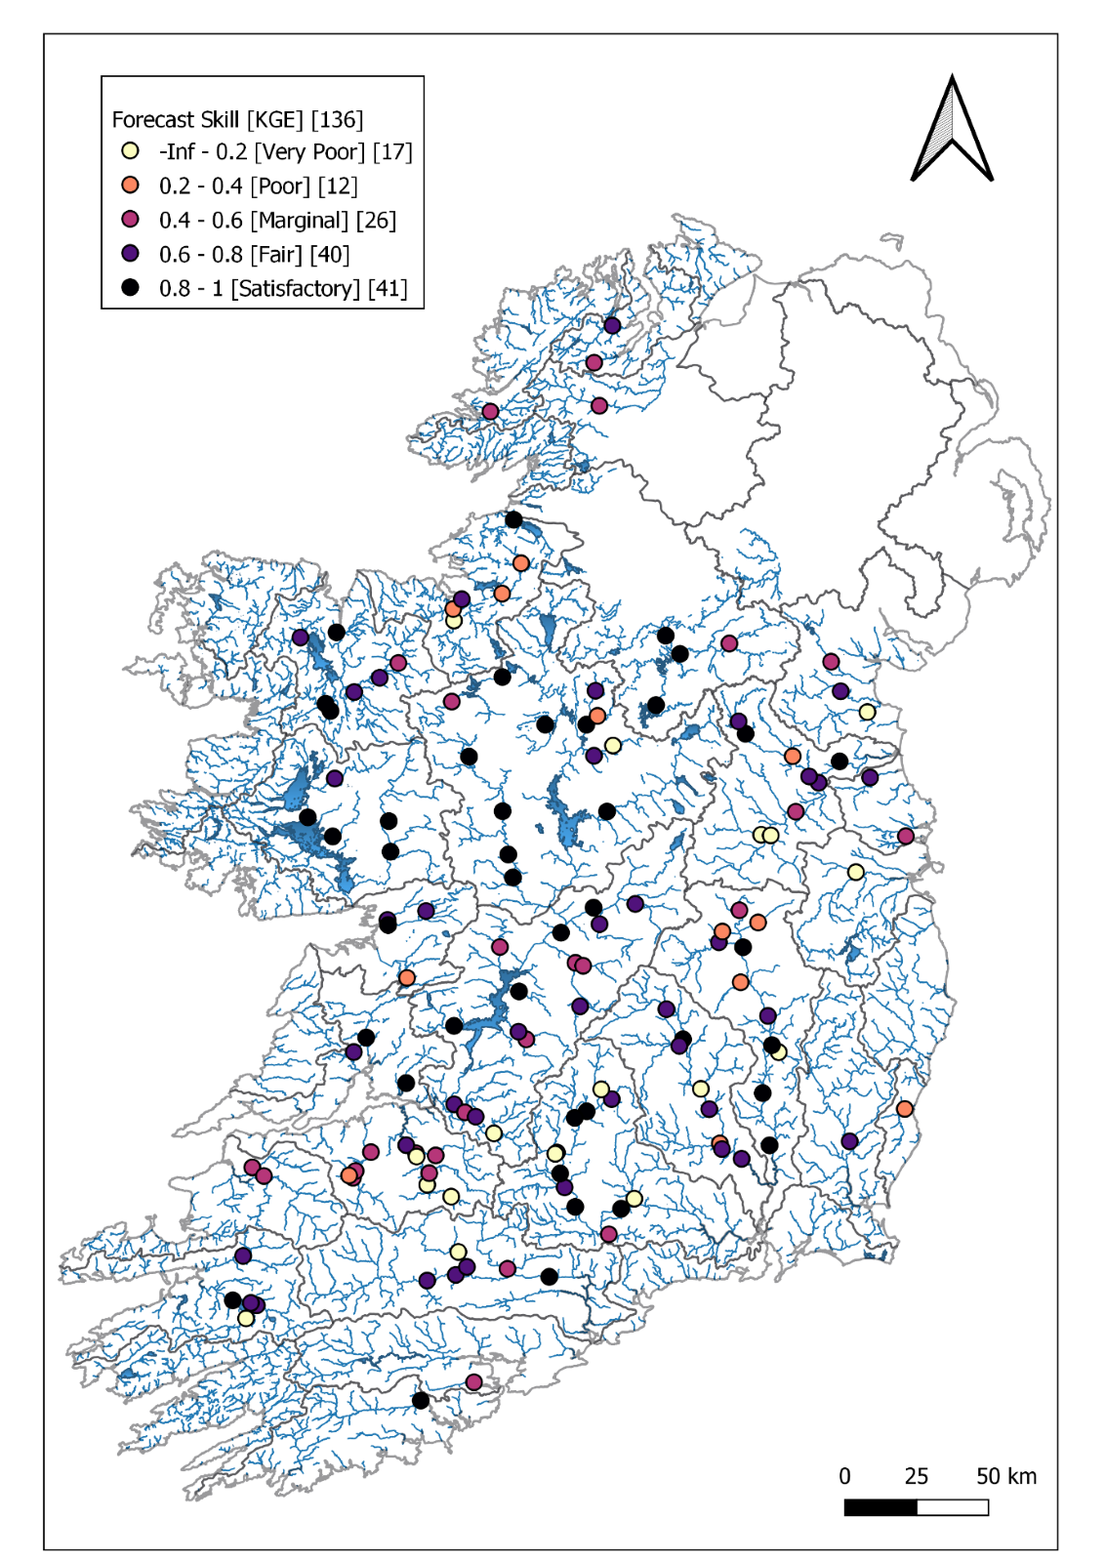
Figure 2 Kling-Gupta Efficiency (KGE) scores estimated for each gauge using observed and forecasted hourly discharge for the period January 2022 - July 2023. A comparison is made with model forecasts having a 24-30 hour lead time.

Conclusion & Recommendations
Significant progress has been made in the development of an operational national and catchment scale fluvial flood forecasting system. This includes the model selection process, the leveraging of existing observational networks, model calibration and the establishment of an operational ensemble-based system running on the cloud 24/7, capable of providing actionable forecast information to stakeholders.
It is recommended that Version II of the river forecast model is developed and continuous improvements are integrated. To provide a greater level of detail in the forecasts, it will be necessary to undertake iterative improvements to the overall forecasting system on an ongoing basis – this is the experience of the HYPE model developers (SMHI).

Appendix 2: Coastal Flood Forecasting System
Overview
The purpose of this document is to describe the Tidal and Storm Surge Forecast (TSSF) Model the FFD will use as the operational coastal flood forecasting system in the Flood Forecast Centre (FFC).

Background
The OPW ran the TSSF model as part of the TSSF Service for over a decade. The model was used to provide forecasts for coastal water and to provide guidance for the issuing of High Tide Advisories. Met Éireann agreed to trial the TSSF model on the ECMWF High Performance Computing Centre. This trial was successful, and it was agreed that Met Éireann would take over responsibility for running the TSSF model as a time-critical system at ECMWF. The aim that it would become part of the Flood Forecast Centre’s suite of operational flood forecast models.
The TSSF model uses software developed by DHI (Danish Hydraulic Institute), which has been set-up for the Irish coastline by RPS Ltd. The TSSF was transferred from RPS computer systems by Met Éireann and now runs on ECMWF’s HPC (High-Performance Computing) environment in Bologna Italy. The Tidal and Storm Surge Forecasting element involves the provision of three daily forecasts for 18 national scale coastal forecast points and more detailed forecasts at 5 additional locations including Cork Harbour, Dundalk Bay, Galway Bay, Shannon Estuary and Wexford Harbour. The forecast runs consist of two daily (am and pm) short range forecasts of astronomical tide, surge residual and combined tide and surge (total water level), and one daily (am only) medium range forecast of surge residual over an extended forecasting period. The short-range forecasts predict water levels for 72 hours into the future, with the medium range forecasts extending out to 144 hours, i.e. 6 days ahead. This is the same schedule of runs historically performed by RPS.

Review and Trial of the TSSF model
The FFD produced a report in collaboration with the third party (RPS Ltd.) who ran the TSSF model for the OPW. They provided details on the model’s performance and recommendations on how to improve the TSSF model. In addition, Met Éireann conducted a performance review of the TSSF model during a non-operational trial (2022-2023).

Standards and Limitations
Appendix 2.1 outlines the results of an evaluation study undertaken to assess the performance of the TSSF model during a trial of the model. This supplements a number of studies undertaken by the OPW, its contractors and Met Éireann during the past several years.

Generally, the model is shown to perform reasonably well, but it has one major issue; it does not include waves in the calculation of the total water level. The developers of the model have suggested that this could add an additional 30 to 50cm of water to forecast levels. Met Éireann intends implementing the recommendations from this report which will improve the model and cater for the known deficiency in relation to waves. It is planned to develop the TSSF model to use the high-resolution Harmonie model and so improve accuracy in terms of both temporal and spatial areas. Additionally, an ensemble model of the TSSF model will be developed. The FFC are developing a plan to address the various report recommendations and implement them over the coming three years.

Preparations for the operational FFC
The FFD have now embedded the TSSF model into the ECWMF HPC architecture ensuring more resilient and robust operations than previously. The model system receives NWP data directly from the operational stream at ECMWF. The forecast data from the TSSF model is now being sent directly to the IFICS and ANYWHERE cloud-based systems. The availability of the TSSF model forecasts in IFICS means stakeholders can view this information alongside other information relevant for decision making including wind, wave and pressure forecasts. All staff of the FFC have been given training on troubleshooting the model and documentation has been developed to support monitoring and maintenance. There is also support from the Operators in ECMWF which will result in frontline assistance in the case an issue develops.
Users of TSSF output are made aware of the limitations of the current model, including the absence of wave height details.
Development and Maintenance
As detailed in the review recommendations, development work will be required to improve the TSSF model. Along with utilizing Met Éireann’s own capabilities, options to improve the model outside Met Éireann, including by the model developers (DHI) and other users in the international community, will be explored. Additional performance reviews by FFC are planned to identify further development requirements. These reviews will be supported by statistical verification and skill score analysis of the model’s performance over time at critical locations around the coast. The TSSF model forecasts are archived which will facilitate performance reviews.

Appendix 2.1: Performance Reports for the TSSF Model
The performance of the TSSF was evaluated for a 19-month period from the 18th of October 2021 to the 22nd of May 2023. Ten TSSF forecast locations were selected for the evaluation due to their proximity to a tide gauge, with all locations within 4km of the nearest tide gauges. To assess the performance of the TSSF, the daily maximum forecast Total Water Levels (TWLs) were compared to the daily maximum observed TWLs for each location. A subset of this data comprising the top 100 observed daily maximum TWLs at each location was assessed concurrently, to give an indication of the forecast performance in the higher range of TWLs to represent periods of heightened coastal flood risk. In addition, timeseries charts of the daily maximum forecast and observed TWLs were assessed at each location if HAT levels were exceeded or approached (within 0.2m) during any of the nine named storms which occurred over the evaluation period.
A summary of the differences between daily maximum forecast and observed TWLs are provided in Table 1 for both the full dataset and the top 100 daily maximum observed TWLs. The mean difference is the average of all the daily differences, which can be negative or positive representing under-prediction or over-prediction respectively. The absolute difference is the deviation between forecast and observed maximum daily TWLs, which is always a positive value, and is summarised in Table 1 as the percentage of daily maximum forecast TWLs that deviate by 0.2m or greater from the observed daily maximum TWLs for each location. The Mean Absolute Deviation (MAD) is the average of the absolute differences for both datasets at each location.
For the full dataset, the MAD varies from 0.08m to 0.19m, while the MAD varies from 0.09m to 0.2m for the top 100. Based on the MAD values, the performance of the TSSF is notably less accurate in the top 100 compared to the full dataset for WH5, Arklow and SE6, with slight improvements at Shannon Estuary, and with similar performance at all other locations.
For the full dataset, half of the locations had more than 10% of absolute differences greater than or equal to 0.2m, with GB8 exceeding 20%. The remaining five locations ranged between 6% and 9% with absolute differences greater than or equal to 0.2m. For the top 100, only three of the locations had less than 10% absolute differences of greater than or equal to 0.2m, with four locations exceeding 20%. Significant increases between the full dataset and top 100 are noted at certain locations such as Arklow increasing from 17% to 41%, WH5 increasing from 8% to 32% and SE6 from increasing 11% to 28% of samples with an absolute difference of greater than or equal to 0.2m which suggests a poorer performance in the higher range of TWLs at these locations. At WH5, GB8 and SE6 at least 1 in 4 forecasts in the higher range of TWLs deviated by 0.2m or greater. At Arklow at least 1 in 3 forecasts deviated by 0.2m or greater.

 | Full Dataset |  |  | Top 100
TSSF Forecast Locations | Mean Difference (m) | % Absolute Difference ≥0.2m | MAD (m) | Mean Difference (m) | % Absolute Difference ≥0.2m | MAD (m)
DB3 | -0.19 | 16% | 0.19 | -0.2 | 17% | 0.2
WH5 | -0.06 | 8% | 0.08 | -0.16 | 32% | 0.16
GB8 | 0.11 | 23% | 0.13 | 0.11 | 26% | 0.13
WH9 | -0.06 | 6% | 0.08 | -0.09 | 13% | 0.1
CH5 | -0.05 | 9% | 0.09 | -0.07 | 9% | 0.09
Arklow | -0.02 | 17% | 0.13 | -0.18 | 41% | 0.18
SE6 | -0.04 | 11% | 0.1 | -0.16 | 28% | 0.16
Shannon Estuary | 0.11 | 18% | 0.13 | 0.08 | 10% | 0.11
CH1 | 0 | 7% | 0.08 | -0.03 | 5% | 0.09
SE2 | 0.04 | 9% | 0.1 | 0 | 5% | 0.09
 |  | Mean Difference
The mean difference presented in Table 2 gives an indication of any bias in the forecast towards under-prediction with a negative mean difference, or over-prediction with a positive mean difference, with a colour scale applied to indicate any bias. For the full dataset only the DB3 location gives a strong indication of underprediction, with a negative mean difference of -0.19m. GB8 and Shannon Estuary locations provide a moderate to strong indication for overprediction with a positive mean difference of 0.11m, with a moderate indication of over-prediction for SE2 also. For CH1 there is little indication of bias in the forecast, with mean difference of zero, while the remaining five locations have a moderate indication for under-prediction with negative mean difference ranging from -0.02m to -0.06m. For the top 100 the mean difference trends towards negative at most locations, with a strong indication for
under-prediction at DB3, WH5, Arklow and SE6 with negative means ranging from -0.16m to -0.2m. GB8 location remains unchanged for the top 100 with a positive mean difference of 0.11m while the Shannon Estuary mean difference reduces from 0.11mm to 0.08mm. The SE2 location mean difference reduces from 0.04m to 0m, with CH1 reducing also from 0m to -0.03m giving an indication for under-prediction in the higher range of TWLs.
The ten TSSF forecast locations are presented spatially in Figure 1 and are located on eastern, southern and western coasts. A colour scale is used for each location to represent the forecast bias for the top 100 maximum daily observed TWLs.
It is notable that the two locations indicating over-prediction in the higher range of TWLs are both on the west coast of Ireland, and the locations with the strongest indication for under-prediction are on the east coast of Ireland, with the exception of SE6. This may suggest that there is a spatial variation in the performance of the model, however there are too few forecast locations with tide gauges in close proximity available in this sample to draw any conclusions.
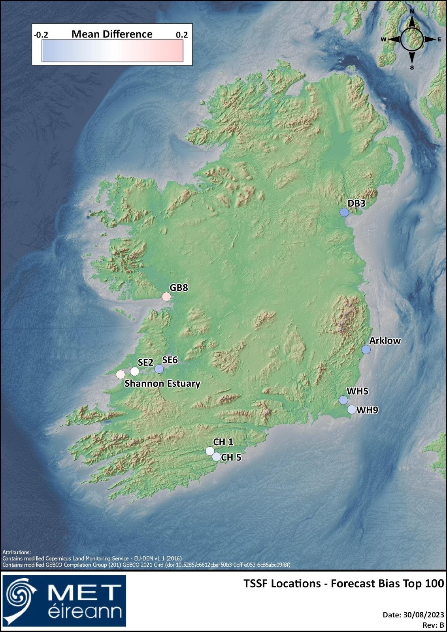
Timeseries charts of the forecast and observed TWLs were assessed at each location if HAT levels were exceeded or approached during any of the nine named storms which occurred over the evaluation period, and Table 2 provides summaries of the difference in daily maximum observed and forecast TWLs, and differences in the timing of the peak TWLs.
Storm Barra and Storm Eunice were the most impactful storm events, with HAT levels approached or exceeded at ten and eight of the tide gauges respectively during these events. Across all storm events and locations, there were 25 instances of HAT levels being approached or exceeded, with absolute differences between maximum forecast and observed TWLs ranging from 0.01m to 0.38m, with a mean absolute difference of 0.15m. Absolute differences between forecast and observed maximum TWLs exceeded 0.2m for 9 of the 25 instances (36%), with two instances exceeding 0.3m, at WH5 during Storm Barra (0.34m) and SE6 during Storm Dudley (0.38m). It should be noted that for all 25 instances, the forecast maximum TWL was under-predicted compared to the observed maximum TWL.
The difference in timing between the maximum forecast and observed TWLs is also summarised in Table 2. The TSSF forecast performed well generally with regards to timing, with the forecast maximum TWL falling within 30 minutes of the observed TWL for 20 of the 25 instances (80%). For three instances there was a difference of an hour or more between the times of forecast and observed maximum TWLs, with the maximum time of 1 hour and 15 minutes for DB3 during Storm Barra. Where the timing of the forecast maximum TWLs did not coincide with the observed maximum TWLs, typically the forecast time was earlier than the observed time, with the exception of Arklow.
Overall, there is large variability in the TSSF forecast performance between different locations, with large mean absolute differences, particularly in the higher range of TWLs at DB3, GB8, WH5, Arklow, SE6 which indicates a poor forecast accuracy during times of heightened flood risk. TSSF forecast performed relatively well at other locations, particularly at CH1, SE2, CH5 and WH9. There is an indication for underprediction at many locations, particularly in the higher range of TWLs, and this is borne out also by the storm event assessment in which none of the forecast maximum TWLs were higher than the observed TWLs.
However, it should be noted that the TSSF forecast is driven by ECMWF high-resolution numerical weather predictions, and deviations between forecast TWLs and observed TWLs will include the impact of any inaccuracies inherited from the numerical weather predictions. Wave set-up is not modelled by the TSSF and hence forecast TWLs do not account for any increases due to wave conditions, which can be significant during storm events, and may have had a significant impact on the under-prediction noted in the storm event assessment results. In addition, while the forecast locations selected were based on their proximity to tide gauges available for evaluation, we would expect some inaccuracies in the forecast due to this spatial variation, particularly in in areas with complex bathymetry.

Storm Names | TSSF Forecast Locations | DB3 | WH5 | GB8 | WH9 | CH5 | Arklow | SE6 | Shannon Estuary | CH1 | SE2
Storm Barra | Δ Max TWLs (m) | 0.06 | 0.34 | 0.13 | 0.2 | 0.04 | 0.13 | 0.06 | 0.13 | 0.11 | 0.24
Storm Barra | Δ Peak Time (min) | 75 | 30 | 45 | 30 | 0 | 15 | 0 | 30 | 30 | 15
Storm Corrie | Δ Max TWLs (m) | - | - | - | - | - | 0.21 | - | - | - | -
Storm Corrie | Δ Peak Time (min) | - | - | - | - | - | 15 | - | - | - | -
Storm Dudley | Δ Max TWLs (m) | - | - | - | - | - | 0.12 | 0.38 | - | - | -
Storm Dudley | Δ Peak Time (min) | - | - | - | - | - | 30 | 15 | - | - | -
Storm Eunice | Δ Max TWLs (m) | - | 0.26 | - | 0.23 | 0.21 | 0.18 | 0.14 | 0.04 | 0.23 | 0.15
Storm Eunice | Δ Peak Time (min) | - | 60 | - | 60 | 30 | 45 | 30 | 15 | 15 | 15
Storm Franklin | Δ Max TWLs (m) | - | - | - | 0.01 | - | 0.03 | 0.1 | - | - | -
Storm Franklin | Δ Peak Time (min) | - | - | - | 15 | - | 15 | 0 | - | - | -
Storm Noa | Δ Max TWLs (m) | - | - | - | - | - | 0.05 | - | - | - | -
Storm Noa | Δ Peak Time (min) | - | - | - | - | - | 30 | - | - | - | -
Absolute Difference
Timing Difference Forecast and Observed Max TWLS

Appendix 3: Statement of Services
The purpose of this document is to outline the services which the Flood Forecast Centre (FFC) will provide at the end of Stage 1 of the National Flood Forecast and Warning Service (NFFWS).
Stage 1 has seen the development of the first ever national scale river flood forecasting system. In addition, coastal flood forecasting functions have transferred to Met Éireann. The FFC once operational will provide the services outlined in this document addressing a critical gap in Ireland’s national capacity to prepare for flood events.
- Background
Met Éireann’s FFC will provide a routine Daily Flood Guidance Statement to each Local Authority and additionally, when forecast conditions merit, the FFC will issue High Tide Advisories (HTAs) and River Flood Advisories (RFAs) to Local Authorities (LAs). FFC products will be available on the Irish Flood Integrated Communication System (IFICS), a web portal which will be accessible to limited stakeholders and not the public.
The FFC’s forecasting capability is supported by fluvial and coastal models. Operationally the HYPE model is being run on the Cloud using the Delft Flood Early Warning System (Delft-FEWS) - which is a model integration platform used around the world to support operational forecasting. HYPE runs using weather forecast data from both Met Éireann (Harmonie) and the European Centre for Medium-Range Weather Forecasts (ECMWF), providing a lead time of up to 7-days to prepare for an event. The selection of Delft-FEWS and HYPE was informed by an independent study conducted by IMDC (International Marine and Dredging Consultants) to identify the best integrator system and hydrological model for use in operational flood forecasting in an Irish context.
The FFC also collaborated with the OPW to transfer their Tidal and Storm Surge Forecast (TSSF) model to the FFC. The TSSF model uses software developed by DHI (Danish Hydraulic Institute), which has been set-up for the Irish coastline by RPS Ltd. The TSSF was transferred from RPS by Met Éireann to run on ECMWF’s HPC (High-Performance Computing) environment in Bologna Italy. The TSSF model currently uses ECMWF’s deterministic forecast as input to produce forecast surge levels at critical points around the Irish coastline with a lead time of 10 days.
Forecast information from the hydrological models along with the TSSF are disseminated to stakeholders using IFICS. Stakeholders can login to this system to view the latest observed and forecast information along with FFC products.
For forecast meteorological information, the FFC uses principally the ensemble forecasts from Harmonie and ECMWF for a range of parameters including for example rainfall, wind and pressure. Hydrometeorologists also work together with their colleagues in the Forecast Office who provide expert guidance on potential weather events.
- Service Standards and limitations
Both the IFICS and Delft-FEWS systems, which support flood forecasting communications and fluvial forecasting respectively, are cloud based, have back-up systems and are geo resilient. They are both supported by their respective contractors via an on-call facility. The IFICS and FEWS maintenance contracts will be managed and reprocured, as necessary, by the FFC.
The selection of the HYPE and Delft-FEWS integrator system was informed by an independent study by IMDC to identify the best model and system for operational flood forecasting by Met Éireann. It is important to highlight that both Delft-FEWS and HYPE are widely used in the international community for operational flood forecasting, have a large user group, and are well supported mature systems. Improvements and enhancements to these systems by the user community as well as the developers will be available to Met Éireann, ensuring that both Delft-FEWS and HYPE can be maintained to current and best international standards.
IMDC set out and followed an approach for the development and testing of the HYPE model which follows best international practice. Met Éireann has also consulted with the developers of the model at SMHI (Swedish Hydrological and Meteorological Institute) to ensure the approach to model development was commensurate with acceptable practices. Hence the models have been developed to a high standard, however there are limitations on the quality of the observational data available for development and testing which restrict the level of accuracy which can be achieved at this Stage. Met Éireann will work with stakeholders to improve the observational network, which will in future address these limitations. Met Éireann’s Hydrometeorologists will be fully trained and understand these limitations. Stakeholders will also be made aware of the limitations of the products which the FFC will provide.
Both the HYPE model and Delft-FEWS Integrator system were tested during a non-operational trial of the system conducted from 2022 to 2023. Based on the results of the model evaluation conducted by IMDC as part of their contract, along with Met Éireann’s own assessment conducted during the trial period, the HYPE model was found to be very accurate for a number of locations, particularly those where the density of good quality flow rated gauges is high; however, better quality observational data is needed to improve the model’s accuracy at other locations. For some areas of the country the models will therefore not be able to provide a high-quality numerical forecast, and interpretation by on-duty Hydrometeorologists will be required.
Although these models demonstrate sufficient predictive skill to provide guidance to trained expert hydrometeorologists, ongoing development work will be necessary to improve the performance of these flood forecasting models. This will initially be informed by the trial report produced by IMDC and Met Éireann’s own expertise. Along with using Met Éireann’s own capabilities, options to improve the model outside Met Éireann, including by the model developers (SMHI) will be explored. Development work will be guided by performance reviews. These reviews will be conducted by Met Éireann through statistical verification and skill score analysis of the flood forecasting system over time at forecast points coinciding with the locations of reliable flow rated gauges. The HYPE model forecasts are being archived as part of the system’s operations to support ongoing and retrospective performance assessments. An annual review of model performance will be conducted. In addition, any further model developments will be benchmarked against the current system to determine the added value of development work.
The Met Éireann Flood Forecast Centre has now embedded the TSSF model into the ECWMF HPC architecture ensuring more resilient and robust operations than previously. The model system receives NWP data directly from the operational stream at ECMWF. Met Éireann produced a report in collaboration with the third party (RPS Ltd.) who ran the TSSF model for the OPW. They provided details on the model’s performance and recommendations on how to improve the TSSF model. In addition, Met Éireann conducted a performance review of the TSSF model during a non-operational trial (2022-2023). Results of the various studies of the model undertaken show that it generally performs well for most coastlines. However, it has one main limitation, it does not include waves in the calculation of the total water level. In addition to this it uses only the ECMWF deterministic forecast.
Development work will be required to improve the TSSF model. As with the fluvial models above, along with utilising Met Éireann’s own capabilities, options to improve the model outside Met Éireann, including by the model developers (DHI) will be explored. Additional performance reviews by FFC are planned to identify further development requirements. These reviews will be supported by statistical verification and skill score analysis of the model’s performance over time at critical locations around the coast. The TSSF model forecasts model forecasts are being archived as part of the system’s operations to support ongoing and retrospective performance assessments. An annual review of model performance will be conducted. In addition, any further model developments will be benchmarked against the current system to determine the added value of development work.
- Service Description

Daily Flood Guidance Statement 3-Day Forecast (DFGS 3 Day)
The DFGS 3-day is a document designed to communicate river and coastal forecast information on a national and catchment scale for a 3-day period. The flood conditions are displayed graphically for a 3-day period and the conditions are colour coded according to whether flood thresholds are: Normal, Elevated, High or Extremely High. The DFGS also includes a summary of the weather forecast, the Coastal and River flood conditions, and FFC contact details. The DFGS is emailed to the Local Authorities, NDFEM and the OPW, the DFGS can also be viewed on the IFICS portal. The DFGS allows the national emergency management function to understand the upcoming flood risk.

River Flood Advisory
A River Flood Advisory is a written report used to communicate a possible flood event. It serves to inform Government bodies, Emergency Management and Principal Response Agencies that a flood event may occur. The aim is to issue the River Flood Advisory via email as early as the forecast models allow, typically 2 to 3 days prior to a possible event. This lead-time will allow the agencies to resource and plan for the forecasted event. River Flood Advisories will be issued when the forecast flood exceeds the High flow thresholds for rivers and High-water level thresholds for coastal areas within the next 72-hour period. A River Flood Advisory will be sent to the Local Authorities, NDFEM and the OPW, the DFGS can also be viewed on the IFICS portal.

High Tide Advisories
A High Tide Advisory is a written report that communicates the possibility of a coastal flood event. It serves to inform Government bodies, Emergency Management and Principal Response Agencies that a coastal flood event may occur. The aim is to issue the HTA via email as early as possible, typically 2 to 3 days prior to a possible event, as allowed by the TSSF model. This lead time allows the agencies to resource and plan for the forecasted event. A HTA will be issued when the forecast flood exceeds the High -water level thresholds for coastal areas within the next 72-hour period.

Irish Flood Integrated Communication System
The Irish Flood Integrated Communication System (IFICS) is a cloud-based visualisation, production and dissemination system for information relating to river and coastal flooding. External stakeholders can use this system to view meteorological and hydrological observations along with flood and metrological forecasts. Due to the specialist nature of this system, currently only specific trained staff from within the Local Authorities, OPW, National Directorate for Fire and Emergency Management (NDFEM) and Met Éireann can access IFICS.
Flood Forecast Information
Operational updates are a series of products that are produced by the FFC to clarify and further explain the forecasted and observed flooding conditions. These can include maps, verbal or written forecast updates, plots, graphs, tables, diagrams, animated images and videos etc. They are generally compiled and produced by the FFC and disseminated via many methods such as email, briefings and presentations. Hydrometeorologists will also be available to provide a briefing during meetings of the National Emergency Coordination Group. In addition, members of the FFC will work with their colleagues in the forecast office to ensure flood information is included in weather warnings and messaging. Along with the physical products, briefing information is used to assist decision making by local responders including local emergency management.
- Stakeholder Interaction & Partnerships
The FFC will work continuously with its stakeholders, including the National Directorate for Fire and Emergency Management, Office of Public Works and Local Authorities, to provide support and gather feedback regarding the provision and use of its products and services. Feedback will be gathered via email, phone and periodic surveys of stakeholders. In addition, workshops will be planned for the SWFLM (Severe Weather Flood Liaison Manager) and SWAT (Severe Weather Assessment Team) team members from each Local Authority. Training will be provided for the users of IFICS. The FFC will develop, maintain and make available training materials. In addition, training sessions will be hosted for IFICS users. Will also maintain close contact with our colleagues working in the European Flood Awareness System, as well as other international partners including other National Meteorological and Hydrological services.
- Service Operations
The operational functions of the FFC will be within Met Éireann’s management function and under the oversight of the NFFWS steering group.

5.1 Evaluation and service improvement
The FFC is committed to ongoing assessment and improvement of coastal and hydrological models, with a focus on rigorous evaluation and the use of statistical measures to gauge its accuracy and reliability over time.
With respect to the evaluation of coastal and hydrological models' performance, the FFC will conduct regular reviews, including the preparation of a comprehensive annual report. These assessments will employ statistical methods and skill scores to precisely measure and track the models' performance and the reliability of their forecasts over time. Key performance metrics will include the Kling-Gupta efficiency (KGE), as well as correlation, bias and variance ratios. The metric is widely used for verification in a hydrological context including in the evaluation of the European Flood Awareness System (EFAS). Additionally, the FFC will assess how well the models perform under various lead times for forecast runs. Attention will also be given to how well flood peaks are captured using contingency tables.
Specifically, for the HYPE model, the FFC will evaluate the performance of the flood forecasting system over time by comparing forecasted values to those from reliable flow rate gauges at specific forecast points. This will provide a quantified measure of the correspondence between observed and forecasted discharge, giving a clear record of the system’s forecasting skill.
Similarly, for the TSSF model, the FFC will analyse data from tide level gauges located along the coast, utilizing point-scale observations. In the context of coastal forecasting, the FFC will closely examine the agreement between forecasted and observed water level heights using the KGE metric and contingency tables to quantify and track performance.
The FFC acknowledges that the current limitations in fluvial and coastal observations may impact the comprehensiveness of our verification systems and performance assessments.
The performance of the ICT systems which support the models (Delft-FEWS) and the communication system (IFICS) will also be assessed on an ongoing basis. This will include a review of operational reliability and support processes. These will be undertaken in conjunction with the system contractors as part of their performance reviews. Information on the performance of the systems will be used to inform future developments.
FFC are continuously in contact with its main stakeholders concerning the development and rollout of the services and products which the FFC will provide. It is planned that the FFC will meet periodically (quarterly) with its stakeholders to gather feedback on their level of satisfaction with the service. This will include at least one in-person meeting per year. Surveys will also be used to measure stakeholder engagement and to objectively quantify the level of satisfaction with the service. Information gathered from stakeholders will be used to identify areas for further improvement and to identify additional or emerging stakeholder requirements. Improvement and development plans along with associated schedules will be developed by the FFC.

5.2 Development and Maintenance
The FFC is staffed by trained hydrometeorologists. Their role is to develop flood forecasts, advisories and guidance and supply the products and services (outlined above). The FFC will have at full complement 11 staff, including 9 Hydrometeorologists. Currently there are 8 Hydrometeorologists employed in the FFD. There is a requirement for 2 more FTEs to deliver the TSSF service. Over the coming years periodic training is necessary to ensure all staff remain familiar and up to date with new developments in the relevant fields. New staff will require at least 6 months training. The role of staff is also to maintain the systems (IFICS, Delft-FEWS, and TSSF) which underpin the service. In this respect training of a more technical nature is also necessary. Staff will also be required to liaise with stakeholders to ensure communication of messaging is adequate and received.
A Continuous Professional Development Plan will be used to ensure FFC staff remain up to date with advancements in the field of flood forecasting. It will also be necessary for enhancing the personal skills and knowledge of staff as well as for their ongoing career growth and effectiveness.
Both the IFICS and Delft-FEWS systems, which support flood forecasting communications and fluvial forecasting respectively, are cloud based, have back-up systems and are geo resilient. They are both supported by their respective contractors via an on-call facility. IFICS and Delft-FEWS are currently in the maintenance phase their contracts and can remain so for at least the next 3 years. In the next 2 years preparatory work will therefore be required for the renewal or retendering of contracts. Over the next 3 years some development work will be required to improve these systems. This will be guided by performance reviews. These reviews will be conducted by the FFD through statistical verification and skill score analysis of the flood forecasting system over time at forecast points coinciding with the locations of reliable flow rated gauges.
The TSSF model is run on the ECMWF’s HPC facility. It’s operation is monitored by staff at ECMWF. All staff of the FFC have been given training on troubleshooting the model and documentation has been developed to support monitoring and maintenance. Over the next 3 years some development work will be required to improve the TSSF model. This will be guided by performance reviews. These reviews will be conducted by the FFD through statistical verification and skill score analysis of the model’s performance over time at critical locations around the coast. It is also important to note that the TSSF model forecasts are archived. This will facilitate performance reviews by other interested parties.

