
National Flood Forecasting & Warning Service
Communication Strategy

Prepared by Communication ‘s Working Group of National Flood Forecasting and Warning Service

Prepared by Communication ‘s Working Group of National Flood Forecasting and Warning Service

National Flood Forecasting & Warning Service
Steering Group

December 2023
This Strategy is compiled by the National Flood Forecasting and Warning Service Steering Group and the members are as follows:

The Office of Public Work (Chair)
Met Éireann (DHLGH)
Department of Agriculture, Food and the Marine
National Directorate for Fire and Emergency Management (DHLGH)
County and City Management Association (CCMA)

Issue Date | Revision | Short summary of change | Prepared | Reviewed
August 2019 | Draft | Initial Draft | CWG | CWG
Dec 2023 | Final Draft | Final Draft | CWG | NFFWS SG

Contents
Executive Summary 3
Introduction and Structure 4
Background of the NFFWS 4
Best Practices, Research and International Guidance 5
Glossary of Terms 5
Risk Register 5
Limitations of the NFFWS and Disclaimers 6
Revisions and updates of the Communications Strategy 6
Part 1 Identification of stakeholders, decision makers, and communication goals for each stakeholder group. 7
Part 2 Main Roles and Responsibilities of the Key Agencies in relation to Flood Forecasting and Flooding Emergency Management 9
Part 3 Identification of key objectives for the communication of expected key NFFWS operational products and information AND Identification and scope of expected key products, outputs and flood information of the NFFWS. 10
Operational Outputs 10
Collaboration with Met Éireann’s Forecast Division 14
Flood Forecast Procedures 15
Part 4 Development of principles for the provision of stakeholder guidance on NFFWS products and information 17
Building a network of contacts. 17
National and International Peer Communications 18
Appendices 19
Appendix 1: CRUE Final Report Guidelines and Link 19
Appendix 2: Glossary of Terms used by the NFFWS 20
Appendix 3: Glossary of Abbreviations and Acronyms 23
Appendix 4: Questionnaire to Stakeholders 24
Appendix 5: Communications Risk Register 25
Appendix 6: Related Government Agencies 30

Executive Summary
The overarching aim of the National Flood Forecasting and Warning Service (NFFWS) is to ensure the effective delivery of operational flood forecasting products and information to its stakeholders. This information helps the stakeholders to make impact-based decisions and take actions that will protect against the loss of life and that will protect and mitigate against damage to property.
A Government Decision in January 2016 agreed to the establishment of a National Flood Forecasting and Warning Service and that the Flood Forecasting Centre would be a new operational unit within Met Éireann.
Met Éireann’s Flood Forecasting Centre is tasked with forecasting the likelihood of river and coastal flooding and, when required, issuing flood guidance and advisories to limited stakeholders, namely the local authorities, OPW and the National Directorate for Fire and Emergency Management. The Flood Forecast Centre is, at the completion of stage 1, not tasked with the communication of flood guidance and advisories to the public. However, it is noted that Met Éireann’s weather warnings, which are issued to the public, do include mention of flooding impacts when appropriate.
The lead agency in flood emergency management in each county is the relevant local authority. In line with the Major Emergency Management Framework, the Multi-Agency response to Flood Emergencies 2016 states that; where a local authority anticipates that flooding of buildings and roads will occur, a flood warning should be issued for the area. The local authority as ‘lead agency’ for flood emergency response will co-ordinate flood warnings and public information messages at the local level. The Principal Response Agencies (PRA) in relation to flooding are Local Authorities, An Garda Síochána and the Health Service Executive.

Introduction
This document outlines the communication methods to be employed by the NFFWS during both flood and non-flood conditions, and details robust mechanisms for two-way communication between the NFFWS and stakeholder groups.
This Communications Strategy will be employed on completion of Stage I of the NFFWS implementation plan. For this stage, the NFFWS remit covers forecasting of floods from two sources, coastal floods, and river floods at national and catchment scales. The Communications Strategy will be revised as the NFFWS progresses in the subsequent stages of implementation.

This Communications Strategy develops the terms of reference set out by the NFFWS Communication’s Working Group (CWG) by answering the following:

- Who is the target audience and what do they need to know? – The Communications Strategy identifies the relevant bodies, decision makers and communication requirements associated with each stakeholder group.
- What is the message? - It outlines the key objectives relating to the communication of operational flood forecast products and information.
- How and in what format will the message be delivered? - It details the various media and formats used to deliver flood forecast information.
- Who will send the message to who? It identifies the responsibilities of the NFFWS members for communicating flood forecast information and products.
- In non-flood conditions, what supports are available to stakeholders and how will they give feedback to the NFFWS? - It puts in place principles for the provision of stakeholder guidance regarding the interpretation and use of NFFWS products and information.

Document Structure

This Communications Strategy outlines the procedures for effectively communicating operational flood forecasting products and information between the NFFWS and its stakeholders. The Strategy outlines the communication methods to be employed by the NFFWS in both flood and non-flood conditions.
Part 1 Identifies the stakeholders, decision makers, and communication goals for each stakeholder group.

Part 2 Defines the main roles and responsibilities of the key agencies.

Part 3. Identifies and scope of expected key products, outputs, and flood information from the NFFWS.

Part 4 develops the principle of the provision of stakeholder guidance.

Background of the NFFWS
In January 2016 the Government agreed to the establishment of the NFFWS and that a Flood Forecasting Centre would be a new operational unit within Met Éireann, with guidance for standards and performance overseen by the Office of Public Works (OPW).

The NFFWS Steering Group was established early in 2016. The Steering Group oversees the establishment of the NFFWS and is chaired by the OPW. The group reports to the Interdepartmental Flood Policy Coordination Group.
The NFFWS has completed Stage I of a multi-stage implementation plan. Stage I was the service’s “establishment” stage. For Stage I, the NFFWS remit covers the development of flood forecasting from coastal and river sources at both national and catchment scales leveraging the pre-existing hydrometric observation system. It is envisaged that in future stages of the Service, enabled by improved hydrometric observations more accurate, detailed and localised forecasts will be produced.

Communications Working Group
To develop a Communications Strategy, the NFFWS Steering Group established the Communications Working Group (CWG) as a sub group. The terms of reference for the CWG are listed here:

Develop a communications strategy for approval by the NFFWS SG, which will:
1. Identify the list of stakeholders and decision makers and communication goals for each stakeholder group.
2. Identify communications responsibilities for NFFWS SG members i.e., the OPW, Met Éireann, Local Authorities.
3. Identify, in line with international best practice, key objectives for the communication of expected key NFFWS operational products and information.
4. Put in place, in line with international best practice, principles for the provision of stakeholder guidance on NFFWS products and information.
The CWG was tasked to provide a written strategy for the NFFWS SG, outlining clear goals and associated objectives for the effective communication of NFFWS operational products and information to key stakeholders and decision makers. The Communications Strategy is subject to approval of the NFFWS Steering Group.

Best Practices, Research, and International Guidance
The CWG developed the Communications Strategy with regard to best practices, research, and international guidance.
The CWG sought guidance from international and national organisations and consulted with the Scottish Environmental Protection Agency, National Resources Wales, and the English Environment Agency. Communication methods employed in America, Canada, Iceland, Sweden, and France were also examined.
Previous research in communicating flood risk was examined, in particular the CRUE Final Report, URFlood – Understanding uncertainty and risk in communicating about floods (August 2011). The Major Emergency Management protocol, guidance and framework documents were also used to inform this Strategy. Several of the guidelines proposed in the CRUE report are employed in this Strategy principally:
- Use multiple channels of communication (to reach different people in different situations).
- Continue to develop and raise awareness of current information sources i.e., repeat campaigns.
- Develop understandable statements on risk.

The CRUE Report guidelines and a link to the final report is given in Appendix 1.

Glossary of Terms
To ensure effective communication and clear understanding of the terms used in this Strategy, as well as in the service at large, a glossary of terms is included in Appendix 2. This explains the terminology, acronyms and abbreviations used throughout.

Risk Register
Various risks in relation to the communication of flood forecast products and information were examined whilst preparing this Strategy. Mitigation measures for these risks have been proposed. The risks and mitigation measures have been compiled into a Risk Register, a copy of which is given in Appendix 3.

Limitations of the NFFWS and Disclaimers
In accordance with the objective for Stage I, the NFFWS, through the FFC, will issue guidance and advisories based on forecasted flows for rivers and forecasted water levels for coastal areas and service products developed at this Stage will be on a National and Catchment scale (sub catchment or local scale products will be developed at later stages in the establishment of the Service). The accuracy of flood forecasts is limited by the extent of the existing hydrometric observation system. Service products developed at this stage of development of the NWFFS are subject to misinterpretation and only suitable for select stakeholders i.e., Local Authorities, OPW and NDFEM. NFFWS products, as this stage of development, are not suitable for issue to the public.
At this point the remit of the NFFWS does not extend to forecasts for pluvial or groundwater flooding.

All service products will carry disclaimer text. Please note that all examples relating to NFFWS products used in this document are for illustrative purposes only and their format and appearance is subject to change.

Revisions and updates of the Communications Strategy
The Communications Strategy is a living document and is subject to change. Policies and decisions adopted by Government; the SG, subgroups of the SG (that are approved by the SG) or other factors, may lead to revisions of this strategy.
The Communications Strategy has been developed in line with existing strategies, polices and communications procedures which are currently in place within Met Éireann, the OPW, the Department of Housing, Local Government and Heritage (DHLGH), Local Authorities and the National Directorate for Fire and Emergency Management (NDFEM). Should these be amended, the Strategy will be revised to reflect these changes.

Part 1 Identification of stakeholders, decision makers, and communication goals for each stakeholder group.

The CWG identified two main stakeholder groups. The identification process included a series of meetings, workshops and reports, etc.
Details of a questionnaire used to identify relevant groups are given in Appendix 4.
The CWG sought to identify information required by the stakeholders, the stakeholder’s communication objectives, and the reason for the communication. It is worth noting that these are the stakeholder’s requirements for a fully developed NFFWS and not all will be met at the end of Stage I.
At the end of Stage I in the development of the NFFWS, communication will principally concern the Local Authorities, NDFEM and the OPW.
These three bodies are the NFFWS’s principal stakeholders for Stage I of the NFFWS development and the communication goals for these stakeholders are outlined in Table 1, under State Bodies and Event Responders. Communication Goals for other stakeholders, such as sectorial interests and media are also described but are not intended to be fully achieved under Stage I.

Stakeholder | Communication Goals
State Bodies and Event Responders
Emergency Management, Principal Response Agencies and Government Department and Agencies (A detailed list of organisations is given Appendix 6 but Stage I of the NFFWS focuses on Local Authorities, NDFEM and the OPW) | Information required: Earliest possible forecast of a flood event with timely, accurate and actionable information. Likely risk levels and impacts.  Communication objectives: To ensure the government agencies and the public are made aware of the likelihood and the severity of the forecasted event.  Reason for communication: To ensure the timely convening of a National Emergency Coordination Group on Severe Weather (if required) which allows for a "whole of Government" response to the flood event. To ensure that the PRA decision makers have sufficient data to enable the correct decision to be made at the earliest possible time. To assess and minimise the impact on transport for the travelling public. To ensure the safety, welfare, and protection of all persons including all staff working on behalf of government agencies
Service Providers, Industrial Sector and National and Local Media
Utilities (for example Eirgrid, Gas Networks Ireland, Eir, SSE) and National/Local Media (Television, Radio, On-line Media), Sectorial interests such as Industry, Construction, Agriculture, Tourism and so on | Information required: Timely, accurate, actionable, and reliable forecast of flood event and likely risks levels and impacts.  Communication objectives: To ensure the service providers and the industrial sector are made aware of the likelihood and the severity of the forecast event.  Reason for communication: To ensure that the service providers and the industrial sector have the correct information to allow for reasonable decisions to be made in relation to the protection of staff, clients, customers, property and facilitate continuity of supply. Minimise network outages at a customer level. Eliminate any public safety hazards associated with flooding Minimise network damage Maximise network availability. To ensure that the media has the correct message to allow for fair and accurate broadcasting and reporting of the flood event.
Table 1: Stakeholder classification. (Please note that these lists are indicative, are non-exhaustive, and will be reviewed during the lifetime of this document).

Part 2 Main Roles and Responsibilities of the Key Agencies in relation to Flood Forecasting and Flooding Emergency Management
Met Éireann was tasked by a Government Decision in January 2016 to set up a new operational unit, the Flood Forecasting Centre (FFC), to provide a flood forecasting service.
The OPW has provided guidance for standards and performance of the NFFWS.
On completion of Stage I development, Met Éireann’s FFC will operate forecasting systems for two types of floods, river and coastal at a catchment and national level and will maintain the capability to issue timely, accurate, actionable, and reliable flood forecast, information, guidance and advisories to specific stakeholders. It is noted that flood forecast accuracy is limited by the extent and reporting frequency of the national hydrometric network.

The National Directorate for Fire and Emergency Management (NDFEM) decides if the forecasted flood risk necessitates the convening of the National Emergency Co-ordination Group (NECG). Should a forecasted flood emergency necessitate the convening of the NECG, the NDFEM will request that the Office of Emergency Planning (OEP) convenes the NECG. The NECG will coordinate the whole of government response to the flood emergency. NDFEM may decide to take other steps proportionate to the risk identified by Met Éireann, including advising local authorities to activate crisis management and local co-ordination arrangements.
It is the responsibility of the PRAs to coordinate the effective flooding emergency response within the affected areas. The PRAs are the relevant Local Authorities, An Garda Síochana and the Health Service Executive.
Local Authorities are the lead agencies in relation to flood emergency response. Flood emergency management should be co-ordinated in accordance with the Major Emergency Management Framework documents as well as Local Major Emergency Plans and Flooding sub-Plans.

The ESB operates hydroelectric power stations on five rivers in Ireland. In its role in the production of electricity, the ESB operates gates, dams, and reservoirs on rivers such as the Lee, the Liffey, and the Shannon. The ESB regulates flood flows and discharges through these structures.
Part 3 Identification and scope of expected key products, outputs, and flood information from the NFFWS.

Operational Outputs
The main operational outputs of the NFFWS used to communicate forecast floods in accordance with Stage I are:
- Daily Flood Guidance Statement
- River Flood Advisory
- High Tide Advisory
- Operational Water Level Updates
- Mapping Portal
- General Enquiries

- National Emergency Coordination Group (NECG) Briefings

In accordance with the objective for Stage I, the NFFWS, through the FFC, will issue guidance and advisories based on forecasted flows for rivers and forecasted water levels for coastal areas and service products developed at this Stage will be on a National and Catchment scale (sub catchment or local scale products will be developed at later stages in the establishment of the Service). The accuracy of flood forecasts is limited by the extent of the existing hydrometric observation system. Service products developed at this stage of development of the NWFFS are subject to misinterpretation and need to be accompanied by expect hydrometeorologists advice. Service Products developed at this stage of development of the NWFFS are only suitable for select stakeholders i.e., Local Authorities, OPW and NDFEM. and are not suitable for issue to the public.

At this point the remit of the NFFWS does not extend to forecasts for pluvial or groundwater flooding.

Each of these is detailed below:

Daily Flood Guidance Statement: (DFGS) will be issued daily by the FFC to limited stakeholders ( the NDFEM, Local Authorities and the OPW) . The DFGS gives a forecasted flood situation for a three-day period countrywide. The DFGS gives a flood situation summary for both coastal and river floods; weather outlook for forecast period; and contact details for the Service.
An example of a DFGS is given in Figure 1.

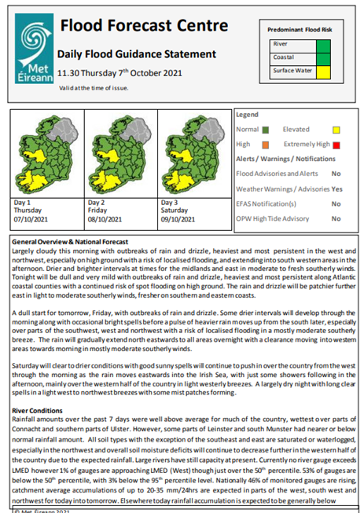
Sample
Figure 1 Example of a Daily Flood Guidance Statement

River Flood Advisory: This is a “Heads up” to stakeholders to communicate that a river (fluvial) flood event may occur. The aim is to issue the River Flood Advisory via email as early as the forecast models allow, typically 2 to 3 days prior to a possible event. This lead-time will allow the agencies to resource and plan for the forecasted event. River Flood Advisories will also be available to view on the IFICS platform.
Where possible, the River Flood Advisory will include confidence indicators quantifying the likelihood of the event occurring. The goal of the River Flood Advisory is to create a state of readiness for the possible event.
The River Flood Advisory will include a detailed Area of Concern map. This will provide spatial information and outline specific details relating to the forecasted event.
River flood advisories are issued when water levels have reached or are expected to exceed a known threshold. This will be informed by river flood forecasts and real-time information from river level gauges. Antecedent conditions (e.g., soil conditions, accumulated rainfall, and current water levels) and forecasted rainfall will also be considered, as will whether a flood notification has been issued by the European Flood Awareness System (EFAS).
An example of a River Flood Advisory is given in Figure 2.

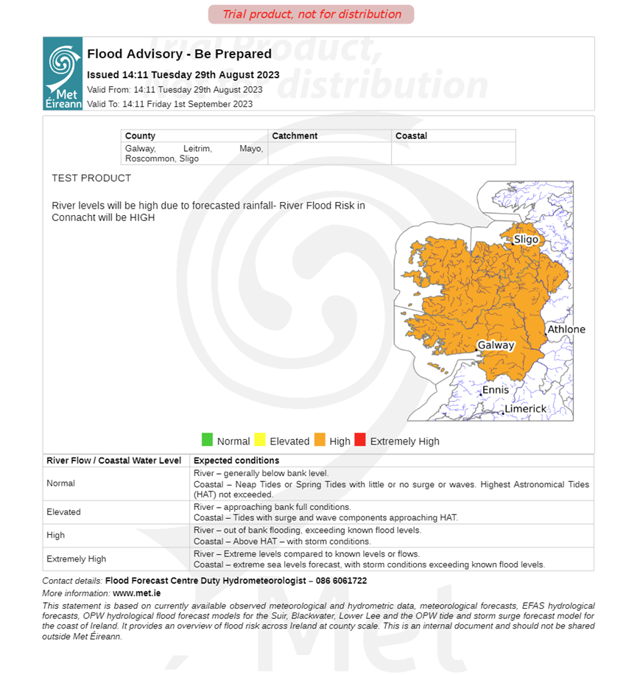
Sample
Figure 2 Example of a River Flood Advisory

High Tide Advisory: This is also a “Heads up” to stakeholders to communicate when times of high-water level conditions may be expected due to high astronomical tides and / or storm conditions.
The aim is to issue a High Tide Advisory via email as forecast models allow, typically 2 to 3 days prior to a possible event. The High Tide Advisory will also be available to view on the IFICS platform.
This lead time will allow the agencies to resource and plan for the forecasted event. The High Tide Advisory will outline where exceedance in the highest astronomical tide level is expected and for what areas along the coastline.
An example of a High Tide Advisory is given in Figure 3.

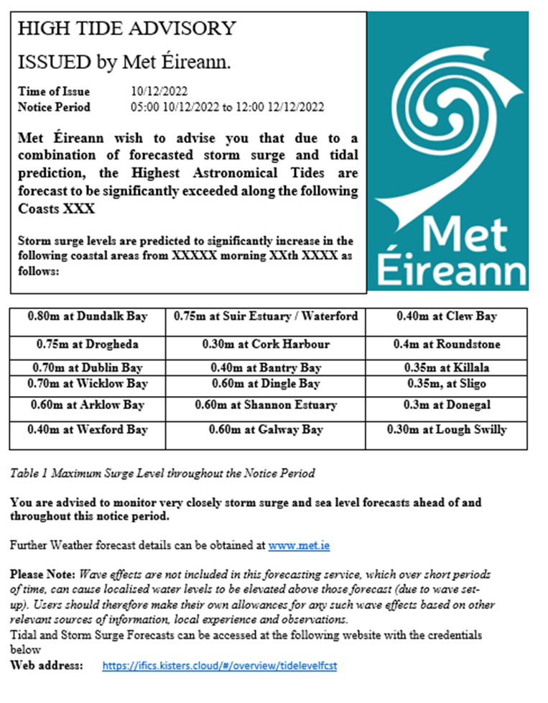
Sample
Figure 3 Example of High Tide Advisory

Operational Water Level Updates: Based on the capabilities of the current national hydrometric network, Met Éireann’s FFC will compile current water level maps, percentage river level maps, direction of water level change maps, forecasted hydrographs and water level summary reports. These products can be used to communicate current and forecasted water levels and or flood risk status to the stakeholders prior to, during or after a flood event. These products will also be available to view on the IFICS platform.

Mapping Portal: Stakeholders will be able to visualise the forecasted flood event via a tailored forecast system portal, known as the Irish Information Communication System (IFICS). Through IFICS, features, such as forecasted flood hydrographs, flood extent mapping, rainfall radar, and animated rainfall forecasts will be available to the users. Client access will be granted to stakeholders via a user account with a secure password, and users will have a read-only access. Access will be limited to certain stakeholders including state agencies and PRAs. Certain service providers and utilities companies may also be granted access.

General Enquiries: The contact details for the Met Éireann FFC will be included in all written communications to key stakeholders and a query email address will be available. Prior to, during, and after a flood event, FFC staff will be available to answer telephone or email queries from stakeholders. All enquiries in relation to flooding emergency management will be directed to the relevant PRA.

National Emergency Coordination Group (NECG) Briefings: Hydrometeorologists will also be available to provide a flood forecast briefing when full meetings of the NECG is deemed necessary. Along with the physical products, briefing information is used to assist decision making by local responders including local emergency management.

Collaboration with Met Éireann’s Forecast Division
It is noted that in addition to the operational outputs detail above, the Flood Forecast Centre in Met Éireann will work with their colleagues in Met Éireann’s Forecast Division to ensure that potential flood impacts, when appropriate, are mentioned in Met Éireann’s weather forecasts and weather warning products which are distributed across traditional and digital media platforms.

Flood Forecast Procedures
For Stage I of the NFFWS, the FFC will issue river flood advisories based on forecasted flow. The FFC will forecast river flow, using hydrological models. River flood advisories are issued when water levels have reached or are expected to exceed a known threshold. This will be informed by river flood forecasts and real-time information from river level gauges. Antecedent conditions (e.g., soil conditions, accumulated rainfall and current water levels) and forecasted rainfall will also be considered, as will whether a flood notification has been issued by the European Flood Awareness System (EFAS).

Thresholds for forecasted river floods have been determined based on calculated design flood return periods such as the 2-, 5- and 20-year return period. Forecasted flows are then compared against the predetermined thresholds. Details of threshold conditions are given in Table 2.

Coastal flood thresholds have been determined based on predicted Highest Astronomical Tides. Forecasted water levels are then compared against the predetermined thresholds. Details of the coastal level thresholds are given in Table 2 below.

The four threshold values for both coastal and river floods are:
- Normal
- Elevated
- High
- Extremely High

As the hydrometric network expands In future stages of the NWFFS, it will allow the FFC to improve the flood threshold information, values will be refined for specific locations. Different locations will have different flood risks and impacts depending on certain flood return periods, flows or water levels, due to such factors as elevation, relief, topography, physical factors, flood defences, drainage and so on.

River Flow Threshold /  Coastal Level Threshold | Threshold | Expected conditions
Normal | Included in DFGS – no advisory issued at this threshold | River – generally below bank level
Normal | Included in DFGS – no advisory issued at this threshold | Coastal – neap tides or spring tides with little or no surge or waves. Highest Astronomical Tides (HAT) generally not exceeded
Elevated | Included in DFGS – advisory not usually issued at this threshold | River – approaching bank full conditions or Flows approaching the 2-year flood (median flood)
Elevated |  | Coastal – spring tides with surge and wave components approaching HAT
High | This threshold would trigger issuing an advisory if forecasted within 72 hrs | River – out of bank flooding, exceeding known flood levels. Flows expected to exceed the 5-year flood
High |  | Coastal – Above HAT, with storm conditions.
Extremely High | This threshold would trigger issuing an advisory if forecasted within 72 hrs | River – extreme levels compared to known levels or flows. Flow expected to exceed the 20-year flood
Extremely High |  | Coastal – extreme sea levels forecast, with storm conditions exceeding known flood levels.
Table 2: Indicative Forecasted Thresholds Classifications
The flow chart in Figure 4 shows how the on-duty Hydrometeorologist disseminates flood forecasts.
The DFGS will be issued each day, in both flood and non-flood conditions. If the forecasted flow for rivers or the forecasted water level for coastal areas within the next 72 hours is greater than or equal to the High threshold, a River Flood Advisory or High Tide Advisory is issued.
The Advisory is reviewed on a 24-hour basis and if the forecasted flow or level has receded, only a DFGS will be issued as usual. Should the forecasted flow or water level remain above the High Threshold, past the current flood advisory validity period; a new flood advisory will be issued.
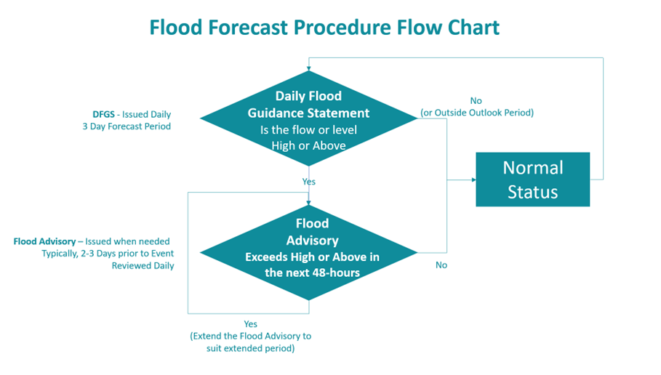
Figure 4: Flood Forecast Procedure Flow Chart

Part 4 Development of principles for the provision of stakeholder guidance on NFFWS products and information

This section outlines the methods employed to communicate with stakeholders during non-flood conditions.

Building a network of contacts.
The CWG recommended establishing a Severe Weather and Flood Liaison Manager (SWFLM) within Local Authorities. The key role of the SWFLM is to liaise with the NFFWS to ensure that the NFFWS send the weather forecast, weather warning, flood guidance and flood advisories to the right personnel in the stakeholders’ organisation.

The SWFLM is a LA's member of staff tasked with managing flood and weather-related communications within their organisation. Each organisation shall nominate a SWFLM and a “backup” SWFLM to act in the SWFLM stead, during times of leave.

The SWFLM is:
- A point of contact between the FFC and the LA.
- A member of the LAs’ Severe Weather Assessment Team
- of a sufficient grade to co-ordinate the communication streams within the stakeholder organisation.
- A person who manages the LA distribution list.
- A person who manages the method of communication to deliver the weather warnings and flood guidance and advisories.

The SWFLM is not:
- The single point of contact within the LA organisation.
- Solely responsible for flood related communications within the LA organisation.

Local Authorities will update the FFC when SWFLM contact details change this is so that the stakeholder’s distribution list is up to date.
The NFFWS manages the establishment of the Severe Weather and Flood Liaison Manager Network and will facilitate regular meetings, workshops, and seminars to promote better communication between SWFLM and the NFFWS.
The NFFWS requests feedback reports on flood events from the stakeholders at conferences, workshops and so on.

National and International Peer Communications
The NFFWS will host training and workshop events at least annually to promote, inform and educate stakeholders of new services and developments within the NFFWS and within flood risk management in general.
The NFFWS will also strive to provide the best service and will always seek to improve the level of service provision in line with best international practices. This will be achieved by engaging in the following:
- Various Conferences – NDFEM, Hydrology, Flood Risk Management.
- Workshops and Emergency Exercises.
- International Networking – site visits and meetings, software user meetings.
- International Conferences – EFAS, ECMWF, WMO.
- Articles and research.
Through the Met Éireann Research Funding and Liaison function, the NFFWS can promote, enhance, and fund research in advancements of flood forecasting and related fields.
The NFFWS will actively seek feedback from its stakeholders after flooding events. A request for feedback, such as observed water levels, photographs and flood inundation maps/sketches will be included on every flood advisory issued.

Appendices

Appendix 1: CRUE Final Report Guidelines and Link
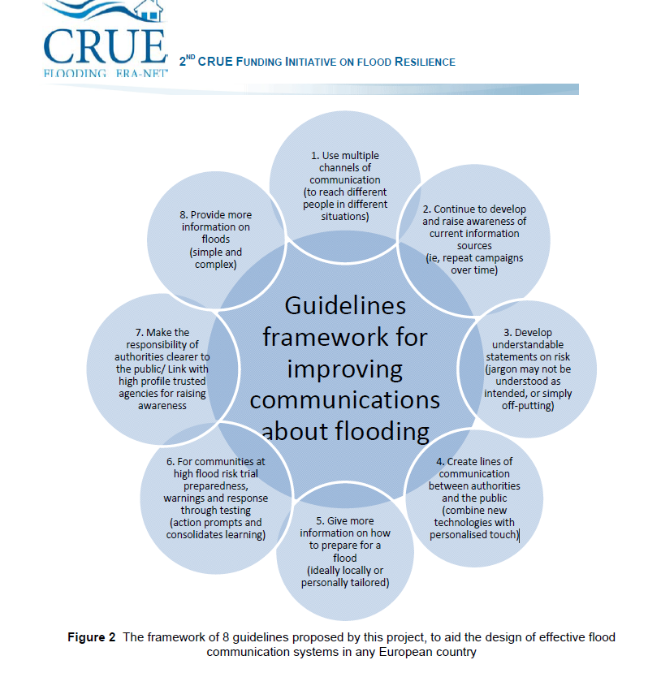

https://www.researchgate.net/publication/273354324_Managing_the_Consequences_of_Flooding_Final_Report_CRUE_Final_Report_URFlood__Understanding_uncertainty_and_risk_in_communicating_about_floods

Appendix 2: Glossary of Terms used by the NFFWS
Advisory | A report giving information (as on the weather or flooding) and often recommending action to be taken
Annual Exceedance Probability  (AEP, %) | Probability of one or more exceedances of a given extreme value in a year (i.e., pre-set rainfall depth in a given duration, water level / flow)
Annual Maximum Flow (Amax) Series | Time series containing the largest value in each water-year (12-month period) of  record for a particular duration
Astronomical Tide | Tides relating only to the variation of gravitational effects on the surface of the earth i.e., the relative positions of the earth, moon, and sun, under normal average atmospheric conditions.
Catchment / (Basin) | Area having a common outlet for its surface runoff.
Coast | The land along or near a sea or ocean
Coastal Flooding | Flooding from extreme tides, waves, or overtopping/breaching of defences.
Crisis Management Team | A strategic level management group, which consists of senior managers from within the Principal Response Agency, which is assembled to manage a crisis and deal with issues arising for the agency both during the emergency and the subsequent recovery phase.
Decision | Choice between alternatives.
Deterministic (Forecast) | A deterministic model produces identical forecasts for the same initial conditions.
Digital | Characterised by electronic and especially computerised
Discharge | Volume of water flowing through a river (or channel) cross-section per unit time.
Elevated (Flow / Water Level) | River– approaching bank full conditions or median flow  Coastal – spring tides with surge and wave components approaching Highest Astronomical Tides
Emergency | An unforeseen combination of circumstances or the resulting state that calls for immediate action
Ensemble (Forecast) | Multiple runs of a model that includes the randomness in hydrometeorological variables. Used to quantify the envelope of possible forecast outcomes and determine their probability.
Evacuation | The process whereby people are directed away from an area where there is danger, whether immediate or anticipated.
Extremely High (Flow / Water Level) | River – Extreme levels compared to historic levels or flows  Coastal – Extreme sea levels forecast, with storm conditions.
False Negative | Failure to forecast a flood.
False Positive | Prediction of a flood that does not occur, also known as a false alarm.
Flash Flood | Flood of short duration with a relatively high peak discharge.
Flood | 1) Rise, usually brief, in the water level of a stream or water body to a peak from which the water level recedes at a slower rate.  (2) Relatively high flow as measured by stage height or discharge.
Flood Forecast | Prediction of stage, discharge, time of occurrence and duration of a flood, especially of the peak flood, at a specified point in a stream, resulting from precipitation and/or snowmelt.
Flood Risk | A combination of probability and degree of flooding and the adverse consequences of flooding on human health, people and society, the environment, cultural heritage and economic activity and infrastructure.
Flow | Movement of a fluid. In hydrological terms Flow is usually measured in cubic metres per second (m³/s
Fluvial Flooding | Flooding from rivers and watercourses.
Forecast | Prediction of some future condition or parameter, normally using a mathematical model.
Hazard | Any phenomenon with the potential to cause direct harm to members of the community, the environment, or the physical infrastructure, or being potentially damaging to the economic and social infrastructure.
High (Flow / Water Level) | River – out of bank flooding, exceeding known flood levels of flows  Coastal – Above HAT – with storm conditions
Highest Astronomical Tide (HAT) | Highest tidal level that can be expected to occur under average meteorological conditions and under any combination of astronomical conditions. HAT is not an extreme level, as certain meteorological conditions can cause higher levels i.e., storm surge.
Hydrograph | Graph showing the variation in time of some hydrological data, such as stage, discharge, velocity, and sediment load
Hydrometeorologist | A person who is employed in or practices hydrometeorology
Hydrometeorology | Study of the atmospheric and land phases of the hydrological cycle, with emphasis on the interrelationships involved.
Hydrometric Area | A region or area of land (both surface and sub-surface) drained by a river and its tributaries.
Hydrometric Network | Aggregate of hydrological stations and observing posts situated within a given area (for example, river basin or administrative region) in such a way as to provide the means of studying the hydrological regime.
Infrastructure | Refers to the public services of a community that have a direct impact on the quality of life. Infrastructure includes communication technology such as phone lines or Internet access, vital services such as public water supplies, sewer treatment facilities, power, and gas supplies, and includes an area's transportation system such as airports, heliports, highways, bridges, tunnels, roadbeds, overpasses, railways, bridges, rail yards, depots; and waterways, canals, locks, seaports, ferries, harbours, dry-docks, piers, and regional dams.
Impact | The consequences of a hazardous event happening, expressed in terms of a negative impact on human welfare, economic activity, environmental welfare, or societal structures.
Impact Based | Decisions that are based on impacts or potential damages, as opposed to the use of thresholds.
Lead Agency | The Principal Response Agency that is assigned the responsibility and mandate for the coordination function.
Lead Time | The time from the flood risk being disseminated to the onset of flooding.
Local Authority | In Ireland 26 County Councils, 2 City and County Councils and 3 City Councils make up the 31 local authorities nationwide. Local authorities make policies and provide services to people in their local communities. Local government operates through the local authority network.
Likelihood | A probability or a frequency, whichever is appropriate for the analysis under consideration.
Median Annual Flood (QMED) | The median of the annual maximum (Amax) series. Half of Amax floods  are larger than QMED and half are smaller; thus, the annual exceedance  probability associated with QMED is precisely 0.5; QMED is said to have a  return period of two years on the Amax scale of frequency
Model (Mathematical / Numerical) in hydrology | 1 Mathematical description of a physical system (such as a river), translated into computer code.  2 Set of mathematical expressions and logical assumptions combined to simulate a water system.
National Emergency Co-ordination Centre | A centre designated for inter-departmental co-ordination purposes.
Neap Tides | Tide of small amplitude occurring twice during a lunar month, near the time of quadrature of the Moon
Normal (Flow / Water Level) | River – generally below bank level.  Coastal – neap tides or spring tides with little or no surge or waves. Highest Astronomical Tides (HAT) not exceeded.
Numerical Weather Prediction (NWP) | Forecast of the fields of meteorological variables by numerical solution of the hydrodynamical equations, typically using a computer model.
Operational | Ready for or in condition to undertake a destined function.
Parliamentary Question | Questions asked by deputies (TDs) of Dáil Éireann to members of the Government relating to public affairs connected with their departments or on matters of administration for which they are officially responsible
Pluvial Flooding | Flooding in urban areas resulting from ponding of surface water or exceedance of urban drainage systems.
Portal (Mapping) | A website serving as a guide or point of entry to the World Wide Web and usually including a search engine or a collection of links to other sites arranged especially by topic.
Potential Evapo-Transpiration (PET) | Maximum quantity of water capable of being evaporated in a given climate from a continuous stretch of vegetation covering the whole ground and well supplied with water; it thus includes evaporation from the soil and transpiration from the vegetation of a specified region in a given time interval, expressed as depth. PET is usually measured in millimetres (mm).
Principal Response Agency (PRA) | The agencies designated by the Government to respond to Major Emergencies i.e. An Garda Síochána, the Health Service Executive and the Local Authorities.
Probability Of Detection (POD) | The ratio of detected aims to the number of all possible blips on the radar screen, i.e., all possible targets in a given direction.
Push notification | A message that is delivered to mobile devices.
Quantitative Precipitation Estimation (QPE) | Methods used to approximate the amount of precipitation at a given location.
Real-time | Describes a system that is used operationally to monitor present conditions
Responder | Organisation or persons who have an operational role to respond to flooding, for example the fire service, the police etc.
Resilience | The term used to describe the inherent capacity of communities, services, and infrastructure to withstand the consequences of an incident, and to recover/restore normality
Return Period T (years) | Long-term average time interval between a hydrological event of a specific magnitude and an event with equal or greater magnitude. Return Period is the inverse of the annual exceedance probability; thus, a 50-year return period corresponds to an AEP of 0.02.
Risk | The combination of the likelihood of a hazardous event and its potential impact. Hazard: Any phenomenon with the potential to cause direct harm to members of the community, the environment, or the physical infrastructure, or being potentially damaging to the economic and social infrastructure.
River Flooding | Flooding from rivers and watercourses
Sectorial | a sociological, economic, or political subdivision of society
Severe Weather Assessment Team | Experts from the Local Authority who are involved in monitoring and analysing data relating to weather and hydrological information to provide information on the potential and scope of flood conditions. The Severe Weather Assessment Team will usually include senior operational personnel who have experience in flood emergency response or flood risk management and who have training on any flood forecast system that is in place.
Social Media | Forms of electronic communication (such as websites for social networking and microblogging) through which users create online communities to share information, ideas, personal messages, and other content (such as videos).
Spring Tides | Tide with large amplitude occurring at times of full moon and new moon
Stakeholder | One who is involved in or affected by a course of action
Status | State or condition with respect to circumstances.
Storm Surge | Storm surge is the abnormal rise in seawater level (usually associated with a storm), measured as the height of the water above the normal predicted astronomical tide. The surge is caused primarily by winds pushing water onshore and low atmospheric pressure. The amplitude of the storm surge at any given location depends on the orientation of the coastline with the storm track; the intensity, size, and speed of the storm; and the local bathymetry.
Surface Water (Pluvial) | Where heavy rainfall on ground that is already saturated, or no paved areas where drainage is poor. (Hydrometeorology, Collier 2016) or where drainage system is overwhelmed.
Threshold | A level, point, or value above which something is true or will take place and below which it is not or will not.
Tidal Flooding | Flooding from extreme tides. Usually but not always restricted to the coast.
Utilities | A service (such as light, power, or water) provided by a public utility
Validity Period | Time period for which a forecast, alert or advisory is valid
Water Levels | Elevation of the free water surface of a water body relative to a datum level.
Water Year | Continuous 12-month period selected in such a way that overall changes in storage are minimal, so that carryover storage is reduced to a minimum. In Ireland and the UK, this is defined as 1st October – 30th September.

Definitions have been obtained from the following sources:
World Meteorological Organisation, Strategic Review of Options for Flood Forecasting and Flood Warning in Ireland, The Office of Emergency Planning documentation, A Framework for Major Emergency Management documentation, National Oceanic and Atmospheric Administration, The Flood Studies Update, Merriam-Webster on-line dictionary, and the NFFWS Technical Working Group

Appendix 3: Glossary of Abbreviations and Acronyms

AFA Area for Further Assessment
CFRAM Catchment Flood Risk Assessment and Management
CWG Communications Working Group
CWMP Customer Warning Management Portal
DHPLG Department of Housing, Planning and Local Government
DFGS Daily Flood Guidance Statement
ECMWF European Centre for Medium-Range Weather Forecasts
EFAS European Flood Awareness System
ESB Electricity Supply Board
FFC Flood Forecast Centre
FSU Flood Studies Update
GDPR General Data Protection Regulations
HAT Highest Astronomical Tide
HSE Health Service executive
MEM Major Emergency Management
NECC National Emergency Coordination Centre
NECG National emergency Coordination Group
NDFEM National Directive Fire and Emergency Management
NFFWS National Flood Forecasting and Warning Service
OEP Office of Emergency Planning
OPW Office of Public Works
PRA Principal Response Agency
SG Steering Group
SWAT Severe Weather Assessment Team
SWFLM Severe weather and Flood Liaison Manager
WMO World Meteorological Organisation

Appendix 4: Questionnaire to Stakeholders
An email like that below was issued to stakeholders in August 2020. Met Éireann received replies from the Department of Transport, Tourism and Sport (DTTAS), Irish Water, the Department of Agriculture, Food, and the Marine (DAFM), the ESB and the combined Department of Defence, Office of Emergency Planning, Defence Forces and Civil Defence.

To whom it may concern,
Following the widespread flood events of 2015/2016, the Government decided to establish a National Flood Forecasting and Warning Service (NFFWS). Following on from this, work is proceeding with a first stage implementation of the service that involves the establishment of a National Flood Forecast Centre (FFC) as a new operational unit within Met Éireann. The establishment of the NFFWS will take a number of years, but we hope to have a limited service up and running within 18 months.
A Communications Working Group (which includes staff from the OPW, County and City Management Association and Met Éireann) has been established to identify potential stakeholders that would require advance warning of a flood event.
A system already exists in Met Éireann for the dissemination of weather warnings to interested parties. Your organisation already receives such information from Met Éireann, and this is why you have been included in this review.
In this context therefore we would like to ascertain:
1. What you consider to be the best way for flood alerts to be communicated:
•Web based
•Email
•SMS text
•Smartphone push notifications
•Twitter
•All of the above
•Other
2. What is your current follow up protocol?
3. Who are the decision makers, internal stakeholders, external stakeholders?
4. What is the Communication Goal for your organisation e.g., ensure the safety and welfare of the public through an effective response to a flood alert, earliest possible notification of a potential flood alerts?
The results from these four questions will enable us to make informed decisions on how we disseminate flood alerts to interested stakeholders.
If you have any queries, please feel free to contact me.
Kind regards,
Eoin Sherlock, (Chief Hydrometeorologist, Flood Forecast Division, Met Éireann)

Appendix 5: Communications Risk Register
Risk  type | Num | Risk | Likelihood (1-5) | Severity (1-5) | Risk Assessment (1-25) | Mitigation Measure | Responsible Agency
Risks due to Dissemination error | NFFWS1 | Failure to send timely and appropriate forecast or advisory | 2 | 5 | 10 | - Assess dissemination procedure/steps and check lists.  - Review forecasting models and system  - Identify staff training gaps & undertake additional training.  - Review dissemination system | Met Éireann
Risks due to Dissemination error | NFFWS2 | forecast or advisory sent to wrong organisation or person | 3 | 4 | 12 | - Assess dissemination procedure/steps and check lists.  - Review of PRA contact register  - Verification of email delivery  - Review dissemination system | Met Éireann & LA
Risks due to Dissemination error | NFFWS3 | Incorrect dissemination of forecast or advisory by LA/(PRA) | 4 | 5 | 20 | - Undertake regular seminars workshops and training.  - Establish SWFLM network.  - Assess internal procedures within PRAs.  - Review communication Strategy  - Compose a clearer disclaimer | LA (PRA) Met Éireann
Risks due to Dissemination error | NFFWS4 | Legal Challenges for a missed flood event due to dissemination error | 1 | 5 | 5 | - Disclaimer text and the issuing of flood notifications, are in accordance with legal advice given by the Department of Housing, Local Government and Heritage  - Ensure adequate legal disclaimers/agreements are in place.  - Document communication Strategy  - Revise guidelines for advisory/alert dissemination  - Undertake a routine review of operational performance.  - Ensure potential forecast uncertainty is adequately communicated | NFFWS
Organisational Communication Error Risk | NFFWS5 | The NFFWS being asked for advice/guidance on matters that are not within its current remit of River and Coastal flood forecasting for Ireland | 5 | 4 | 20 | - Avoid providing information relating to matters outside the remit.  - If unavoidable caveats/ disclaimers should be included on any information given  - Reiterate the FFC’s current remit | NFFWS
Organisational Communication Error Risk | NFFWS6 | Non-authoritative voices (e.g., members of the media) giving incorrect messages | 4 | 5 | 20 | - Promote excellence within the NFFWS.  - Advertise NFFWS  - Liaise with Met Éireann’s Forecasting Division | NFFWS
Organisational Communication Error Risk | NFFWS7 | Premature launch of FFC | 2 | 4 | 8 | - Undertake extensive trial and testing of model and products.  - Execute mock scenarios and exercises.  - Undertake routine review of operational performance within trial period. | NFFWS
Organisational Communication Error Risk | NFFWS8 | Loss of confidence in FFC due to communication failures | 1 | 5 | 5 | - Undertake an extensive trial and testing of model and products.  - Review communication procedures  - Facilitate regular seminars workshops and training.  - Establish SWFLM network.  - Assess dissemination procedure/steps and check lists | Met Éireann & LA (PRA)
Organisational Communication Error Risk | NFFWS9 | Terminology not understood by stakeholders | 2 | 3 | 6 | - Expand glossary of terms provided.  - Ensure simple and agreed terms are used.  - Ensure jargon free forecasts | NFFWS
Organisational Communication Error Risk | NFFWS10 | Lack of preparedness | 2 | 4 | 8 | - Provide annual workshops and seminars for stakeholders to increase message dissemination.  - Assess agreed procedures to produce time, accurate and actionable forecasts | LA (PRA) & Met Éireann
Organisational Communication Error Risk | NFFWS11 | Lack of concern by stakeholders | 3 | 3 | 9 | - Provide workshops and seminars for stakeholders to increase awareness of flooding consequences | LA (PRA)& Met Éireann
Hydrological/Meteorological Model and Systems Failures | NFFWS12 | Hydrological/Meteorological Model Failure | 3 | 4 | 12 | - Review forecasting models and system using post-event analysis.  - Identify model weaknesses.  - Improve input/output data quality and coverage.  - Identify staff training gaps & undertake additional training.  - Assess Met Éireann’s Business Continuity plans.  - Liaise with Met Éireann NWP research staff in case of meteorological model failure | Met Éireann & OPW
Hydrological/Meteorological Model and Systems Failures | NFFWS13 | IT or Network (e.g., radar, rain gauges etc.) systems failure within Met Éireann | 2 | 5 | 10 | - Adheere toMet Éireann’s Business Continuity planning and procedures. | Met Éireann
Hydrological/Meteorological Model and Systems Failures | NFFWS14 | Systems failure with OPW gauge network | 2 | 5 | 10 | - Implement a Service level agreement | OPW
Hydrological/Meteorological Model and Systems Failures | NFFWS15 | Systems failure with OPW website (waterlevel.ie) | 2 | 5 | 10 | - Implement a Service level agreement | OPW
Hydrological/Meteorological Model and Systems Failures | NFFWS16 | Legal Challenges for a missed flood event due to incorrect forecasts (model error) | 1 | 5 | 5 | - Ensure adequate legal disclaimers/agreements are in place.  - Document all aspects of model and systems performance  - Undertake a routine review of operational performance.  - Ensure potential forecast uncertainty is adequately communicated | NFFWS

*This is not an exhaustive list of risks, but this captures the main risks at this Stage of the development of the NFFWS. This is a living document and will be updated if necessary.
The PRAs are not part of the NFFWS but as they are a vital component of the Major Emergency Framework they are included.

Appendix 6: Related Government Agencies
This is a non-exhaustive list of Government Agencies that will fall into the Relevant Government Departments, Agencies and Emergency Services sector in the identification of NFFWS stakeholders:
- Department of Agriculture, Food and the Marine
- Department of Business, Enterprise and Innovation
- Department of Children and Youth Affairs
- Department of Communications, Climate Action and Environment
- Department of Culture, Heritage and the Gaeltacht
- Department of Defence
- Department of Education and Skills
- Department of Employment Affairs and Social Protection
- Department of Finance
- Department of Foreign Affairs and Trade
- Department of Health
- Department of Housing, Planning and Local Government
- Department of Justice and Equality
- Department of Public Expenditure and Reform
- Department of Rural and Community Development
- Department of Transport, Tourism and Sport
- Department of the Taoiseach
- Commission for Aviation Regulation
- Commission for Communications Regulation
- Commission for Energy Regulation
- Commission for Railway Regulation
- Commissioners of Irish Lights
- Defence Forces
- Health and Safety Authority
- IDA Ireland
- Inland Fisheries Ireland
- Ireland Irish Blood Transfusion Service Board (IBTS)
- Irish Prison Service
- Irish Rail
- Marine Institute (Foras na Mara)
- National Transport Authority
- Road Safety Authority
- Transport Infrastructure Ireland
- Waterways Ireland
- Irish Coast Guard
- National Ambulance Service
- Civil Defence Ireland
- ESB Networks
- Ervia
- Environmental Protection Agency
- Bord na Móna
- Geological Survey Ireland
- Ordinance Survey Ireland
- Bord Bia (Irish Food Board)
- Bord Iascaigh Mhara (Irish Sea Fisheries Board)
- Commissioner for Environmental Information
- Fáilte Ireland
- Health Service Executive
- An Garda Síochána
- Housing Agency
- Horse Racing Ireland (HRI)
- Local Government Management Agency (LGMA)
- NAMA-National Asset Management Agency
- National Economic and Social Council
- National Property Services Regulatory Authority
- Office of Public Works
- Property Registration Authority
- Residential Tenancies Board (PRTB)
- RTE – Raidió Teilifís Éireann
- Sea Fisheries Protection Agency (SFPA)
- Solas
- Sport Ireland
- Sustainable Energy Authority of Ireland (SEAI)
- The Loughs Agency
- Teilifís na Gaeilge - TG4
- Teagasc (Agriculture and Food Development Authority)
- Údarás na Gaeltachta

31 Local Authorities
- Carlow County Council
- Cavan County Council
- Clare County Council
- Cork City Council
- Cork County Council
- Donegal County Council
- Dublin City Council
- Dún Laoghaire–Rathdown County Council
- Fingal County Council
- Galway City Council
- Galway County Council
- Kerry County Council
- Kildare County Council
- Kilkenny County Council
- Laois County Council
- Leitrim County Council
- Limerick City and County Council
- Longford County Council
- Louth County Council
- Mayo County Council
- Meath County Council
- Monaghan County Council
- Offaly County Council
- Roscommon County Council
- Sligo County Council
- South Dublin County Council
- Tipperary County Council
- Waterford City and County Council
- Westmeath County Council
- Wexford County Council
- Wicklow County Council

National Flood Forecasting and Warning Service


